**WECARE: WEB APPLICATION FOR SENIOR CITIZEN SERVICES**

A Proposal

Presented to the Faculty

of College of Computer Studies

University of Cebu - Main

Cebu City

In Partial Fulfillment

of the Requirement for the Degree in

Bachelor of Science in Information Technology

By:

Dumali, Hespher

Pepino, John Lloyd

Dagle, Mathew James

Remando, Jerkhim Y.

Cañete, Kristine

Mr. Nonito Odjinar

Adviser

July 2024

**APPROVAL SHEET**

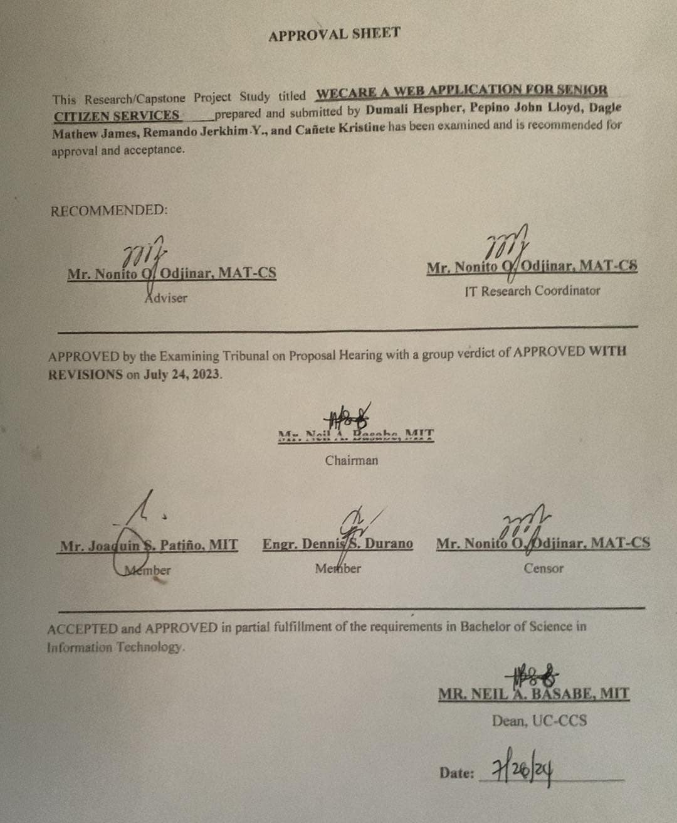

**ACKNOWLEDGMENT**

The realization of this capstone project has been made possible through the assistance and encouragement of numerous individuals. We wish to express our heartfelt gratitude to each and every one of them.

Above all, we express our deepest gratitude to the gracious Almighty for enabling us to undertake and overcome the challenges encountered in this research project. His unwavering love and guidance provided us with the strength and wisdom needed to successfully navigate this academic journey.

We are grateful to our esteemed dean, Mr. Neil Basabe, for granting us the opportunity to pursue this inspiring idea. Thank you for your belief in both the project and our team.

We extend our heartfelt gratitude to Mr. Nonito Odjinar, our skilled advisor, whose invaluable guidance has been indispensable during the entire project's evolution. We genuinely value the expertise, wisdom, and counsel you have graciously imparted to us.

We also want to extend our sincerest appreciation to everyone who supported this project and the team, with a special thanks to our families for their unwavering support and belief in us. Additionally, we are grateful to our friends, classmates, and mentors for their encouragement and valuable insights that greatly contributed to the completion of this research project.

Lastly, we wish to recognize the team who worked tirelessly on this endeavor—**Hespher Dumali, John Lloyd Pepino, Mathew James Dagle, Jerkhim Y. Remando, and Kristine Cañete**—for their dedication and collaborative efforts in developing this research project to the best of our capabilities.

**The Researchers**

**DEDICATION**

We dedicate this research to advancing knowledge and its practical application for societal improvement. Through our combined efforts, we have aimed to push the limits of human comprehension and innovate solutions that can positively influence global progress. Our research underscores the significance of human curiosity and the capacity of science to foster development.

We are profoundly thankful to our advisor, whose guidance and expertise have played a pivotal role in shaping this endeavor. Their steadfast support and mentorship have been priceless, and we sincerely appreciate their contributions to our journey. We also recognize the tireless dedication of our family and friends, whose unwavering emotional support and encouragement have been a continuous source of motivation and inspiration throughout this project.

This work is dedicated to those who understand the profound impact of research in driving progress and change. We hope that our findings will spark curiosity and innovation, inspiring others to undertake their own research endeavors. By enhancing our understanding of the world, our aim is to create a better future for generations to come. We feel honored to have played a role in advancing knowledge and eagerly look forward to future discoveries.

**TABLE OF CONTENTS**

APPROVAL SHEET…………………………………………………………..……….…ii

ACKNOWLEDGEMENT………………………………………………………..………iii

DEDICATION……………………………………………………………….…………...iv

TABLE OF CONTENTS**………………………………………………………..……...…v**

LIST OF TABLES**………………………………………………………………..………ix**

LIST OF FIGURES**……………………….……………………………………...…….…x**

CHAPTER I INTRODUCTION**……………………………………………...…………...1**

Rationale of the Study ………………………………………………………..……1

Objectives of the Study……………………………………………………..……..2

Scope and Limitations of the Study…………………………………….…………3

Scope of the Study………………………………………………………….……..3

Limitations of the Study…………………………………………………..……….3

Significance of the Study………………………………………………..………3-4

Definition of Terms…………………………………………………………..……4

CHAPTER II REVIEW OF RELATED LITERATURE AND STUDIES**..………...…….6**

Related Literatures…………….………………………………………..……….6-7

Related Studies……………………...…………………………………………7-14

Comparative Matrix………………………………………………………..…14-15

Comparative Analysis……………………….…………………………..……15-17

Legal Basis……………………………………………………………………….

CHAPTER III RESEARCH METHODOLOGY…………..…………….…………..….18

Research Design………………………………………………….…………...…18

Method…………………………………………………….……………..18

Flow of the Study………………………………………….…………18-19

Research Environment……………..…………………………………19-20

Respondents……………………………………………………...………20

Research Instrument……………………………………………...………21

Research Procedure……………………………………………...……….21

Data Gathering………………………………………...…………22

Treatment of Data………………………………………………..22

Ethical Considerations…………………………………………..……22-23

Software Engineering Methodology…………………………………….……23-24

Planning/Conception-Initiation Phase……………………………………..…….24

Business Model Canvas……………………………………...………24–27

Program Workflow…………………………………………...………28-30

Validation Board (Stage 1 and 2 ).........................................................31-32

Business Roadmap……………………………………………………33-34

Functional Decomposition Diagram……………………….…………34-36

Gantt Chart………………………………………………...…………37-40

Analysis-Design Phase…………………………………………………...………40

Use Case Diagrams………………………………………...…………41-43

Storyboard……………………………………………………………44-76

Database Design……………………………………………….…………77

Entity-Relationship Diagram…………….………...…………77-78

Data Dictionary……………………………….………………79-85

Network Design………………………………………,,,,,………………85

Network Model…………………………………………….…….85

Network Topology…………..………………………..………86-87

Development/Constructional/Build Phase……………………………………….87

Technology Stack……………………………………………….……87-89

Software Specification……………………………………...………...…89

Hardware Specification………………….……………………….…...…90

Program Specification ……………………………………………...……91

List of Modules…………………………………………….…91-94

Testing Plan………………………………………………………………95

Unit Testing…………………………………….…...…..……95-97

Integration Testing……………………………………………….97

System Testing………………………………………...…………98

Acceptance Testing…………………………………...……….…98

REFERENCES**…………………………………………………………………...…**99-100

CURRICULUM VITAE**………………………………………………...…………**101-105

APPENDICES**……………………………………………………………...……..……**106

Accomplished Forms………………………………………………....……106-125

Transmittal………………………………………………………………...……126

Questionnaire………………………………………………………………127-132

**LIST OF TABLES**

Table 1 COMPARATIVE MATRIX………………………………………….………14-15

Table 2 COMPARATIVE ANALYSIS…………………………………….…………15-17

Table 3 BUSINESS MODEL CANVAS………………………………..………….…….27

Table 4 STAGE 1 PROBLEM VALIDATION……………………………………..……31

Table 5 STAGE 2 SOLUTION VALIDATION……………………………………..…...32

Table 6 GANTT CHART CAPSTONE 30……………………………………….…..37-40

Table 7 Data Dictionary……………………………………………………….…...…79-85

Table 8 SOFTWARE SPECIFICATION FOR DEVELOPMENT……………………...…….89

Table 9 HARDWARE SPECIFICATION FOR DEVELOPMENT………………...……90

Table 10 LIST OF MODULES……………………………………………….……..91-94

Table 11 UNIT TESTING…………………………………………………..………..95-97

Table 12 INTEGRATION TESTING……………………………………….…………...97

Table 13 SYSTEM TESTING……………………………………………………...……98

Table 14 ACCEPTANCE TESTING………………………….…………………………98

**LIST OF FIGURES**

Figure 1: Senior Living…………………………………………………..……….…….7-8

Figure 2: Care…………………………………………….……………….…………….8-9

Figure 3: Anvayaa………………………………………………………….…………..9-11

Figure 4: AgingCare……………………………………………………………...…..11-13

Figure 5: Home Instead………………………………………………………...…….13-14

Figure 6: Flow of the Study…………………………………………………...……...18-19

Figure 7: Software Engineering Methodology………………………………….……23-24

Figure 8: User Program Workflow……………………………………………...……….28

Figure 9: Senior Assistant Program Workflow…………………………………………..29

Figure 10: Admin Program Workflow……………………………………………..…….30

Figure 11: Business Roadmap…………………………………………..……………33-34

Figure 12: Functional Decomposition Diagram………………………………..…….34-36

Figure 13: Senior Citizen Use Case Diagram……………………………………………41

Figure 14: Senior Assistant Use Case Diagram………………………………………….42

Figure 15: Admin Use Case Diagram……………………………………....……………43

Figure 16: Landing Page……………………………………………………...………44-45

Figure 17: Log-in Page……………………………………………………...…………...46

Figure 18: Registration Account Details…………………………………………………47

Figure 19: Registration Profile Set-up……………………………………...……………48

Figure 20: Registration Roles and Agreement……………………………………...……49

Figure 21: Application Form…………………………………………………….....…....50

Figure 22: Homepage………………………………………………………....………….51

Figure 23: Application Reminders………………………………………………....…….52

Figure 24: Find Senior Assistant……………………………………………...…………53

Figure 25: Appointment Section……………………………………………………....…54

Figure 26: Payment Method…………………………………………………..….……....55

Figure 27: Search Filter…………………………………………………………...……..56

Figure 28: Payment w/ Credit Card……………………………………………..….……57

Figure 29: Payment w/ Gcash……………………………………………….……..…….58

Figure 30: Payment Failed……………………………………………………...………..59

Figure 31: Message Contents…………………………………………………...………..60

Figure 32: Feedback & Ratings……………………………………………..……….…..61

Figure 33: Message Recipient List……………………………………….……...………62

Figure 34: Emergency Contact…………………………………………………….…….63

Figure 35: Logout………………………………………………………..……..….…….64

Figure 36: Senior Assistant Homepage………………………………..………..….……65

Figure 37: Senior Assistant Request………………………………………...….….……66

Figure 38: Senior Messages…………………………………………………....…..…….67

Figure 39: Message Content…………………………………………………..……..…..68

Figure 40: Notes and Reminders…..…………………………………………………….69

Figure 41: Senior Assistant Account…..…………………………..…………..………...70

Figure 42: Admin Homepage………………………………………………..….…..……71

Figure 43: Senior Assistant Users Management………………………………….……...72

Figure 44: Remove User Prompt…………………………………………..……..….…..73

Figure 45: Senior Users Management………………………………………...…...……..74

Figure 46: Manage Ratings………………………………………………….…….……..75

Figure 47: Manage Application………………………………………….……....….…...76

Figure 48: Entity-Relationship Diagram………………………………………...…...77-78

Figure 49: Hybrid Network Topology………………………………………...…...…….86

Figure 50: Development Technology Stack Diagram……………………….………..….88

**CHAPTER I: INTRODUCTION**

**Rationale of the Study**

As the world's population ages, there is an increasing demand for competent aged care services. Traditional methods of identifying and arranging senior assistants are typically inefficient, onerous, and unavailable to many older persons. This project seeks to solve these issues by creating WeCare, a web application meant to improve the quality of life for elderly persons by providing a user-friendly platform for appointment scheduling and assistant selection.

Current solutions for aged care frequently lack efficiency, usability, usefulness, and security. These inadequacies can prevent older persons from receiving the care they require and from properly adopting technology alternatives. WeCare intends to address these hurdles by providing an easy-to-use interface for locating and hiring senior assistants. By concentrating on these critical areas, the research hopes to guarantee that the proposed system fits its users' demands completely.

The use of new technology solutions is critical in eliminating inefficiencies in aged care services. WeCare uses technology to build a strong and secure platform that links seniors with senior assistants while also offering services like booking and scheduling, senior assistant profiles, secure communication, and task management. These features are intended to ease the assistance process and improve the overall experience for elders and senior assistants.

WeCare is more than simply a technical solution; it is a community-based project dedicated to creating a friendly atmosphere for older persons. By boosting access to caregiving services, the application reduces the strain on community resources and social services while encouraging a culture of caring and support. This, in turn, promotes increased community participation and improves the well-being of the elderly.

Given the delicate nature of personal data used in caring, WeCare prioritizes data security and privacy. The program is meant to protect users' personal information, allowing older folks to trust the platform with their data. This emphasis on security is critical for instilling trust in users and guaranteeing the system's long-term viability.

This report gives useful information about the development and deployment of digital solutions for geriatric care. This study's findings and techniques can be used to support future studies in the field of gerontechnology. By detailing the obstacles and triumphs experienced.

Throughout the creation of WeCare, this study provides a road map for future academics and developers working on comparable projects.

Finally, the goal of this research is to close the gap between the expanding requirements of an aging population and the technology options accessible for aged care. This study's goal in establishing WeCare is to create a dependable, efficient, and secure platform that improves the quality of life for seniors, helps senior assistants, and builds a more inclusive and supportive community.

**Objectives of the study**

This study aims to analyze, design, and develop a web application called WeCare, where senior citizens can schedule appointments and choose a senior assistant thereby enhancing their quality of life and fostering a sense of community.

Specifically, it seeks to answer the following:

1. Identify the current or existing system in terms of:

1.1. senior care process;

1.2. problems encountered with application compatibility;

1.3. functionality of the system; and

1.4. data and communication security

1. Determine the mechanism or technique to be utilized for the proposed system in relation to.

2.1. appointment and scheduling;

2.2. user-friendly feedback; and

2.3. assisted functionality/features for senior care service.

1. Define the best features of the proposed WeCare appointment system.
2. Established the level of acceptability of the proposed appointment system.

**Scope and Limitation of the Study**

**Scope of the study**

The creation of an approachable platform to link elderly people and senior assistants is part of the scope. The study's main objectives are to create an easy-to-use interface, assemble an extensive database of senior assistants, and put in place a comprehensive assistant system that helps elderly people and senior assistants keep track of appointments, daily responsibilities, and medical information. It also highlights the importance of maintaining strict guidelines for data security and privacy, developing a system of evaluation and feedback for senior assistants, and offering assistance and resources to both elderly residents and senior assistants. Enabling a dependable and effective service to improve senior care is the aim. It will strive to lessen senior assistant stress, raise the standard of assistance, and improve the whole experience of providing care through this system.

**Limitations of the study**

The limitations of the web application include several key challenges. Initially, the application may be restricted to a specific location, limiting its accessibility. Senior citizens might face difficulties in adopting new technology, affecting the app’s usage. The accuracy of the senior assistant database relies on the honesty of the information provided by the senior assistant. Additionally, the need for internet access could be a barrier for some users, especially in remote areas. Compliance with various regulations and resource constraints, such as funding and technical expertise, also pose significant challenges to the development and maintenance of the application. The system may still be vulnerable to unforeseen cyber threats and other malicious software, beyond the control of the researchers.

**Significance of the Study**

This study contributes significantly to advancements in the system by promoting senior citizen well-being, improving efficiency, and fostering a more inclusive and supportive community. The researchers believe that the outcome of the study would benefit the following:

1. **Senior Citizens.** WeCare significantly enhances the quality of life for senior citizens by providing a reliable platform to find and hire qualified senior assistants. The application ensures that elderly individuals receive the necessary care and support, contributing to their overall well-being. Additionally, the platform prioritizes data privacy and security, safeguarding their personal information. With an intuitive and accessible interface designed specifically for their needs, senior citizens can easily navigate and use the application, making the process of finding care straightforward and stress-free.
2. **Senior Assistant.** For senior assistants, WeCare opens up increased employment opportunities by allowing them to showcase their skills, experience, and availability. The platform’s feedback and rating system helps senior assistants build their reputation and trustworthiness, leading to more consistent and rewarding work. By connecting with more clients through the application, senior assistants can gain diverse caregiving experiences, contributing to their professional growth and development.
3. **Community at large.** The community at large benefits from WeCare by fostering a more supportive and connected environment for senior citizens. By facilitating access to reliable caregiving services, the application helps reduce the burden on community resources and social services. It promotes a culture of care and support, encouraging community members to engage in and contribute to the well-being of their elderly neighbors.
4. **Researchers**. This research project is a significant accomplishment for the researchers as it enhances their abilities in developing programs. The study also assesses their abilities that enabled them to feel fulfilled and accountable. It also teaches them how to get ready for the competitive professional environment.
5. **Future Researchers**. Future researchers would gain advantages from the system. Through this research, they could gain insight into how to carry out their own investigation. The research may provide valuable data and serve as the foundation for a better system.

**Definition of Terms**

**Booking and Scheduling**: The application allows for easy booking and scheduling of senior assistant services. Seniors can view senior assistant availability and set up appointments directly through the platform.

**Senior Assistant:** Someone who provides essential assistance and support to senior citizens to fully care for themselves due to illness, disability, aging, or other challenges, helping with daily tasks and enhancing their quality of life.

**Senior Assistant Profiles**: Detailed profiles of senior assistants include information on their skills, experience, certifications, availability, and user reviews. This helps seniors make informed choices based on comprehensive data.

**Emergency Contacts and Alerts**: Allows users to store and manage critical contact information for emergency situations. This feature enables seniors and their senior assistant to input and update contacts such as family members, doctors, or emergency services. In case of an emergency, the application can swiftly notify designated contacts via alerts, ensuring timely assistance and support. This functionality enhances the safety and security of seniors by facilitating quick access to help when needed, thereby improving overall peace of mind for both users and their senior assistant.

**Search and Filter Options**: Users can search for a senior assistant using various filters such as location, availability, services offered, and language spoken. This customization ensures that seniors find the most suitable senior assistant for their specific needs.

**Secure Communication**: WeCare offers a secure messaging system for seniors and senior assistants to communicate, discuss needs.

**Task Management and Reminders**: Enables users to organize and track daily tasks and appointments efficiently. It allows senior assistants to create, prioritize, and schedule tasks such as medication reminders, doctor appointments, or daily activities. The application provides alerts and notifications to remind users of upcoming tasks, ensuring they stay on track with their routines and obligations. This functionality enhances the independence and quality of life for seniors by promoting better organization and adherence to schedules, thereby reducing stress and improving overall well-being.

**User-Friendly Interface**: WeCare is designed with a simple and intuitive interface to accommodate users of all technological proficiency levels. Seniors can easily navigate the application to find and select a senior assistant.

**CHAPTER II**: **REVIEW OF RELATED LITERATURE**

**Related Literature**

Family caregivers of seniors with complex needs face significant challenges, including emotional stress, lack of resources, and difficulties in coordinating care. A study conducted by Charles et al. (2017) aimed to describe these experiences and challenges and to outline support strategies and research priorities aimed at supporting these caregivers.

Information and communication technology (ICT) holds promise in providing support and reducing isolation among older adults, as demonstrated by the impact of the Personal Reminder Information and Social Management (PRISM) system (Czaja et al., 2016).

With the population aging, the burden of chronic disease will increase and so will the need for the caregiving support of family and friends. (Adelman RD et al., 2014).

With the increasing need for AIP, new roles and adaptations are required for various types of caregivers, including care service providers, care workers, family members living together, long-distance family members, relatives, and significant others, who are involved in caregiving at home as an alternative to hospitals or nursing homes.(Kang EA et al., 2019).

Laura Funk’s study underscores the significant challenges faced by Canada's aging population and their caregivers in accessing fragmented health and social care services. The study highlights that older Canadians with chronic illnesses, disabilities, and cognitive impairments

often encounter discouraging barriers when navigating these systems. These challenges are exacerbated for individuals lacking familial support, adding to caregivers’ burdens. (Funk, 2019)

In this context, the assistance of technology offers much potential and can improve the quality of life of people with dementia and their informal caregivers. (B.C. Zapata et al., 2015)

FCGs play an integral, yet often invisible, role in the health-care system. They provide essential care that allows seniors to live in their communities, reducing the burden on institutional care facilities. Supporting FCGs not only enhances the quality of care provided to seniors but also improves the quality of life for the caregivers themselves (Fisher et al., 2017). Effective support

for FCGs ensures that they can continue their caregiving duties without experiencing burnout or excessive stress.

**Related Studies**

**Seniorliving**

SeniorLiving.org serves as a vital online resource offering comprehensive information and tools for individuals navigating senior care decisions. This study explores the benefits of SeniorLiving.org in supporting users' information-seeking and decision-making processes related to senior living options. Through qualitative interviews and quantitative surveys, this research examines user perceptions of the website's credibility, usability, and impact on decision outcomes. Findings reveal that SeniorLiving.org plays a crucial role in providing reliable information, facilitating informed choices, and enhancing user confidence in selecting appropriate senior care solutions. Recommendations include optimizing content relevance, enhancing user experience, and expanding interactive tools to further empower users in their senior care journey.

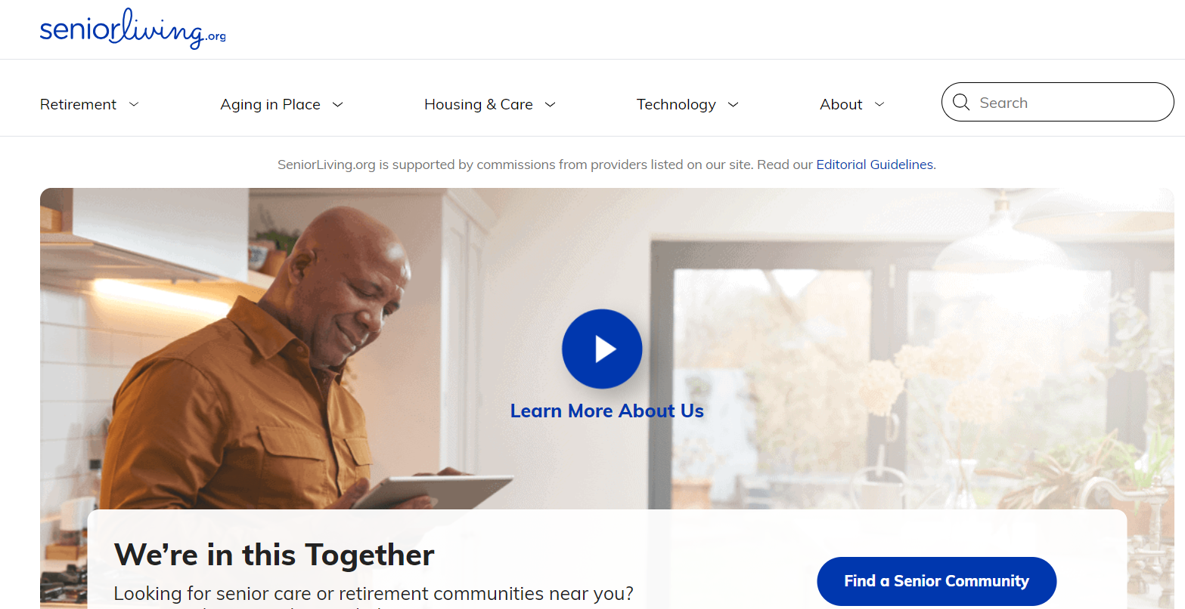

**Figure 1: Seniorliving**

SeniorLiving.org is a comprehensive platform designed to assist families in finding suitable senior living options, including assisted living, independent living, memory care, and nursing homes. Users can search for senior living communities by location, view detailed profiles, and read reviews from residents and their families.

The site emphasizes user convenience, offering resources such as cost calculators, expert advice, and informative articles on senior care. SeniorLiving.org prioritizes safety and reliability, providing tools to help families make informed decisions about senior care options.

Additionally, the platform supports diverse senior living needs and local availability, enabling users to find the best care solutions within their area. The site also offers guidance on financial planning, legal considerations, and health and wellness tips to ensure families are well-equipped to manage their loved ones' care.

**Care: Connecting families with quality, local caregivers**

Care.com is a platform that connects families with senior assistants for various needs, including child care, senior care, tutoring, pet care, and housekeeping. Founded in 2006, it aims to make the process of finding and managing care easier and more reliable. The website offers a searchable database of senior assistant and care-related services, enabling users to view profiles, read reviews, and check references.

Care.com also provides resources and tools for managing care, such as background checks, payroll services, and insurance options. The platform supports a wide range of care needs and helps families find suitable senior assistants locally and globally.

The site has received mixed reviews, with some users praising its convenience and extensive database, while others have raised concerns about the quality and safety of the services provided​

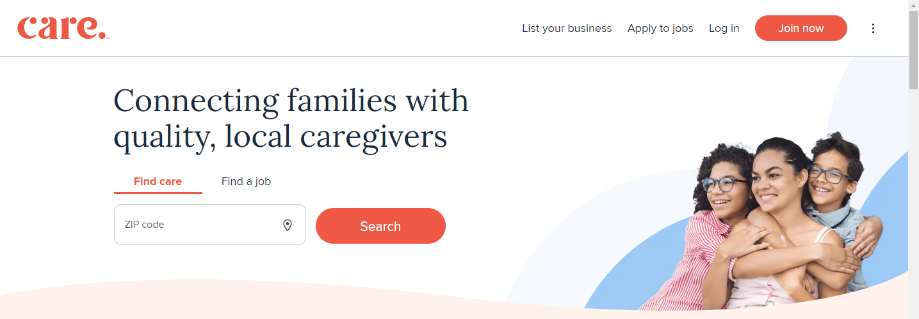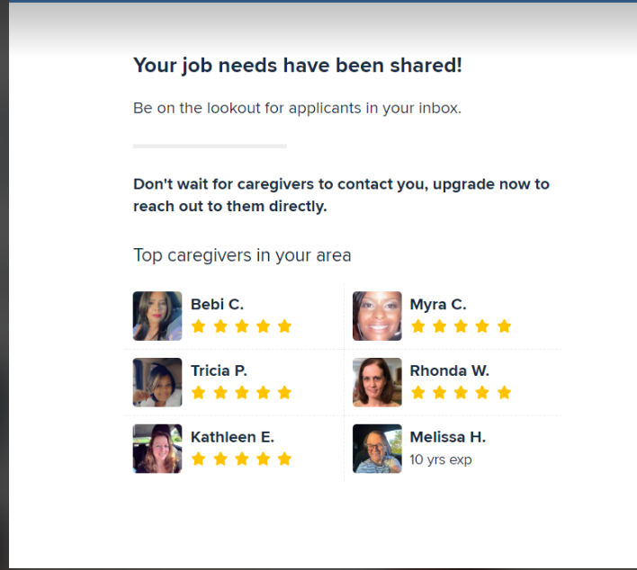

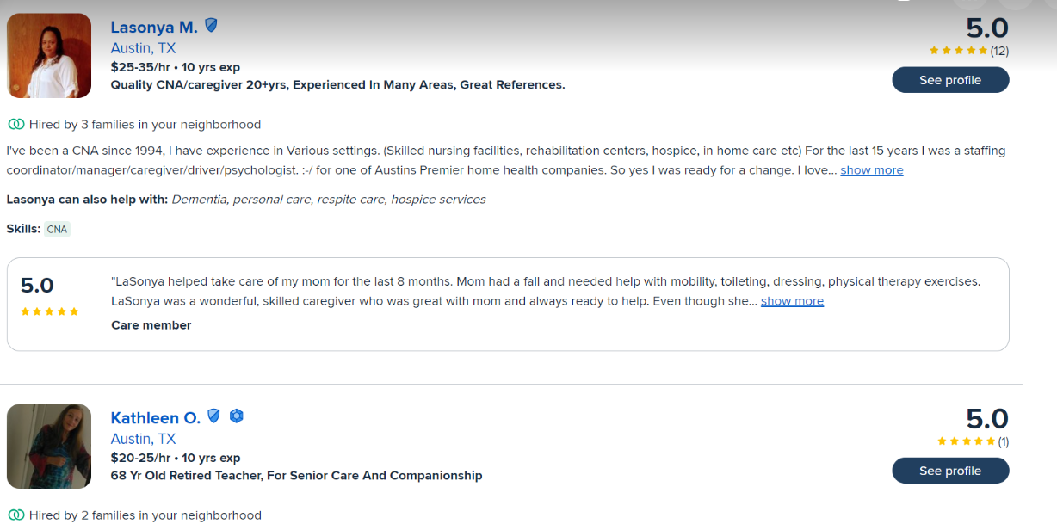

**Figure 2: Care: Connecting families with quality, local caregivers**

A platform designed to connect families with senior assistants for various needs, including child care, senior care, special needs care, tutoring, pet care, and housekeeping. Users can search for local senior assistants, view their profiles, check reviews, and communicate directly through the site. Care.com aims to facilitate the process of finding reliable and qualified senior assistants to meet diverse family needs.

Care.com aims to connect families with quality, local senior assistants by providing a comprehensive platform where users can search for, vet, and hire senior assistants for various needs, including child care, senior care, pet care, tutoring, and housekeeping. The platform emphasizes convenience, offering an easy-to-use interface where families can quickly find and connect with senior assistants that match their specific requirements. It prioritizes safety and reliability by providing tools like background checks, reference checks, and reviews to ensure the senior assistant hired are trustworthy and qualified. Additionally, Care.com caters to diverse care options and supports local availability, enabling users to find senior assistants within their area, as well as globally. The platform also offers resources and tools for managing care, such as payroll services, insurance options, and care guides, to simplify the caregiving process for families​.

**Anvayaa: care-comfort-convenience**

Anvayaa is a web-based application focused on providing elder care services across India. This study explores its comprehensive care model, offering health management, daily assistance, leisure activities, and emergency support. The app connects families with certified senior assistants, ensuring personalized and reliable care for elderly members.

The aim of Anvayaa is to enhance the quality of life for seniors by offering a holistic care approach. It ensures real-time updates and seamless communication, providing peace of mind to families who cannot always be physically present to care for their elders.

Anvayaa exemplifies an effective elder care solution through its comprehensive service offerings and user-friendly platform. It bridges the gap between professional care and familial support, ensuring that the elderly receive the care they need while their families stay informed and involved.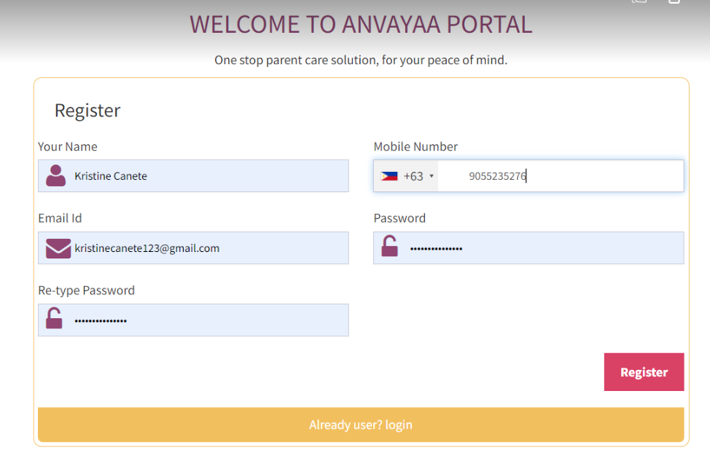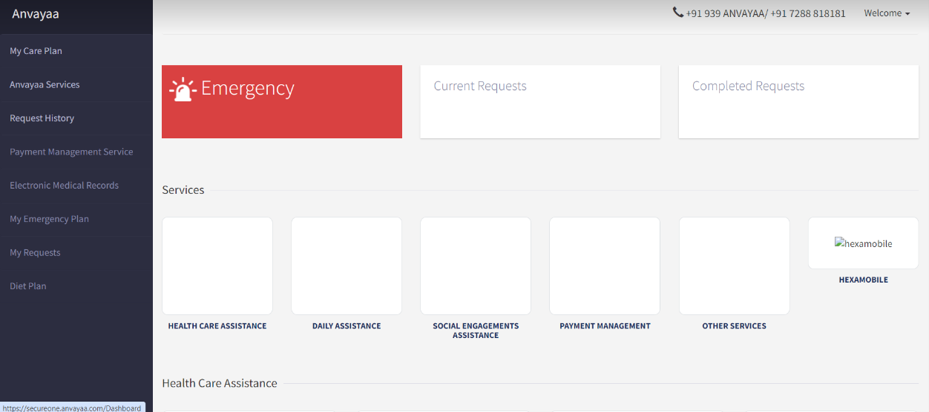

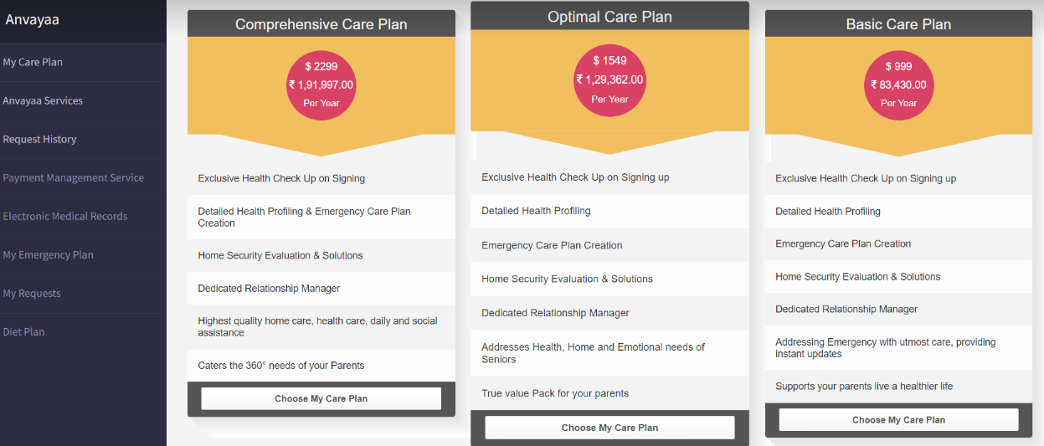

**Figure 3: Anvayaa: care-comfort-convenience**

Anvayaa is a web app designed to provide elder care services across India. It offers a range of personalized care plans that include health care management, daily assistance, leisure activities, emergency support, and companionship. The app connects users with certified and trained senior assistants, ensuring that elderly family members receive comprehensive and reliable care. Families benefit from real-time updates, easy communication, and the ability to manage and monitor care plans remotely, ensuring the well-being and safety of their elderly loved ones.

The Anvayaa app offers several benefits for users, especially those concerned about elderly care. Firstly, it facilitates efficient care coordination by allowing users to manage and coordinate various services for their elderly loved ones seamlessly. Secondly, the app provides crucial emergency response services, ensuring rapid assistance during medical emergencies or urgent situations. Additionally, Anvayaa enables the creation of personalized care plans tailored to individual needs and preferences, enhancing the quality of care provided. Users can remotely monitor the well-being and activities of their loved ones, offering peace of mind through real-time updates and alerts. The app also facilitates easy communication among family members, senior assistants, and healthcare professionals involved in the care process. Furthermore, Anvayaa maintains comprehensive documentation and generates reports on health metrics, activities, and services provided, supporting informed decision-making and ensuring holistic care management.

The Anvayaa app provides a robust framework for managing elderly care, offering users peace of mind through efficient care coordination, personalized plans, and responsive emergency services. With features for remote monitoring, easy communication, and comprehensive documentation, Anvayaa empowers families to ensure the well-being and quality of life for their elderly loved ones, making it a valuable tool in modern caregiving.

**AgingCare: In Home Care, Assisted Living Caregiver Support**

AgingCare is a comprehensive online platform designed to support families in finding and managing elder care services. The platform offers a wide range of resources, including in-home care, assisted living options, senior assistant support, and emergency assistance. AgingCare aims to simplify the process of locating and coordinating care for elderly family members by providing a centralized, easy-to-use interface.

Founded to address the growing needs of the aging population, AgingCare connects users with professional senior assistants and care facilities, allowing families to view profiles, read reviews, and communicate directly through the platform. It emphasizes safety and reliability by offering tools such as background checks, reference checks, and user reviews to ensure that the senior assistant and services provided are trustworthy and qualified.

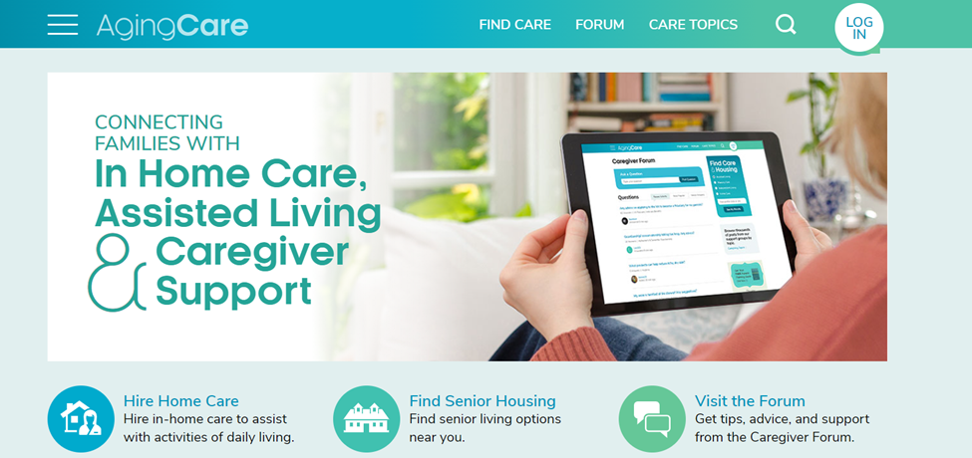

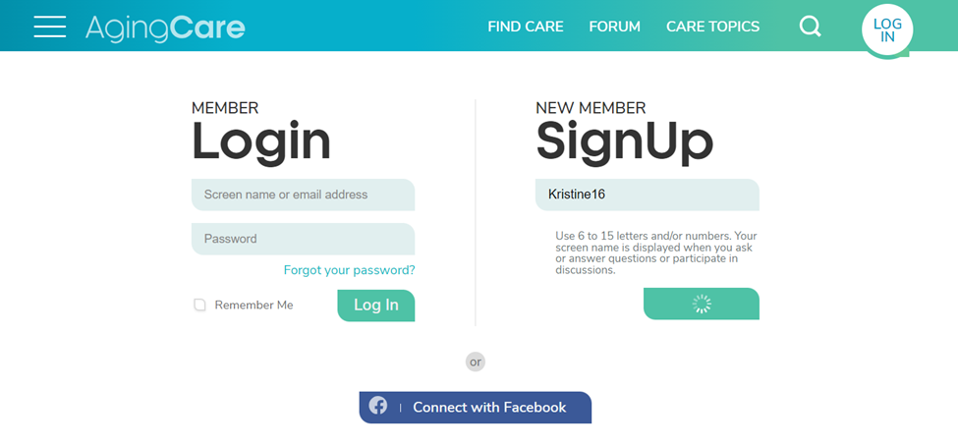

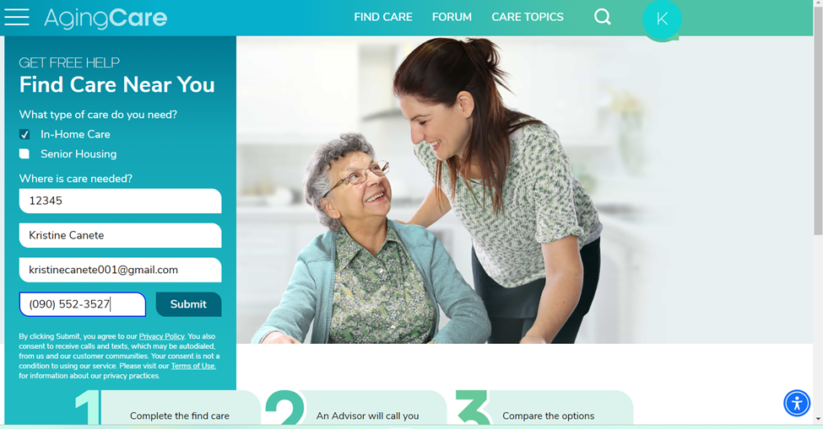

**Figure 4: AgingCare: In Home Care, Assisted Living Caregiver support**

AgingCare also provides a wealth of resources to assist families in managing elder care, including financial advice, legal information, and health and wellness guides. The platform supports a holistic approach to elder care, catering to diverse needs and ensuring that seniors receive personalized and comprehensive care.

The site has received mixed reviews, with some users praising its extensive database and user-friendly design, while others have noted concerns about the consistency of service quality. Despite this, AgingCare remains a valuable resource for families seeking reliable and effective elder care solutions, offering peace of mind through its commitment to quality and safety.

**Home Instead: The care they need. The home they love.**

Home Instead is a distinguished provider of in-home care services, specializing in enhancing the quality of life for seniors across diverse needs and preferences. With a steadfast commitment to promoting independence and dignity, Home Instead offers a comprehensive range of personalized care solutions. Their senior assistant, known as senior assistant, undergo extensive training and are selected for their compassionate approach and dedication to exceptional care.

At the heart of Home Instead 'mission is the belief in fostering meaningful connections between senior assistants and seniors. This approach ensures continuity of care and companionship, addressing daily needs such as medication reminders, meal preparation, personal care, and assistance with activities of daily living. By prioritizing individualized attention and support, Home Instead enables seniors to maintain their routines and lifestyles comfortably within their own homes.

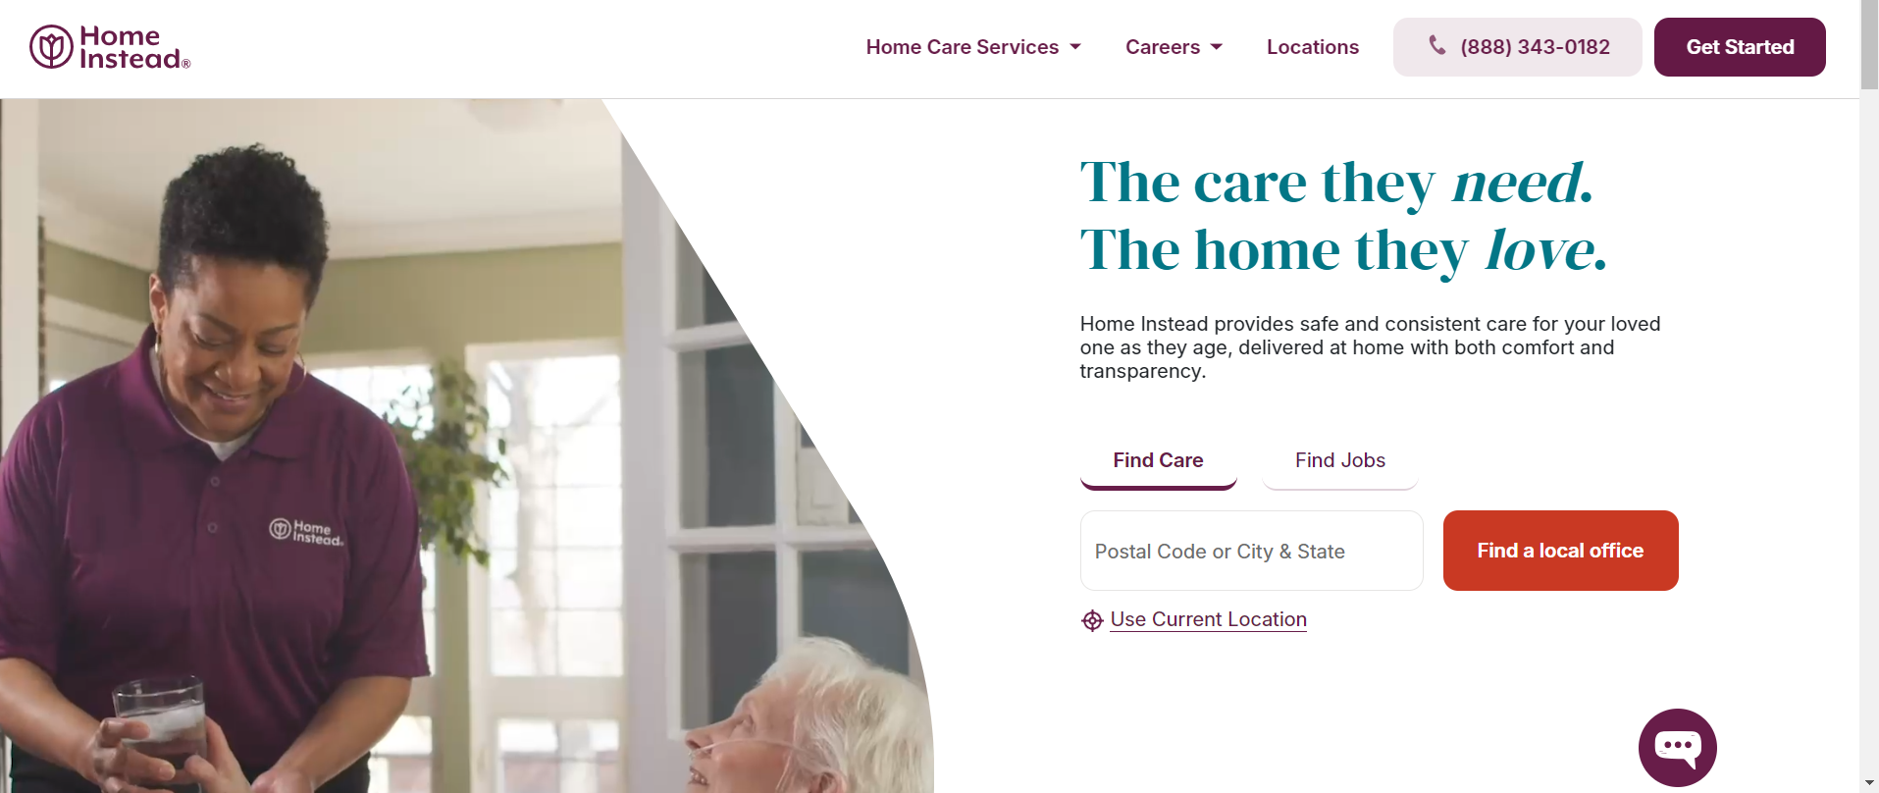

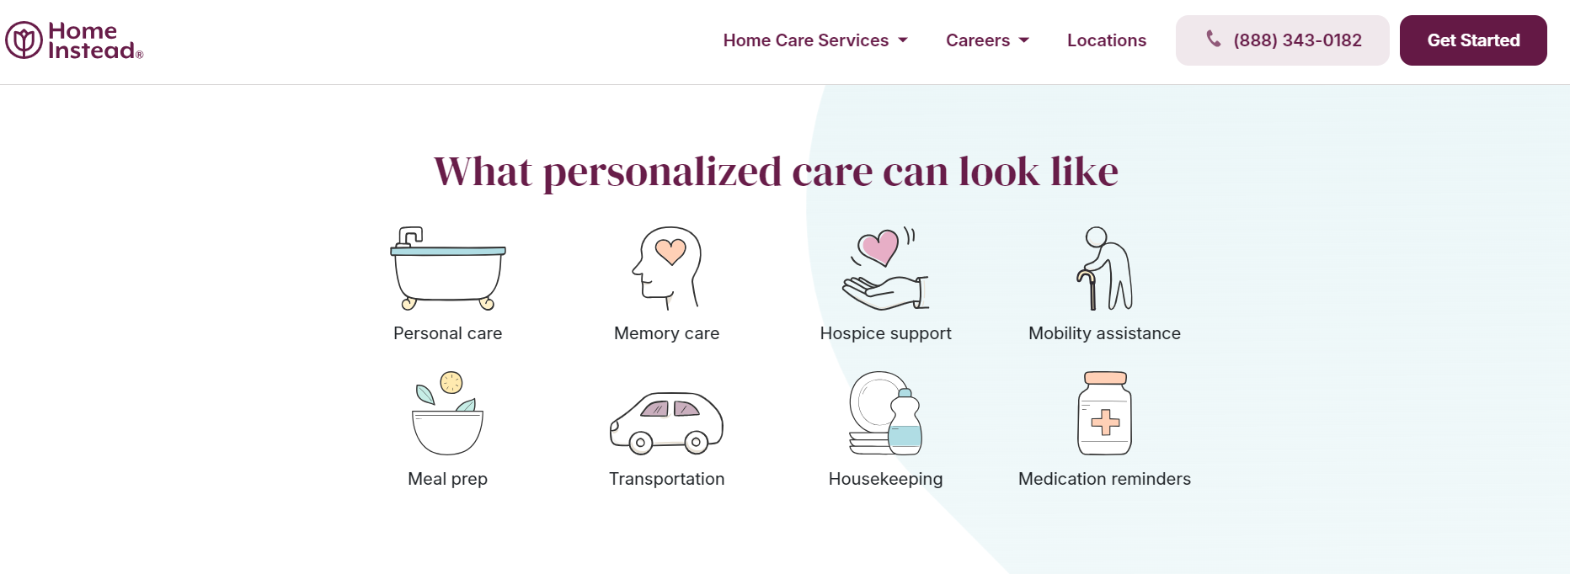

**Figure 5: Home Instead: The care they need. The home they love.**

Beyond caregiving, Home Instead provides families with peace of mind through stringent senior assistant screening processes, including thorough background checks and ongoing quality assurance measures. They also offer valuable educational resources and support networks, equipping families with the knowledge and tools to navigate the complexities of aging and caregiving effectively.

Recognized for their commitment to excellence and compassionate care, Home Instead has established itself as a trusted partner for families seeking reliable in-home care solutions. Their values of integrity, empathy, and respect underscore every aspect of their service, ensuring that seniors receive the highest standard of care tailored to their unique needs and preferences.

**Comparative Matrix**

Comparative Matrix The comparative framework is designed to demonstrate and evaluate the distinctive features of the study and existing related studies and compare and calculate the percentage according to the number of features covered by the competitors.

**Table 1**

**Comparative Matrix**

| **Functions** | **Care** | **Anvayaa** | **Seniorliving** | **Home Instead** | **AgingCare** | **WeCare** |
| --- | --- | --- | --- | --- | --- | --- |
| Booking and Scheduling | **✔** | **✔** | **✖** | **✖** | **✖** | **✔** |
| Senior Assistant | **✔** | **✔** | **✔** | **✔** | **✔** | **✔** |
| Caretaker Profiles | **✔** | **✔** | **✔** | **✔** | **✔** | **✔** |
| Emergency Contacts and Alerts | **✖** | **✖** | **✖** | **✖** | **✖** | **✔** |
| Freemium | **✔** | **✖** | **✖** | **✖** | **✖** | **✔** |
| Search and Filter Options | **✔** | **✔** | **✔** | **✖** | **✖** | **✔** |
| Task Management and Reminders | **✖** | **✖** | **✖** | **✖** | **✖** | **✔** |
| Secure Communication | **✔** | **✖** | **✖** | **✖** | **✖** | **✔** |
| User-Friendly Interface | **✖** | **✖** | **✔** | **✔** | **✔** | **✔** |
| Total: | **67%** | **44%** | **44%** | **33%** | **33%** | **100%** |

**Table 2**

**Comparative Analysis**

| **Related Studies** | **Features** | **Limitations** | **Platform Details** | **Support** |
| --- | --- | --- | --- | --- |
| **Name:** Anvayaa  **URL:** <https://www.anvayaa.com/>  **Year:** 2016 **Proponent(s):**  **1.** Prashanth Reddy  **2.** Deepika Reedy | * Care coordination * Emergency response * Personalized care plans * Remote monitoring * Communication tools * Documentation & reports * Professional support | Common limitations could include geographical availability, dependency on internet connectivity, device compatibility, and specific service restrictions based on subscription plans. | available as a mobile app (iOS and Android) and possibly as a web-based platform for access across different devices. | customer service through various channels such as email, phone, or in-app support, possibly offering 24/7 assistance for users. |
| **Name:** Care  **URL:** <https://www.care.com>  **Year:** 2006 **Proponent(s):**  **1.** Michelle Arbov  **2.** John W. Buchanan  **3.** Wes Burke | * Matching senior assistant with families * Categories of care: child care, senior care, pet care, etc. * Reviews and background checks on senior assistant * Access to care-related articles and resources | Availability and quality of senior assistant may vary by location  Limited direct control over senior assistant scheduling and services  Service fees may apply for certain premium features or transactions | Accessible via web browser  Mobile apps available for iOS and Android | Customer support available via email, phone, and help center  Community forums and resources for users |
| **Name:** seniorliving  **URL:** <https://www.seniorliving.org/>  **Year:** 2013 **Proponent(s):**  **1.** Jeff Hoyt  **2.** Taylor Shuman  **3.** Linda Schlenker, MS, MA, OTR | * Articles and guides on senior care and housing * Tools for comparing senior living facilities * Information on financial planning for seniors | Availability and accuracy of information may vary.  Limited direct services or caregiving matching (typically an informational resource rather than a service provider).  Specific limitations can vary based on the scope and focus of the website. | Accessible via web browser.  provides a user-friendly interface for browsing articles and tools. | Support channels such as contact forms, email, or possibly phone support for inquiries.  resources like FAQs or community forums for additional support. |
| **Name:** AgingCare  **URL:** <https://www.agingcare.com/>  **Year:** 2007 **Proponent(s):**  **1.** Joe Buckheit | * Resource Library * Community Forum * senior assistant Support * Senior Care Locator | User Experience: May vary depending on individual needs and preferences.  Resource Availability: Some areas may have limited local resources listed. | Website: Accessible on desktops, tablets, and mobile devices.  Navigation: User-friendly interface with categorized content. | Customer Support: Available through contact forms and community forums.  Guidance: Expert advice and articles on various elder care topics. |
| **Name:** Home Instead  **URL:**<https://www.homeinstead.com/location/850/home-care-services/our-process-to-provide-quality-senior-care/>  **Year:** 1994  **Proponent(s):**  **1.** Paul  **2.** Lori Hogan | * Personalized Care Plans * Professional senior assistant * Range of Services * 24/7 Availability | Cost: Can be expensive depending on the level of care required.  Service Availability: May vary by location | Website: User-friendly interface with detailed service information.  Accessibility: Available on desktops and mobile devices. | Customer Support: Accessible via phone and email.  Additional Resources: Educational materials and support groups. |

**CHAPTER III: DESIGN AND METHODOLOGY**

**Research Design**

This study employs a qualitative research design to explore the development and implementation of “WeCare,” a web application for senior citizen services. Qualitative methods are chosen to gain in-depth insights into the experiences, needs, and perceptions of the stakeholders involved, including senior citizens, and senior assistants.

**Method**

The integration of qualitative data will provide a comprehensive understanding of the research problem. The qualitative insights will inform the development of the survey questionnaires and usability testing instruments. A non structured interview will also be conducted with senior citizens and their families to understand their needs, challenges, and expectations regarding elderly care services.

A purposive sampling technique will be used to select participants who are most relevant to the study. This includes senior citizens who require assistant services, their family members, senior assistant, and community members involved in elderly care. The sample size will be determined based on the principle of data saturation, where data collection continues until no new information or themes emerge.

**Flow of the Study**

This research will follow a user-centered approach, gathering input on senior needs through literature review and user research. This data will be used to design and develop a web application prototype WeCare, with functionalities targeted towards senior citizens. Usability testing will then refine the application before concluding with a research report and recommendations for future development and implementation.



**Figure 6: Flow of the Study**

**Research Environment**

This study is situated in Cebu City, Philippines, renowned for its diverse demographic composition and rich cultural heritage, which significantly influences the development of the "WeCare" web application. The physical setting includes access to modern facilities and robust technological infrastructure essential for conducting qualitative research and implementing digital solutions.

Cebu City's population features a notable proportion of senior citizens, senior assistant, and community stakeholders actively engaged in elderly care services, providing a fertile ground for understanding their nuanced needs and expectations. Cultural and social contexts, including local customs and historical landmarks, enrich participant interactions and inform culturally sensitive application design.

Collaborations with local healthcare providers, educational institutions, and community organizations ensure comprehensive data collection and community engagement, facilitating a user-centered approach to application development. Ethical considerations, such as informed consent and confidentiality, are upheld throughout the study, supported by institutional policies and regulatory frameworks that safeguard participant welfare and data integrity.

The research environment in Cebu City thus serves as a dynamic backdrop for iteratively designing, testing, and refining the "WeCare" web application to effectively meet the diverse and evolving needs of its senior citizen users.

**Respondents**

1. Senior Citizens - Respondents for this study will be senior citizens residing in Cebu City. These individuals are the main beneficiaries of the WeCare web application, and their input is crucial for understanding the specific needs and challenges they face in accessing elderly care services.

Criteria for selection:

* Age must be 60 years old and above
* Must be a resident in Cebu City
* Willing to participate in interviews

1. **senior assistant**: senior assistants who are actively providing care to senior citizens will be included as respondents. They will share their experiences, perspectives on the usability and effectiveness of the application, and any challenges they face in their caregiving roles. Their input will help in refining the features and functionalities of WeCare to better support their work.

Criteria for selection:

* Has experience involving elderly care
* Must be based in Cebu City
* Willing to participate in interviews

**Research Instrument**

In this study, there will be a systematically organized questionnaire, designed to gather detailed facts and information from senior citizens, senior assistants, and community members. To ensure relevance and clarity, the questionnaire will be developed through a literature review, stakeholder input, and pilot testing. It will comprise sections covering demographic information, current senior assistant practices, needs and expectations, usability and effectiveness of WeCare (for those who have used the prototype), and feedback and suggestions. A mix of closed-ended and open-ended questions will be used to capture qualitative data. The questionnaire will be administered through both online surveys on a secure platform and face-to-face interviews to ensure broad participation and convenience. The collected data will be systematically organized and analyzed, with qualitative data undergoing thematic analysis. This comprehensive approach aims to gather valuable insights that will inform the development and implementation of the WeCare web application, ultimately enhancing elderly care services in Cebu City.

**Research Procedure**

The initial step involves conducting a literature review on online consultation appointment systems and selecting Cebu City as the research location.

The next step involves the creation of surveys and questionnaires tailored for senior assistants and senior citizens to gather qualitative data. These instruments will be designed to capture insights and perspectives that will contribute to a comprehensive understanding of their experiences and needs within the context of the study. Careful consideration will be given to ensuring the clarity and relevance of the questions to facilitate meaningful responses and valuable data analysis. This phase aims to provide rich qualitative insights that will inform the subsequent stages of the research process.

Qualitative data will undergo transcription, coding, and thematic analysis to identify recurring themes and patterns. This analytical process aims to extract meaningful insights from the narratives and perspectives shared by participants. Finally, we will compare and analyze whether accessibility, efficiency, and user satisfaction show improvements between the existing and proposed systems based on these qualitative findings.

**Data Gathering**

Qualitative data was collected for a study focused on WeCare in Cebu City using surveys and questionnaires. These instruments included questions aimed at assessing user satisfaction regarding the platform's efficiency, user-friendliness, functionality, and security. Participants were tasked with rating their perceptions of WeCare's effectiveness in these areas.

The study will employ maximum variation purposive sampling to select approximately 15 senior assistant and 15 senior assistant from Cebu City. Participants will be chosen based on their voluntary willingness to take part in the research.

**Treatment of Data**

The qualitative data collected through surveys and questionnaires on WeCare in Cebu City provides valuable insights into user perspectives regarding the platform's performance. Participants were asked to evaluate aspects such as efficiency, user-friendliness, functionality, and security. Initial analysis reveals diverse opinions among senior assistants and senior citizens regarding these attributes. Some respondents highlighted the platform's ease of use and effective functionality, emphasizing its utility in accessing healthcare services. Conversely, concerns were raised about security measures and certain functionality issues that may impact user experience negatively. This data not only sheds light on current user satisfaction levels but also identifies specific areas where enhancements or modifications could improve overall service delivery and user satisfaction within the WeCare system.

**Ethical Consideration**

In conducting the study “WeCare: A Web Application for Senior Citizen Services,” several ethical considerations are of greatest importance to ensure the protection and respect of all participants. First and foremost, informed consent/letter will be obtained from selected participants. This involves providing detailed information about the study’s purpose, procedures, potential risks, and benefits, ensuring that participants fully understand and voluntarily agree to participate.

Confidentiality and anonymity are also critical; personal information and responses will be kept confidential and anonymized. Participation in the study will be entirely voluntary, with participants having the right to withdraw at any time without any negative consequences. To minimize any potential harm, the study procedures will be designed to be as non-intrusive as possible, and participants will be monitored for signs of distress, with support or referrals provided if necessary.

Transparency and honesty will be maintained in all interactions with participants and in the reporting of research findings, ensuring that participants receive accurate information about the study and that findings are reported truthfully, acknowledging any limitations or potential biases. Respect for participants is fundamental, and all interactions will be conducted with courtesy and consideration, valuing their time and contributions. The research instruments and procedures will be designed to be culturally appropriate and respectful, considering the norms and values of the participants.

By addressing these ethical considerations, the study aims to protect the rights and well-being of all participants while maintaining the integrity and credibility of the research.

**Software Engineering Methodology**

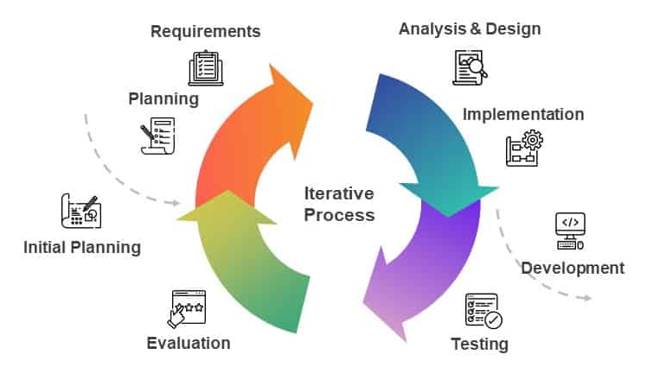

**Figure 7: Software Engineering Methodology**

The Iterative process in software engineering focuses on breaking down projects into smaller, more manageable pieces, known as iterations. Each iteration entails planning, developing, implementing, and testing a tiny portion of the entire system. This process is repeated, with each cycle creating a more polished version of the program until the final result is ready. Iterative technique prioritizes incremental development, with each iteration building on the preceding one to progressively add more features. Continuous feedback is collected after each iteration to enhance the next cycle, ensuring that the program improves in accordance with user demands and requirements. Furthermore, it prioritizes risk management by addressing possible concerns in early iterations, allowing for modifications and improvements throughout the development cycle. This technique encourages teamwork, open communication, and swift decision-making among team members.aligning well with the development approach for the WeCare web application.

**Planning/Conception - Initiation Phase**

Strategic planning and analysis utilize tools like Business Model Canvas, Program Workflow, and Gantt Chart. These tools ensure alignment with senior citizen and senior assistant needs, validate assumptions, set goals, break down requirements, and track progress. This thorough approach supports the successful development and implementation of WeCare, enhancing elderly care services.

**Business Model Canvas**

WeCare will collaborate with various key partners to ensure the success of the web application. These partners include senior assistant agencies that provide a pool of qualified senior assistants, healthcare providers who can offer medical insights and support, and technology partners responsible for the development and maintenance of the app. Investors will play a crucial role in providing the necessary financial resources to support the development and scaling of the platform.

The core activities of WeCare involves developing and maintaining the web application, which includes building a user-friendly interface and ensuring robust functionality. Ensuring data security and privacy is a top priority to protect users’ personal information. Additionally, marketing and outreach efforts will be essential to attract both senior citizens and senior assistants to the platform.

To achieve its objectives, WeCare will rely on several key resources. A skilled development team, including software developers and designers, will be essential for creating and maintaining the application. A marketing team that will help drive outreach efforts. Financial resources from investors will be necessary to fund development and operations, and robust technology infrastructure, such as cloud services, will support the app’s functionality.

WeCare offers several value propositions to its users. For senior citizens, the platform provides easy access to senior assistants, enhancing their quality of life. The user-friendly interface is designed to be intuitive for elderly users. The feedback and rating system ensures the reliability of senior assistants.

WeCare aims to build strong relationships with its users through regular updates. The app will facilitate continuous communication with users, keeping them informed about new features and improvements. Feedback mechanisms will allow users to share their experiences and suggestions, contributing to the app’s continuous improvement.

The primary channel for delivering WeCare’s services will be the mobile-responsive, web application. Social media platforms will be used for marketing and outreach, helping to attract users and build a community around the app. Partnerships with healthcare providers will also serve as important channels for reaching senior citizens and senior assistants. Online marketing and advertising will further enhance visibility and user acquisition.

WeCare targets several customer segments, including senior citizens who need senior assistant services, their families who seek reliable care for their loved ones, senior assistants looking for opportunities, and healthcare providers and social services that coordinate elderly care. Each segment has unique needs that WeCare aims to address through its comprehensive platform.

The cost structure of WeCare includes expenses related to the development and maintenance of the web application, marketing and outreach efforts, and salaries for the development, and marketing teams. Technology infrastructure costs, such as servers and cloud services, are also significant. Additionally, compliance with regulatory requirements will incur costs, ensuring that the platform adheres to relevant laws and standards.

WeCare will generate its revenue through multiple streams. Subscription fees from users, either senior citizens or their families, will provide a steady income. Commission fees from senior assistants for job placements will also contribute to revenue. Advertising revenue from relevant products and services can also be added as an additional source of income.

**Table 3**

**BUSINESS MODEL CANVA**

| **KEY PARTNERS**  **•** Senior Assistant Practitioners.  **•** Healthcare Providers.  **•** Technology Partners.  **•** Investors. | **KEY ACTIVITIES**  **•** Developing and maintaining the web app.  **•** Marketing and outreach to senior citizens and senior assistants.  **•** Ensuring data security and privacy. | **VALUE PROPOSITION**  **•** Easy access to qualified assistance for senior citizens.  **•** User-friendly interface tailored to elderly users.  **•** Reliable feedback and rating system for senior assistants.  **•** Comprehensive support and resources for elderly care. | | **CUSTOMER RELATIONSHIP**  **•** Feedback mechanisms for continuous improvement.  **•** Regular updates and communication through the app. | **CUSTOMER SEGMENTS**  **•** Senior citizens in need of day-to-day assistance.  **•** Senior assistants seeking employment opportunities. |
| --- | --- | --- | --- | --- | --- |
| **KEY RESOURCES**  **•** Development team.  **•** Marketing team.  **•** Financial resources for development and operations.  **•** Technology infrastructure. | **CHANNELS**  **•** Web-application. (Mobile-Responsive)  **•** Social media platforms.  **•** Online marketing and advertising. |
| **COST STRUCTURE**  **•** Development and maintenance costs.  **•** Marketing and outreach expenses.  **•** Technology infrastructure costs.  **•** Compliance and regulatory costs. | | | **REVENUE STREAM**  **•** App commission (5% commission in every transaction)  **•** Advertising revenue from relevant products and services. | | |

**Program Workflow**

To achieve the desired outcome in a program, users need to complete a series of tasks. The following is a step-by-step explanation of how the program functions. The tasks within the program's workflow must be completed for users to reach the desired outcome. The capabilities and features of "Users/Clients," "Admins," and "senior assistant," along with their interactions with the system, are illustrated in the figures below. This explanation details how the program operates, highlighting the roles and functionalities of "Users/Clients," "Admins," and "senior assistant" and their respective interactions with the system.

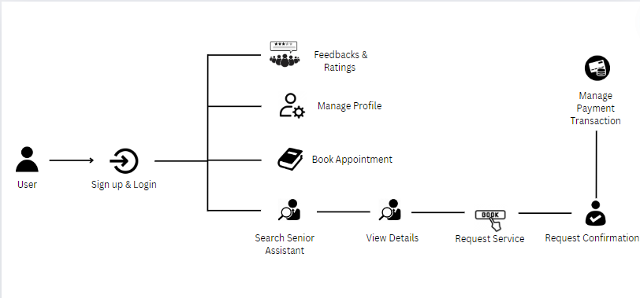

**Figure 8: User Program Workflow**

Figure 7 depicts the user program workflow. Users begin by signing up and enrolling on the platform, then constructing a personal profile with vital information. After registering, individuals may maintain their profiles, changing personal information and preferences as needed. They may schedule appointments by exploring offered services and selecting convenient times. Users may search for a senior assistant using particular criteria, examine extensive senior assistant profiles, and evaluate their credentials and reviews. After selecting a senior assistant, users can request services, which initiates the request confirmation procedure. Once the request is confirmed, users proceed to manage payment transactions securely through the platform. Finally, after receiving services, consumers may review senior assistants, which helps maintain high-quality care standards within the WeCare community.

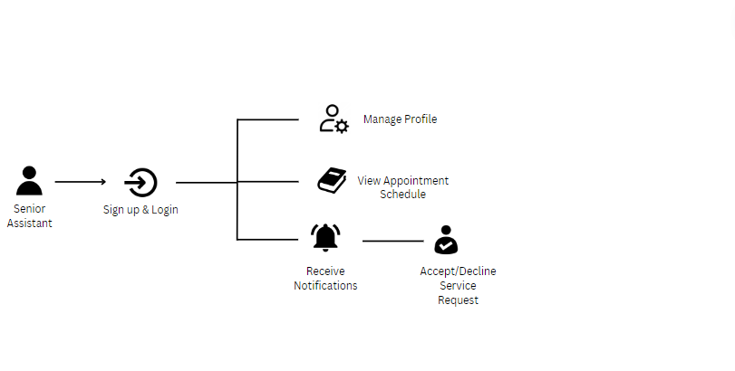

**Figure 9: Senior Assistant Program Workflow**

Figure 8 depicts the senior assistant' program workflow. Senior assistants begin by signing into their own accounts and updating their profiles, which include skills, availability, and contact information. They may keep track of their appointment schedules and receive reminders when new service requests or schedule changes occur. When a user seeks a service, senior assistants assess the information and either accept or deny based on their availability and preparedness. They monitor payment processes to ensure timely remuneration for their services while preserving financial transparency.

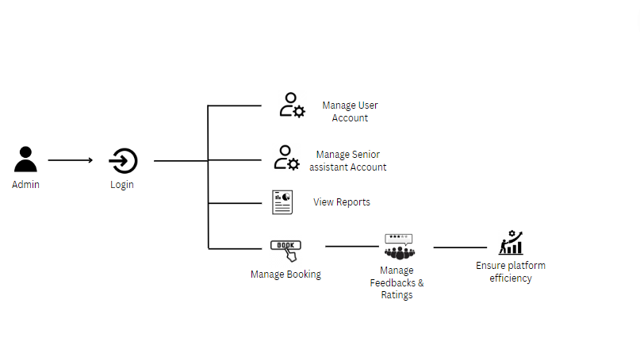

**Figure 10: Admin Program Workflow**

On the WeCare program process, administrators on the WeCare platform manage the operational backbone, assuring seamless functionality and user satisfaction. They access the administrative dashboard to handle user and senior assistant accounts while ensuring data correctness and security. Administrators validate senior assistant credentials and monitor service availability to ensure smooth booking management. They manage appointments between users and senior assistants to avoid scheduling conflicts and improve service delivery. Administrators are also responsible for maintaining comments and ratings, as well as gathering user input in order to maintain service standards and handle any issues as soon as possible. In addition, administrators use the reporting capabilities to create and evaluate detailed reports on booking data and payment transactions. This enables them to monitor appointment statuses, evaluate patterns, and maintain financial responsibility.

**Validation Board**

**Table 4**

**STAGE 1 PROBLEM VALIDATION**

|  | **Senior Citizens** | **Senior Assistant** | **Community Members** |
| --- | --- | --- | --- |
| Problem | - Inefficient and cumbersome methods for finding and scheduling senior assistant <br>- Lack of user-friendly platforms for elderly care services <br>- Concerns about data privacy and security | - Limited employment opportunities and exposure <br> - Difficulty in showcasing skills and gaining trust from clients | - Overburdened community resources and social services <br> - Lack of a supportive environment for elderly care |
| Riskiest Assumptions | The problem exists. | The problem exists. | The problem exists. |
| Success Criteria | 70% (and below) PERSEVERE | 60% PERSEVERE | 60% PERSEVERE |
| Results and Discussions | 75% of respondents found current senior assistant services inefficient and challenging to navigate, highlighting a significant need for a more user-friendly solution. | 65% of respondents expressed difficulty in finding consistent caregiving jobs and building trust with clients, emphasizing the need for a platform to showcase their skills. | 70% of community members agreed that the current system overburdens resources and lacks a supportive environment, indicating a strong need for a streamlined solution like WeCare. |
| Learning | This outcome highlights the need for a more efficient and user-friendly platform to connect senior citizens with senior assistants. | This result emphasizes the importance of creating a platform that offers senior assistants better opportunities and a way to build trust with clients. | This outcome underscores the importance of developing a community-centric platform that supports elderly care services and reduces the burden on the community. |

**Table 5**

**STAGE 2 SOLUTION VALIDATION**

|  | **Senior Citizens** | **Senior Assistant** |
| --- | --- | --- |
| Solution | WeCare web application providing an intuitive platform for finding and scheduling senior assistant | WeCare web application offering a profile system, secure communication, and rating/feedback features to help senior assistants build trust and find jobs. |
| Riskiest Assumptions | The proposed solution addresses the problem. | The proposed solution addresses the problem. |
| Success Criteria | 80% PERSEVERE | 80% PERSEVERE |
| Results and Discussions | 82% of respondents found the WeCare application easy to navigate and useful for scheduling senior assistants, indicating strong acceptance and need for the platform. Features like secure communication and task management were particularly appreciated. | 90% of respondents felt that the WeCare platform provided them with better job opportunities and a way to showcase their skills. They also appreciated the feedback and rating system, which helped build trust with clients. |
| Learning | The high acceptance rate highlights the importance of intuitive design and secure communication features. Continuous improvement and user feedback integration will be crucial for ongoing success. | The positive feedback and willingness to recommend the platform to peers indicate the potential impact of WeCare in improving senior assistant employment opportunities and trust-building. Engaging senior assistant in the development process can further enhance the platform. |

**Business Roadmap**

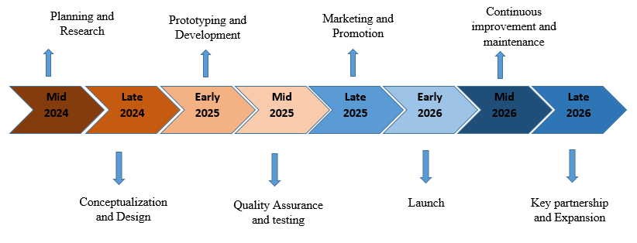

**Figure 11: WeCare Business Roadmap**

Figure 10 shows the strategic timeline and milestones for the development and expansion of the WeCare online application. This roadmap outlines important phases and actions required for the WeCare project's success. The enterprise began in mid-2024 with intensive study and issue analysis, allowing the research team to obtain significant insights into the target population while also identifying current problems in aged care.

Moving further, the roadmap moves to the conception and design phase in late 2024, when the WeCare vision takes shape and the application's functionality and user experience are meticulously designed. In early-2025, the research team will move on to the prototyping and development stage, where they will create a minimal viable product and then validate it in the market. At this point, the program is iteratively developed to improve its functionality and user experience while responding to comments from beta testers.

As development nears completion, the emphasis will move to quality assurance and testing in mid 2025 to ensure that WeCare achieves the highest standards of performance, usability, and overall quality. Subsequently, marketing and promotion activities begin in late 2025, with the goal of raising awareness and interest among the target demographic.

The much anticipated debut of WeCare is scheduled for early-2026, marking a critical milestone in the project's path. Following the launch, the team pledges to continuing improvement and maintenance by providing frequent updates to solve any issues and bring new features.

Looking ahead, the corporate strategy emphasizes the necessity of significant collaborations and expansion by late 2026. This phase entails forming partnerships with healthcare providers, local governments, and other possible partners to broaden WeCare's reach and influence on improving aged care services.

**Functional Decomposition Diagram**

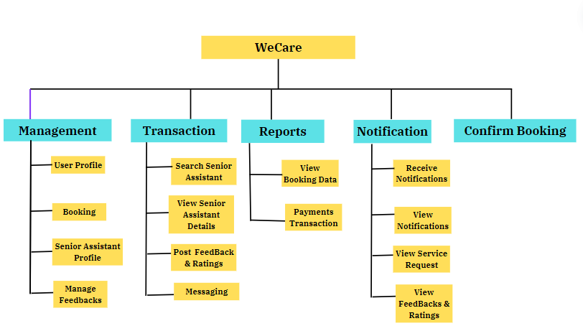

**Figure 12: WeCare Functional Decomposition Diagram**

The graphic above depicts WeCare's functional decomposition, which divides the system's functionality into manageable tiers. This hierarchical structure makes it easier to do a thorough requirements analysis and understand how each component in the design works and interacts. Functional components and sub-processes are clearly defined by breaking down the entire system into successive tiers. WeCare's major functions include management, transactions, notifications, reports, and confirmed booking.

The first main functionality of the WeCare platform is "Management." This area includes different components relating to user and admin accounts, as well as appointment scheduling. Signing up and registering for the platform, establishing and updating personal profiles, and setting preferences are all examples of user account management responsibilities. Administrators are responsible for confirming senior assistant credentials, maintaining data correctness, and guaranteeing security. The appointment booking function enables consumers to browse various services, pick appropriate times, and conveniently manage their reservations.

The second major feature is "Transactions," which describes many facets of how the WeCare platform works. This covers user actions such as rating and feedback, looking for a senior assistant using particular criteria, and requesting services. The transaction capability also includes payment processes, which ensure secure and timely transactions for both users and senior assistants. Additionally, the platform offers texting between users and senior assistants, allowing for straightforward communication. Senior assistants can accept or deny service requests based on their availability, and new account registrations are monitored to ensure a consistent influx of senior assistants.

The third primary component is "Notifications," which keeps all stakeholders informed and involved. Users get notifications for service requests, emergency alerts, financial transactions, and task reminders. Senior assistants are alerted of new service requests and changes to their schedules. Admins receive notifications about system status and policy changes. This coordinated notification system supports successful communication by keeping users, senior assistants, and administrators informed of key platform updates and activities.

The fourth major feature of the WeCare platform is "Reports," which gives administrators full information on booking data and payment activities. This feature enables administrators to create and see detailed reports on many elements of the platform's functioning. It allows them to analyze all users' booking history, track appointment statuses, and monitor service usage patterns over time. Administrators have access to aggregated data on all reservations, which they may use to monitor service demand patterns and find improvement opportunities. Furthermore, reporting

Payment transactions promote transparency and financial responsibility by providing complete records of payments made and received, as well as any outstanding balances.

The fifth major feature of the WeCare platform is "Confirm Booking," which completes the appointment scheduling process and assures a smooth service experience. When a user chooses a service and an open time slot, the platform sends a booking request to the selected senior assistant. The senior assistant then has the choice of accepting or declining the request based on their availability. Upon acceptance, both the user and senior assistant get a confirmation notice that includes appointment details such as time, location, and service details.

**Table 6**

**GANTT CHART**



University of Cebu

College of Computer Studies

Cebu City

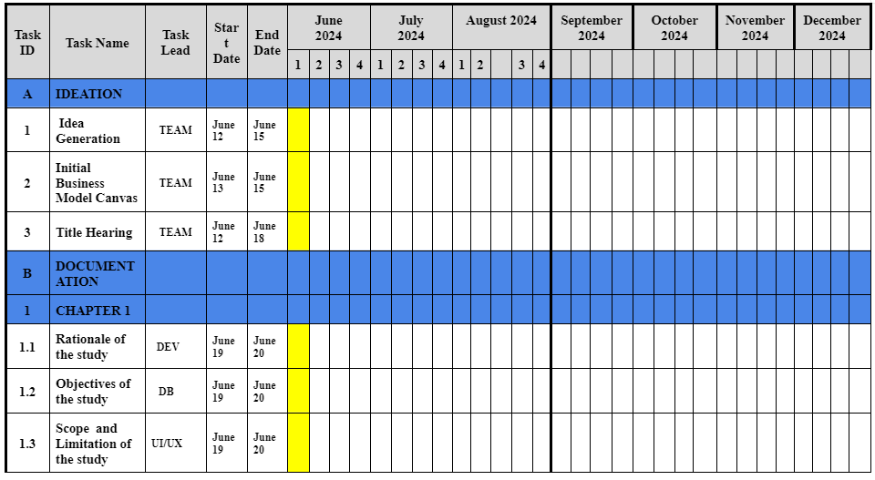

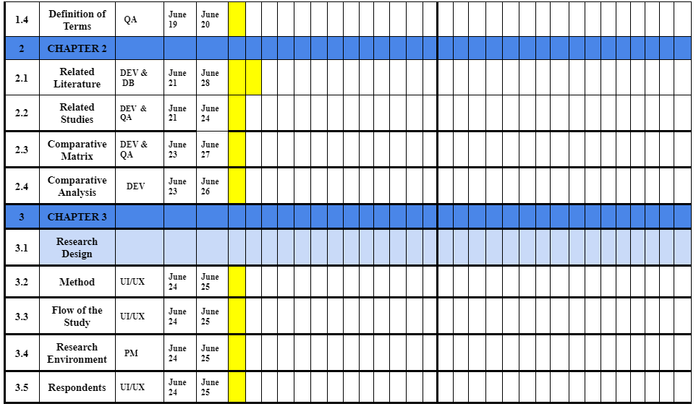

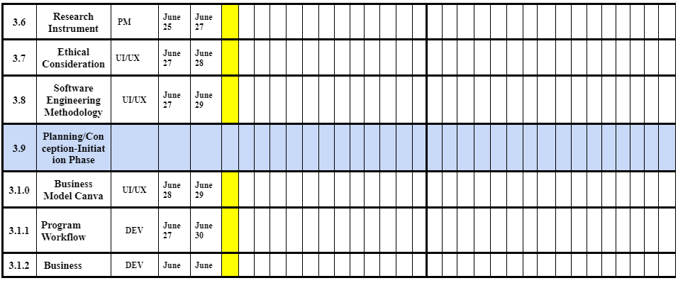

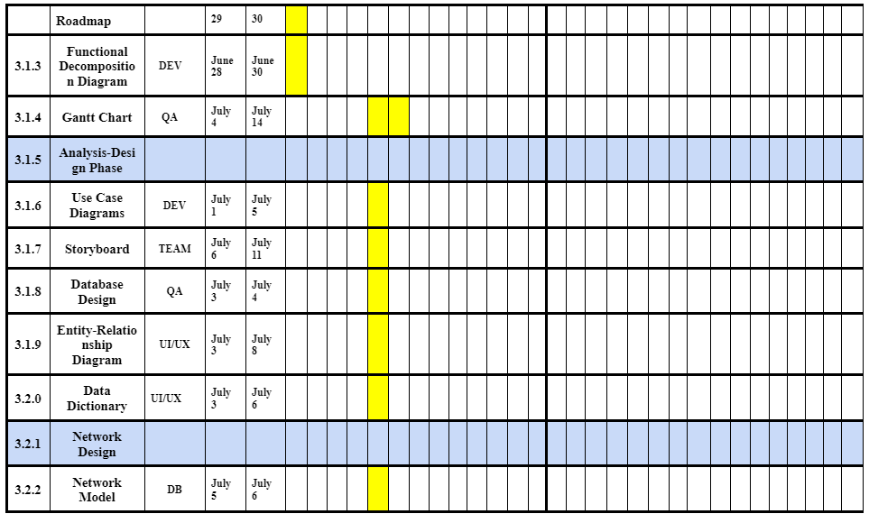

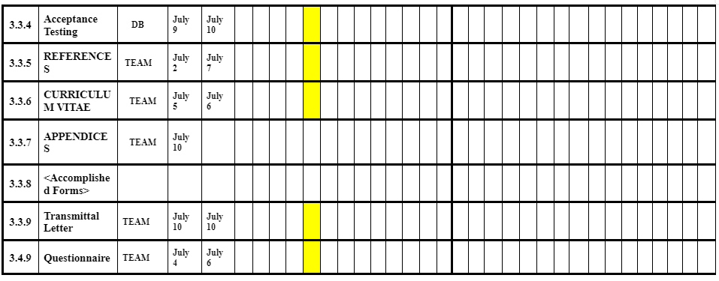

**Analysis-Design Phase**

This section includes the use case diagrams, storyboard, database design, and network design for the analysis and design of the proposed system.

**Use Case Diagrams**

A use case diagram is a graphical representation of the interaction between a user and a system. The figures below provide a high-level overview of the various user types and their respective use cases

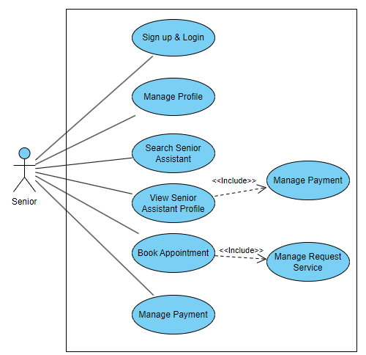

**Figure 13: Senior Citizen (User) Case Diagram**

Figure 12 shows a use case diagram for the WeCare platform's service management. Users begin by registering and generating extensive profiles that describe their caring requirements and preferences. They may search for senior assistant by area, services provided, and credentials, and browse detailed senior assistant profiles that include reviews and availability information. Users may easily arrange appointments, request services and review senior assistants after service, ensuring that the community's high-quality care standards remain consistent.

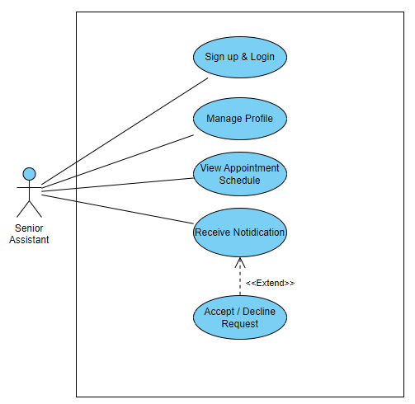

**Figure 14: Senior Assistant (User) Case Diagram**

Figure 13 depicts the use case diagram for senior assistant management on the WeCare platform. Senior assistants begin by signing into their accounts and updating their entire profiles, including skills, availability, and contact information, to appropriately reflect their capabilities. They use the platform to monitor complete appointment calendars, which ensures organization and responsiveness to new service requests and schedule modifications via prompt alerts. Senior assistants examine service requests from users and accept or decline them depending on their availability and preparedness to offer care.

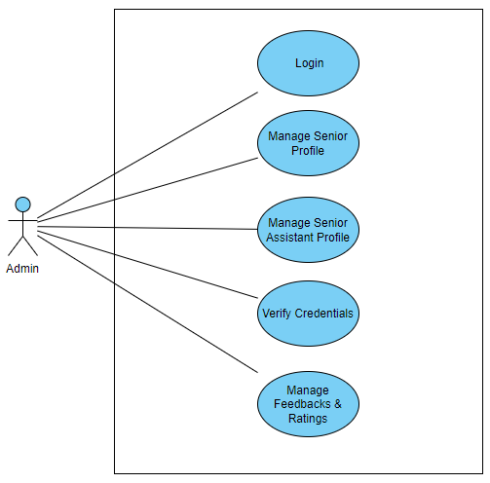

**Figure 15: Admin Case Diagram**

Figure 14 displays a use case diagram for administrative administration on the WeCare platform. Admins play an important role in ensuring operational integrity by diligently managing user and senior assistant accounts through the administrative dashboard. They assure data correctness and security, validate senior assistant credentials, and manage profiles for both seniors and assistants. They carefully track customer comments and ratings, employing this information to maintain high service standards and respond quickly to any problems that occur. Administrators ensure that the platform runs smoothly, creating trust and happiness among users and senior assistants while preserving a strong and user-centric caring environment.

**Storyboard**

A storyboard is a type of graphic organizer used to pre-visualize a motion film, animation, motion graphic, or interactive media sequence. It consists of illustrations or images displayed in a specific order,

#### **WeCare: Senior**

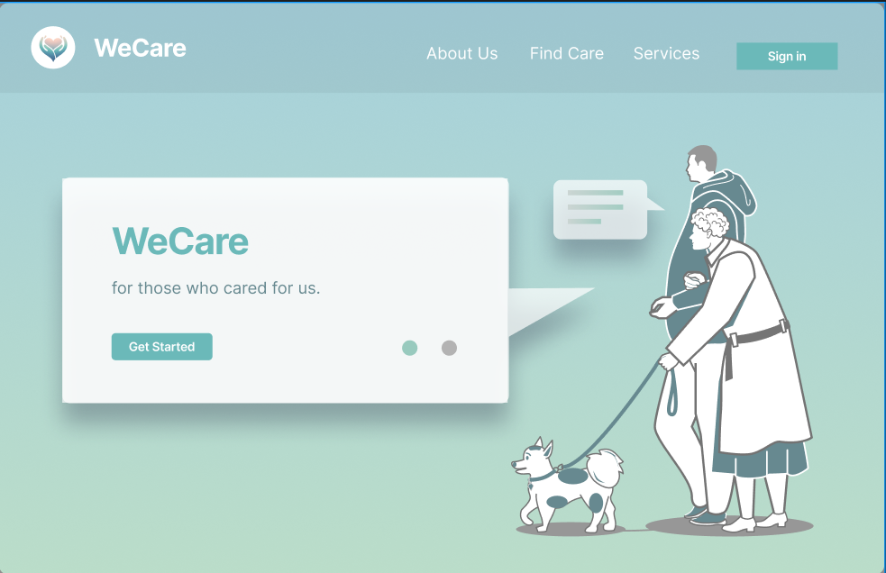

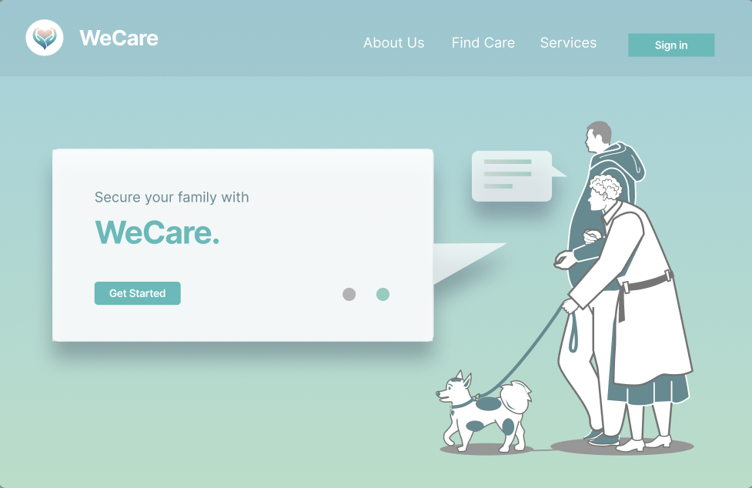

**Figure 16: Landing Page**

Welcome to WeCare, your dependable go-to source for top-notch care for your family members. When a user opens our program, this page appears. Kindly create a new account or log in using an already-existing one to access our vast array of services. WeCare links you with trained senior assistants who are dedicated to providing the highest quality of care for your loved ones.

WeCare is aware of the value of dependable and sympathetic caregiving. Finding and managing qualified senior assistants who are committed to improving the quality of life for the people you care about will be simple thanks to the support of our platform. You can easily peruse senior assistant profiles, read reviews, and choose the ideal fit for your requirements thanks to our intuitive layout.

We are proud of our stringent screening procedure, which guarantees that every senior assistant in our network has extensive training, a clean criminal record, and experience. WeCare provides a wide range of services that are customized to match your unique needs, whether you need help with everyday tasks, specialized medical care, or company.

Our dedication to quality extends beyond only placing you in contact with providers. To make sure you have a smooth and stress-free experience, we provide flexible scheduling and safe payment methods. Become a member of the WeCare community now to feel secure in the knowledge that your loved ones are in capable care.

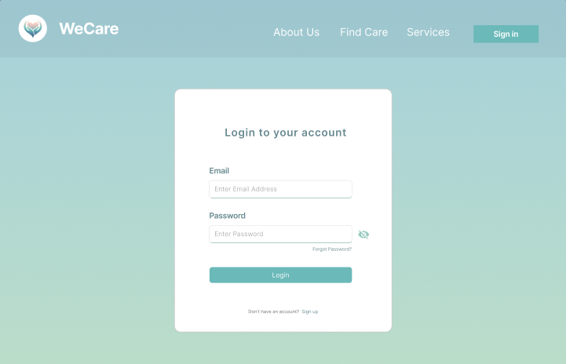

**Figure 17: WeCare Login**

To access your account and keep using our application, please log in. Through WeCare, you may get in touch with qualified senior assistants who are committed to giving your loved ones the best care possible.

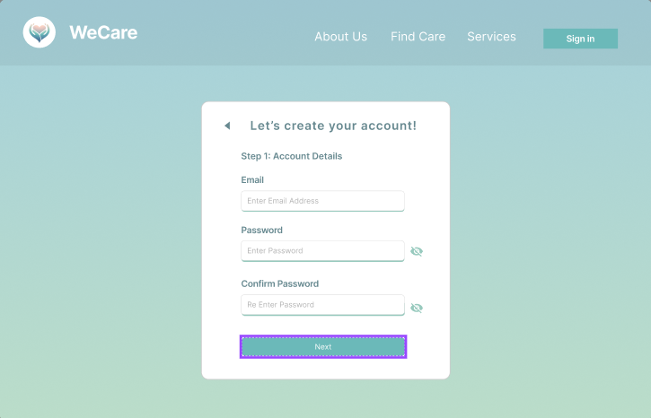

**Figure 18: Registration Step One - Account Details**

The first part of the registration process which shows the input fields asking for the user’s email and password as well as the confirm password to match. There is also an option to show or hide the characters to secure the password.

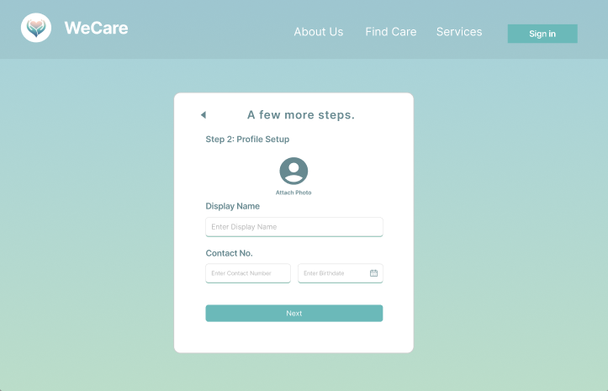

**Figure 19: Registration Step Two - Profile Setup**

This page lets the user attach their image for identification purposes. The input field is then followed by asking the contact no. and birthdate. The input date field includes an autopicker to eliminate the process of typing date manually.

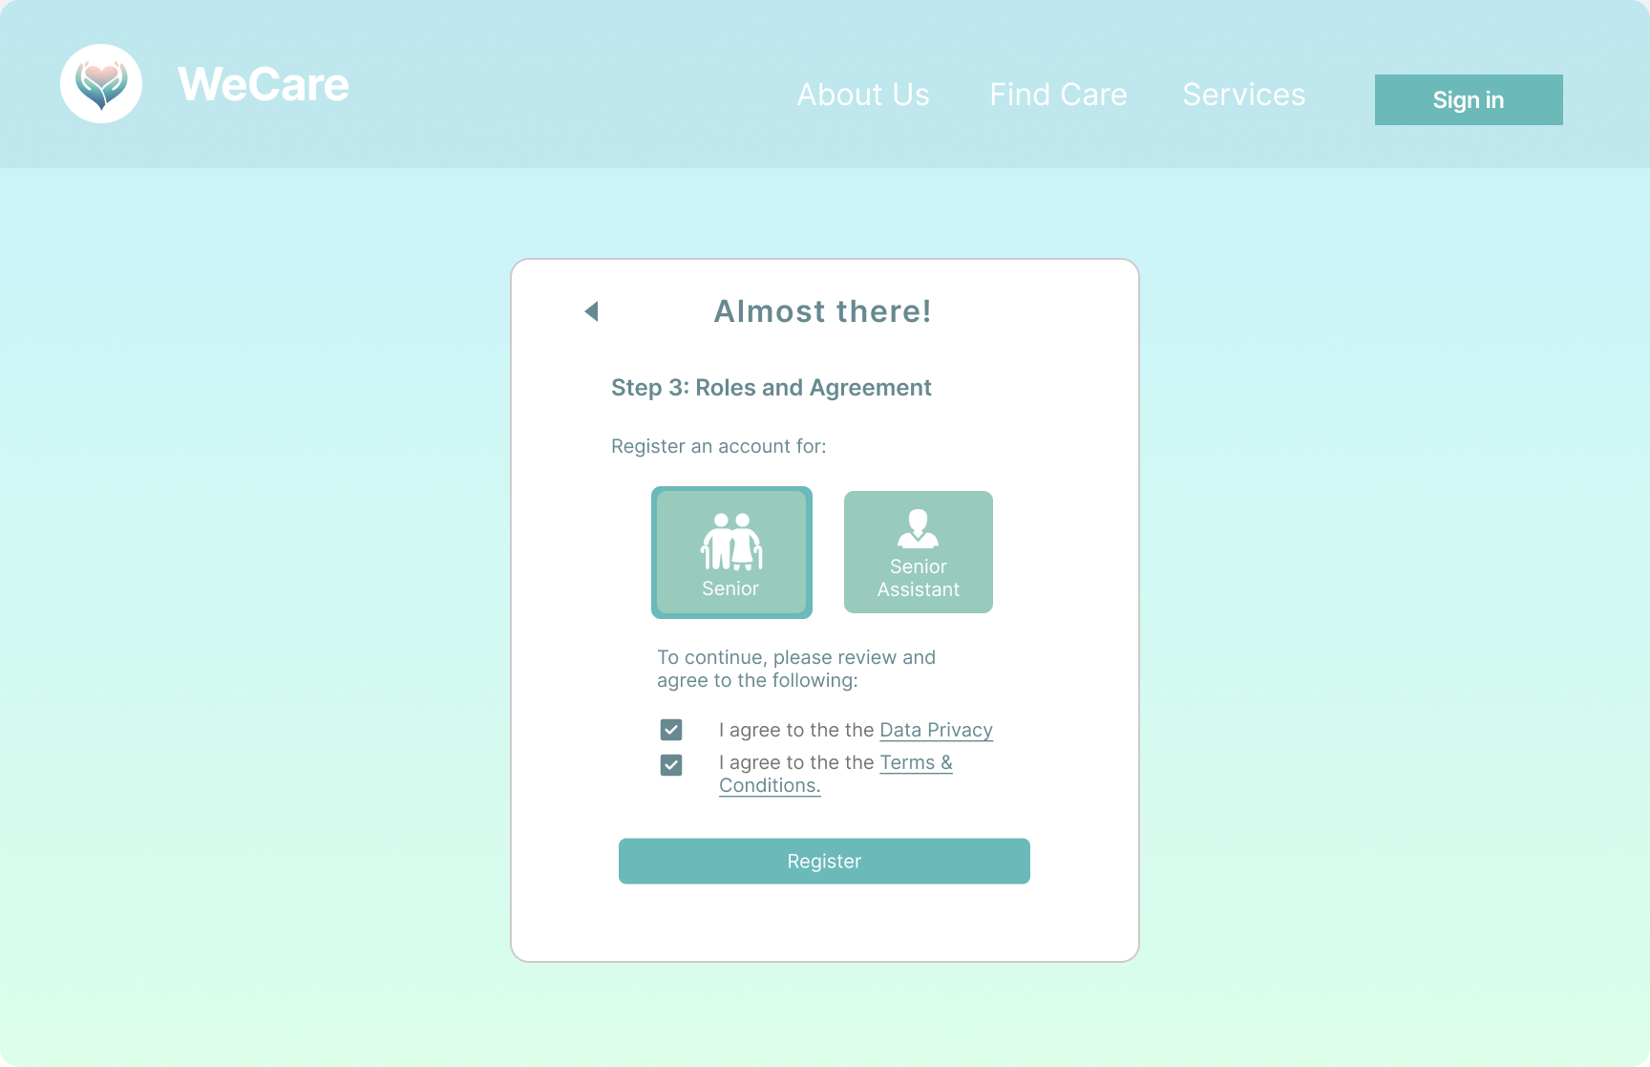

**Figure 20: Registration Step Three - Roles and Agreement**

The third step in the registration process is the page shown above. The user is able to select the role they wish to register for. They have to read and accept the terms and conditions of using the web app as well as the data privacy before they can continue.

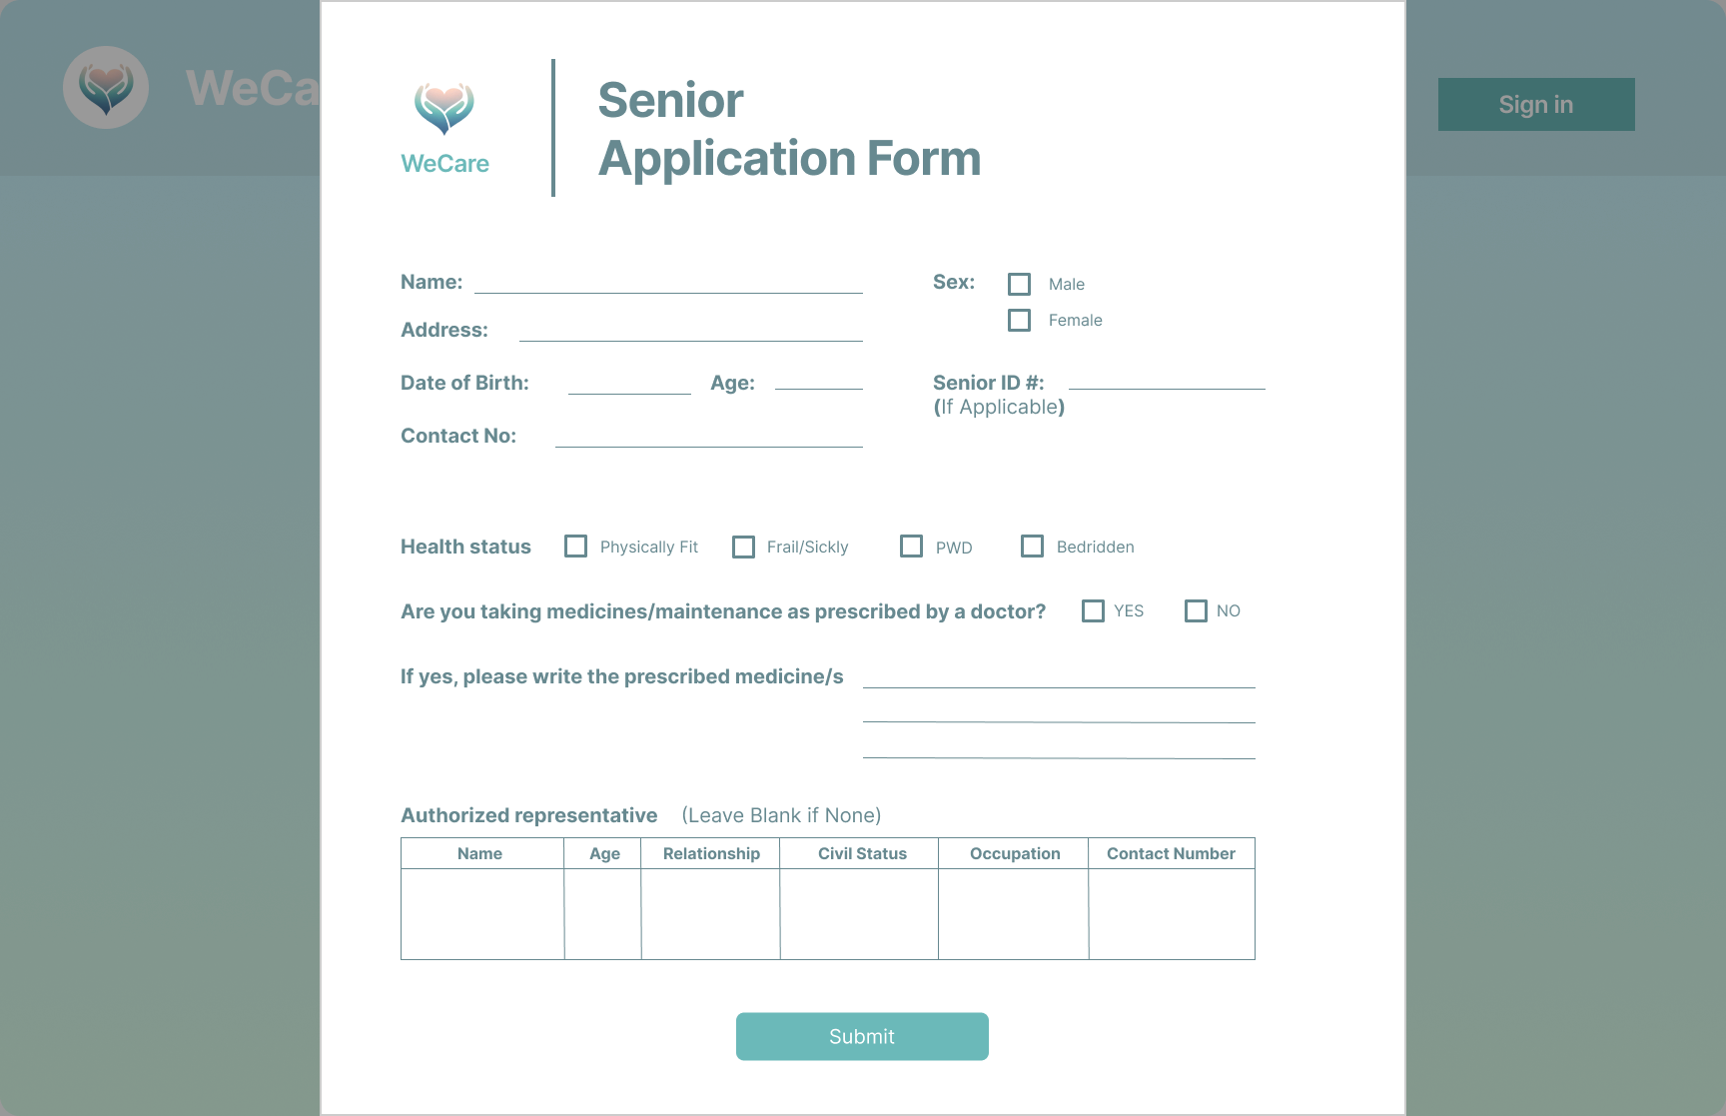

**Figure 21: Senior Application Form**

This form comes up after the senior user is done with the whole registration process. The response to this page is necessary to ensure that the registrant is legitimate and their accounts are verified by the admin before they can do further transactions. The user can input some of their personal and health information as well as assign an authorized representative if ever they are faced with difficulties in using the app.

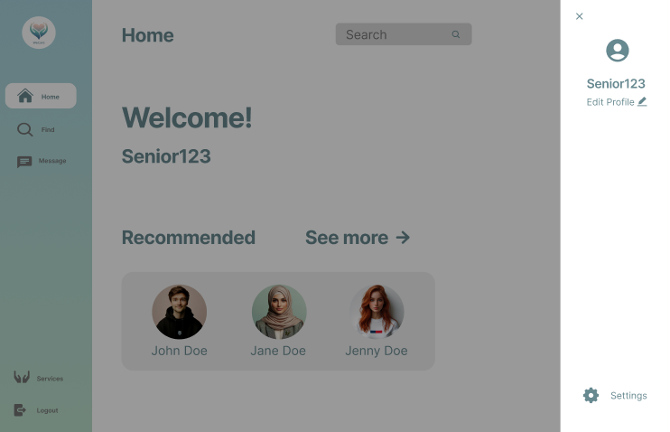

**Figure 22: WeCare Homepage**

The WeCare App's user-friendly homepage greets them and gives a brief rundown of its capabilities and objectives. Here, consumers can quickly browse through different areas to find licensed senior assistants that are dedicated to providing their loved ones with top-notch care.

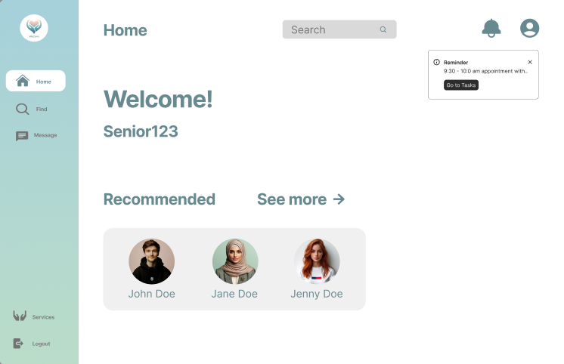

**Figure 23: WeCare Application Reminders**

The reminders function in the WeCare app makes sure that users may schedule notifications for their senior assistant appointments. In order to assist users keep organized and make sure they never miss a crucial care session, they can easily schedule and manage appointments and receive timely reminders. This feature improves the user experience by offering a dependable method for effectively scheduling caregiving schedules within the app.

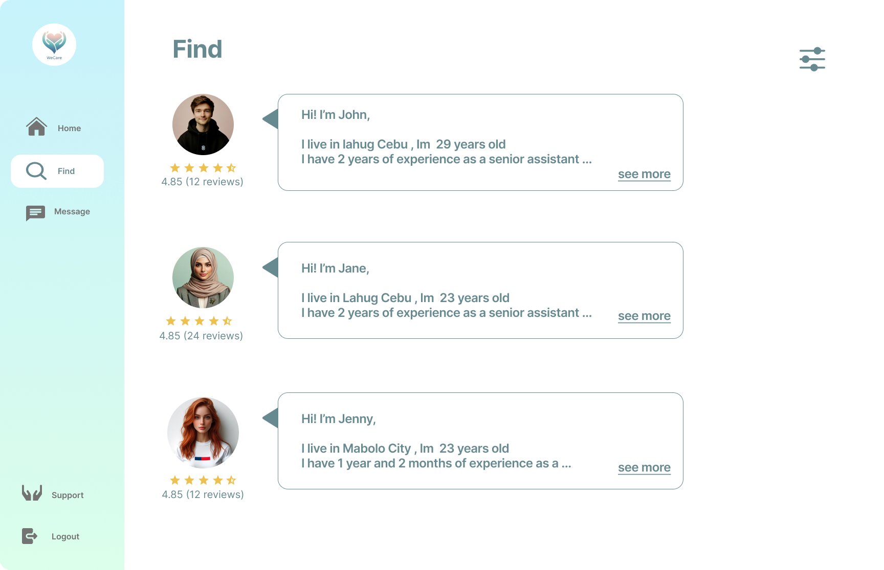

**Figure 24: WeCare Find Senior Assistant**

WeCare Find senior assistant allows users to select the type of senior assistant of their choice in a free and open manner.

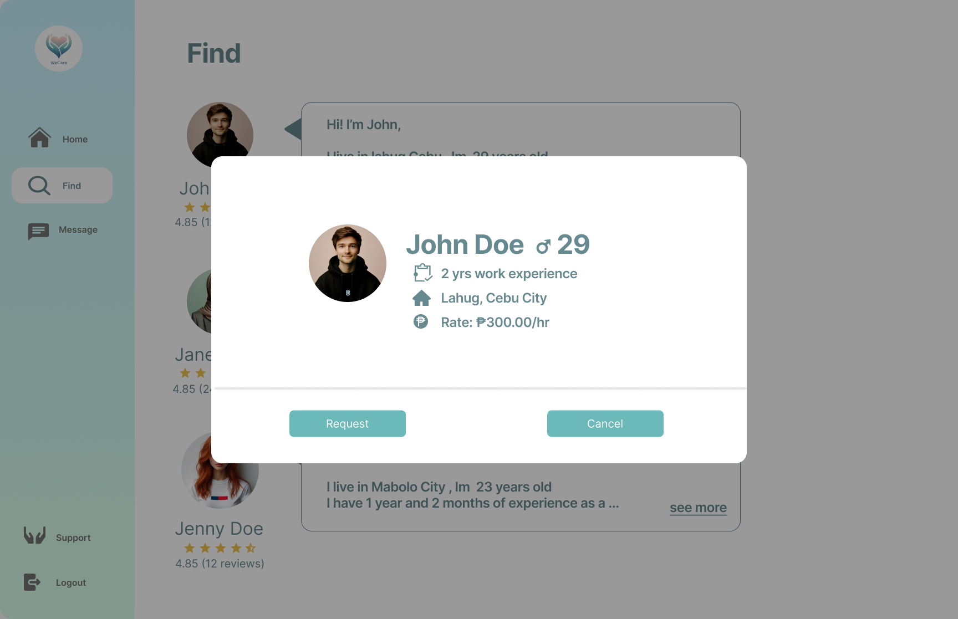

**Figure 25: WeCare Appointment Section**

In the WeCare appointment section, users have the flexibility to book a specific senior assistant who meets their standards and preferences.With the use of this individualized method, customers may examine senior assistant profiles that include availability, qualifications, and reviews, enabling them to select the best senior assistant for their loved ones' requirements. WeCare makes sure that users feel empowered and secure in their ability to choose the senior assistant that most closely matches their needs and expectations by providing this degree of personalization.

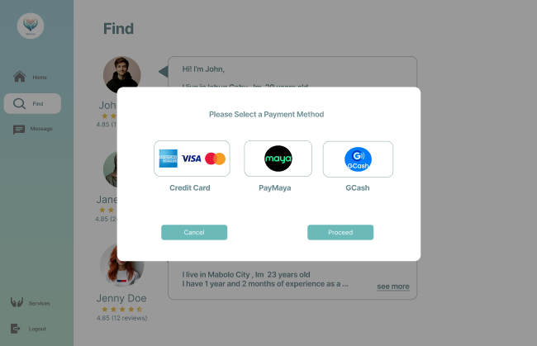

**Figure 26: WeCare Payment Method**

Users can select a payment option that best suits their needs by visiting the WeCare payment method area. Paying for caregiving services can be made easy and accessible with options like Gcash, Paymaya, and Visa Credit Card. With so many different ways to pay, consumers can handle transactions safely and easily within the WeCare app, which improves their experience in general.

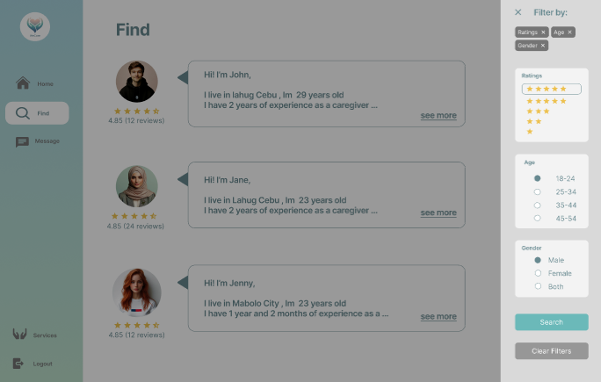

**Figure 27: WeCare Search Filter**

After selecting the filter option, a pane displaying the additional options to narrow down senior assistant searches based on ratings, gender, and age will appear. Additionally, there is a clear filters button that allows you to remove them.

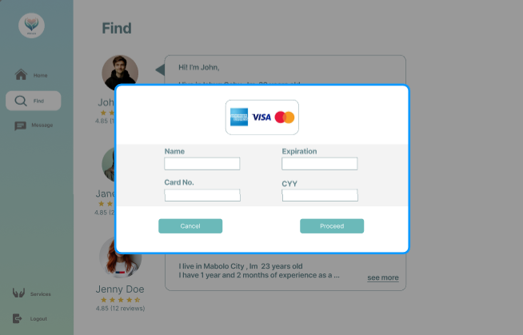

**Figure 28: WeCare Payment w/ Credit Card**

Following the options where you select the payment method is the pop-up. To complete the payment, the user can provide details like name, expiration date, card number, etc.

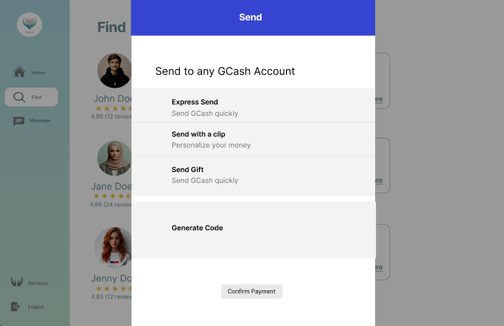

**Figure 29: WeCare Payment w/ GCash**

Selecting the GCash option on the selected payment method will cause the pop-up to appear. The following integrated app functionalities allow the user to produce QR codes and send money.

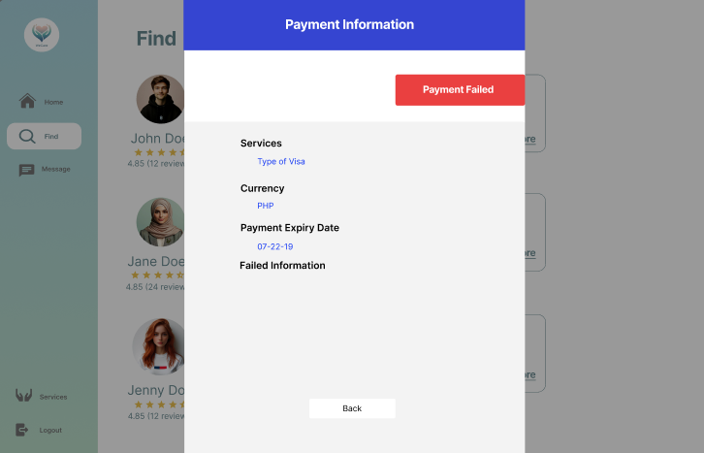

**Figure 30: WeCare Payment Failed**

After a failed payment, the payment details are displayed in the pop-up. The information shown will vary based on the kind of error the system generates.

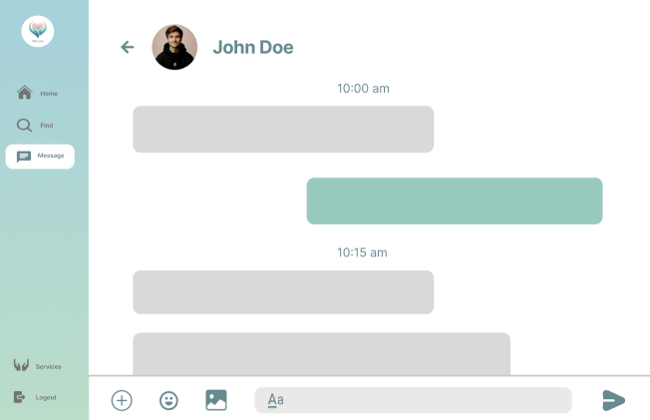

**Figure 31: WeCare Message Contents**

The interface facilitates amiable communication between the user and the senior assistant. It allows you to exchange text messages, photos, and emoticons just like any other messaging app. If the user wants to add more content to the message, they use the + symbol.

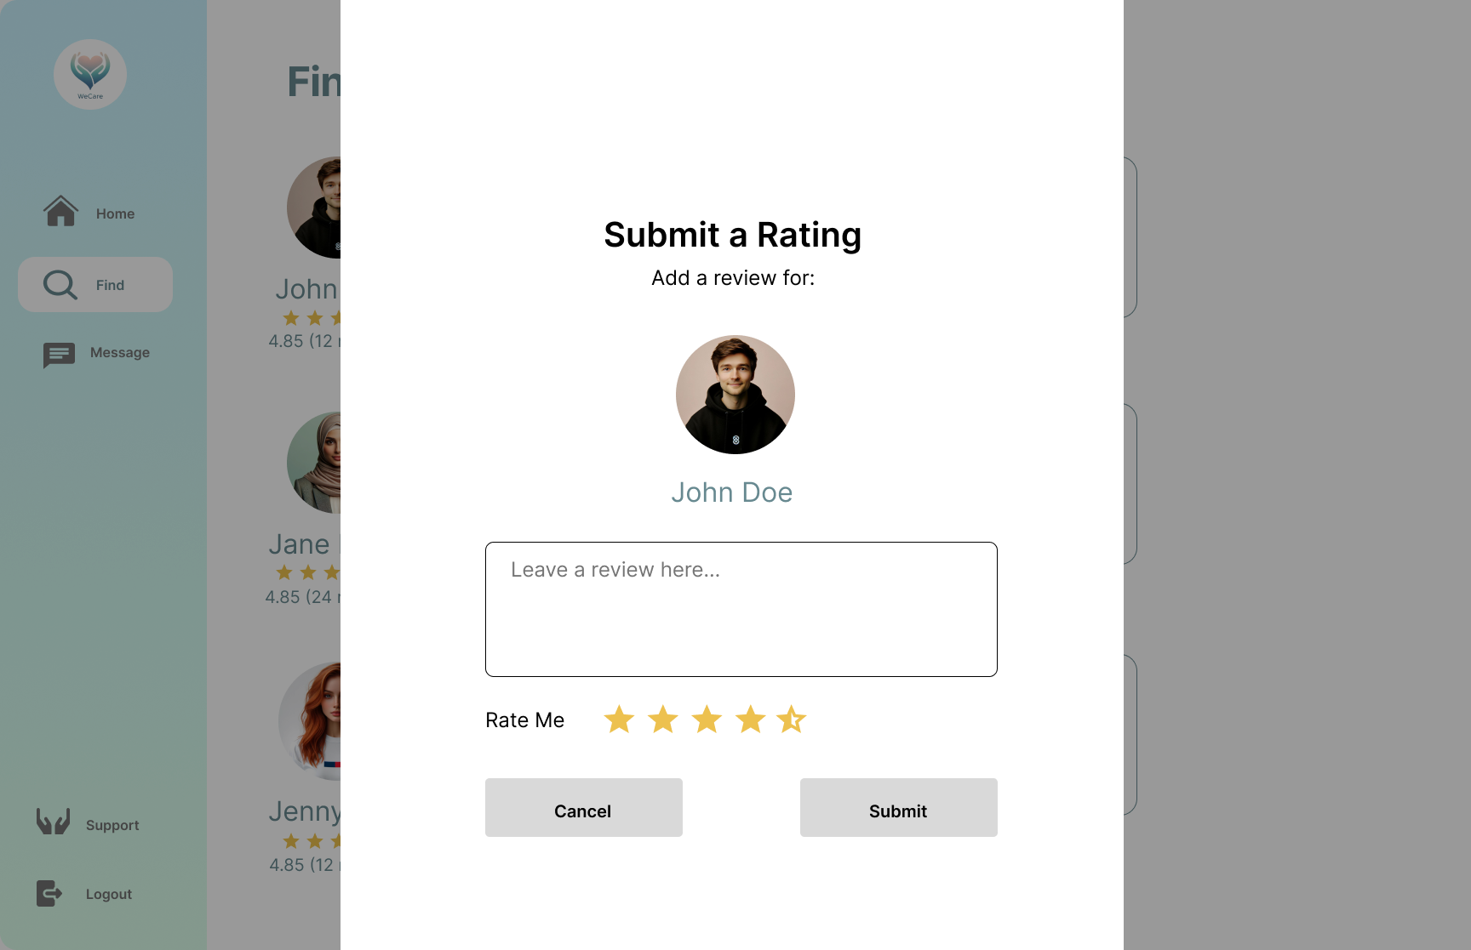

**Figure 32: WeCare Feedback & Ratings**

The interface lets the user submit a review and rating for the senior assistant after the service. The user can input any comments regarding their care in the textbox and rate them using stars.

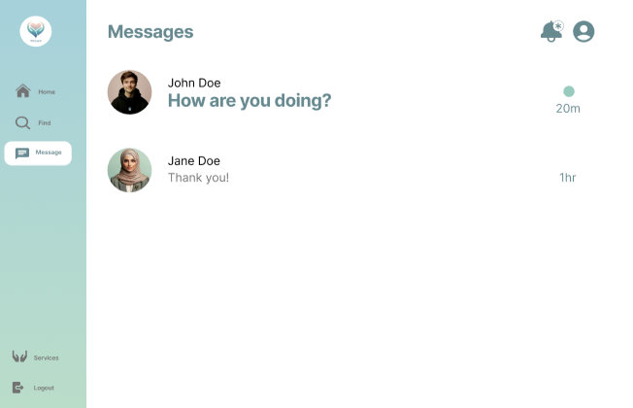

**Figure 33: WeCare Message Recipient List**

The page where users can see all of their discussions. Together with a read/unread message indication, the duration of the most recent conversation is displayed.

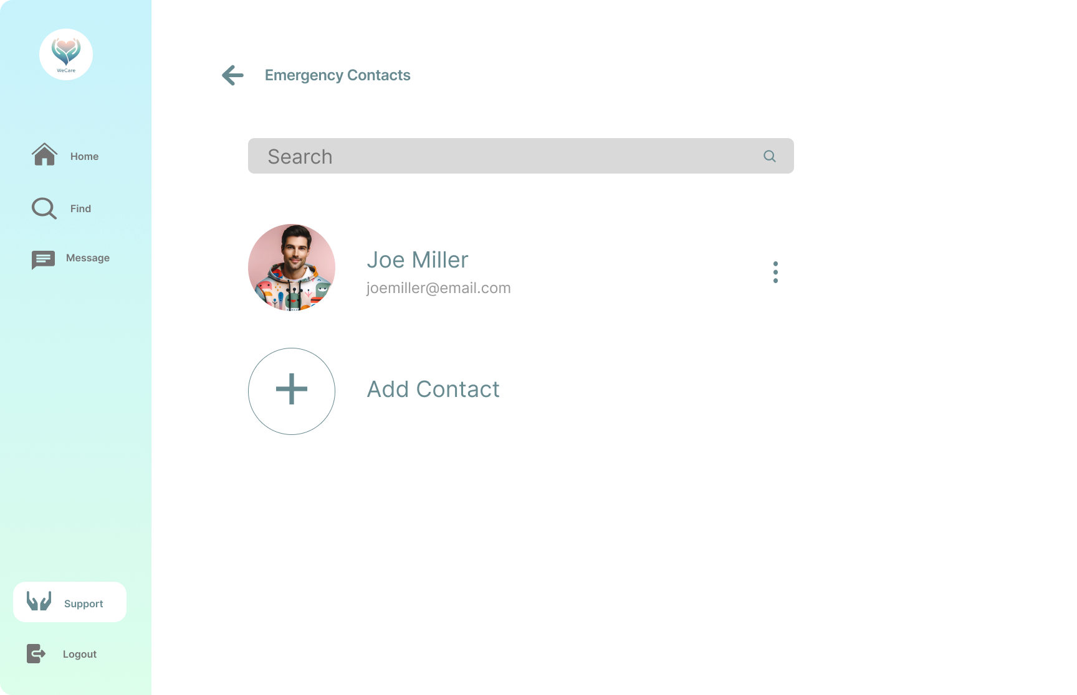

**Figure 34: WeCare Emergency Contact**

The page that shows the list of emergency contacts in case of emergency. It is accessed through the support tab of the navigation panel.

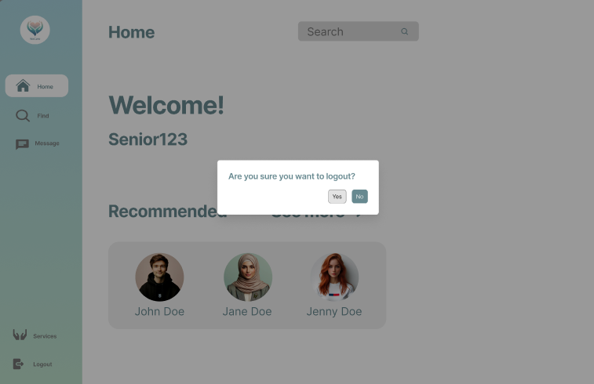

**Figure 35: WeCare Logout**

We appreciate your use of WeCare. To safely log out of your account, click this YES button. Remind yourself that you can always log in again to keep using our senior assistant services and helping your family members.

#### 

#### 

#### 

#### 

#### 

#### 

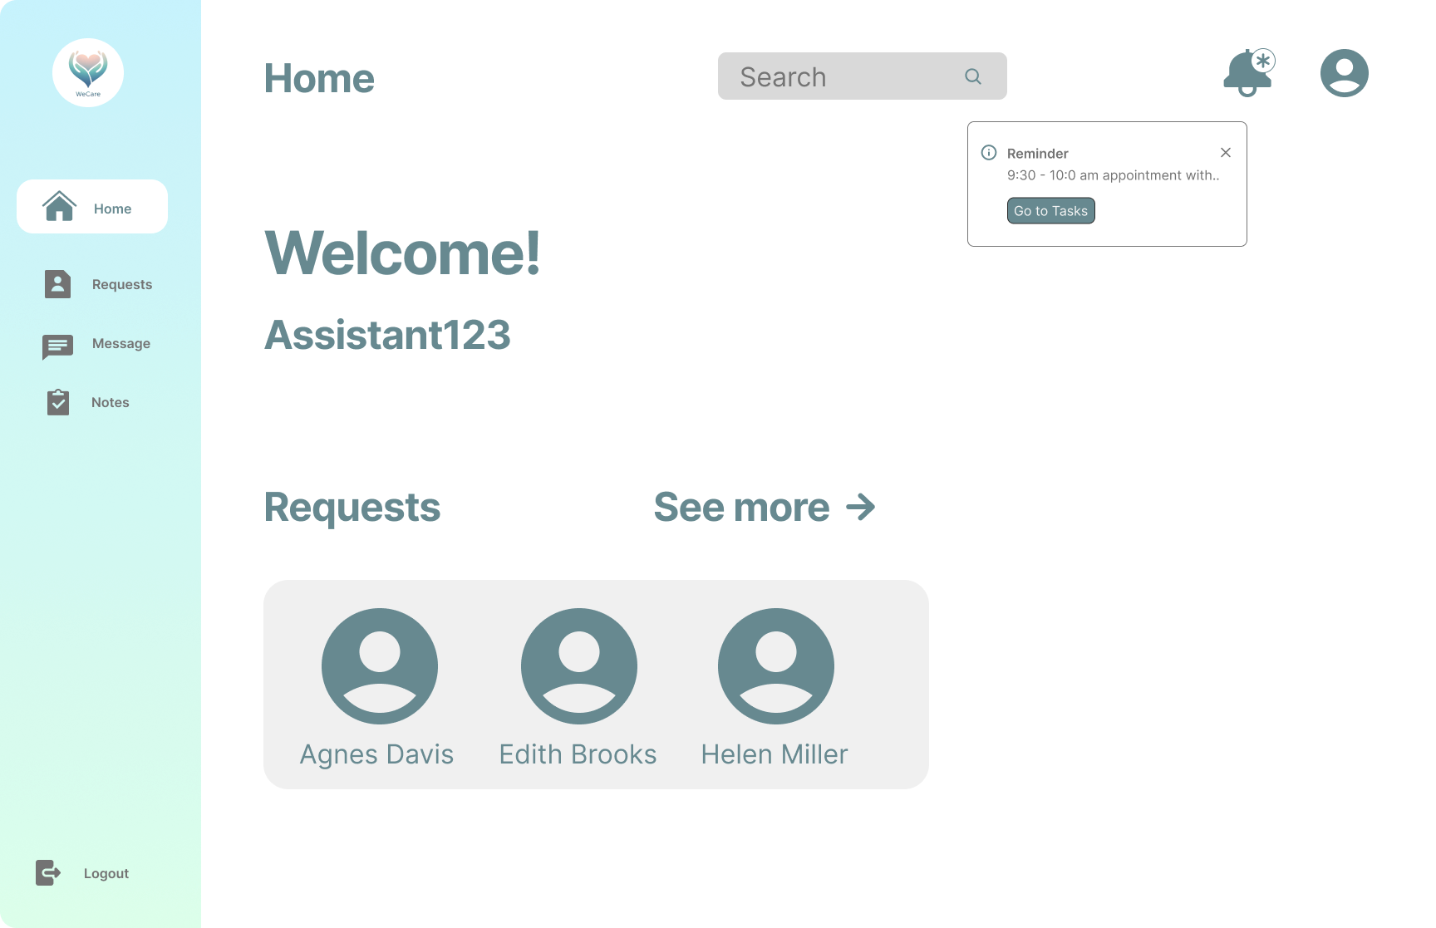

**Figure 36: WeCare Senior Assistant Home Page**

This is the senior assistant's account homepage, displaying a list of recent seniors with whom the senior assistant has had any kind of interaction. utilizing the same style as the senior's account page.

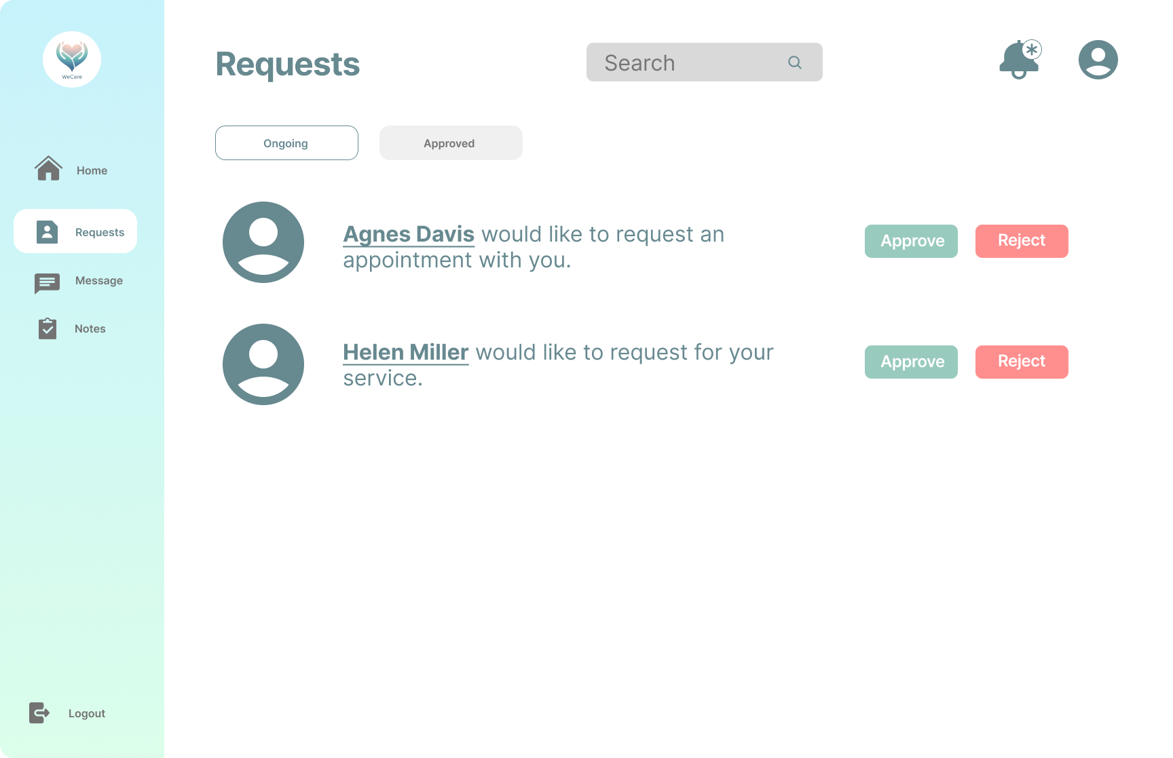

**Figure 37: WeCare Senior Assistant Request**

This page lets the senior assistant see the ongoing and approved list of seniors requesting for their assistance or appointments. The senior assistant can either approve or reject the said assistance.

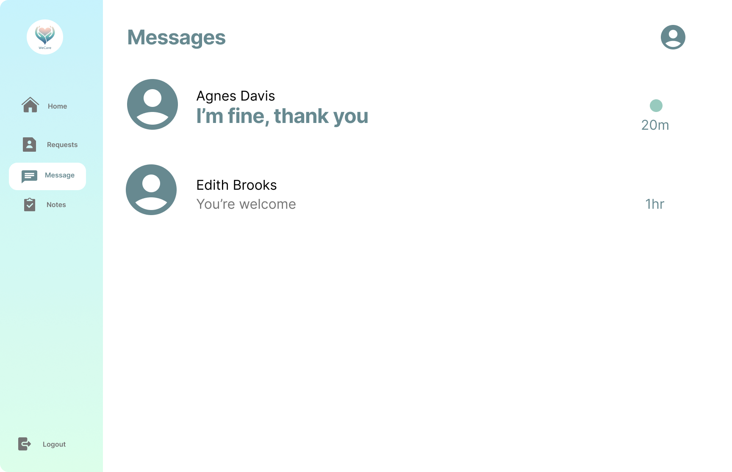

**Figure 38: WeCare Senior Messages**

The list of conversations done with senior users as seen through the senior assistant’s perspective is displayed on this page. It shows the amount of time since the last chat was made as well as a few read/unread message indicators.

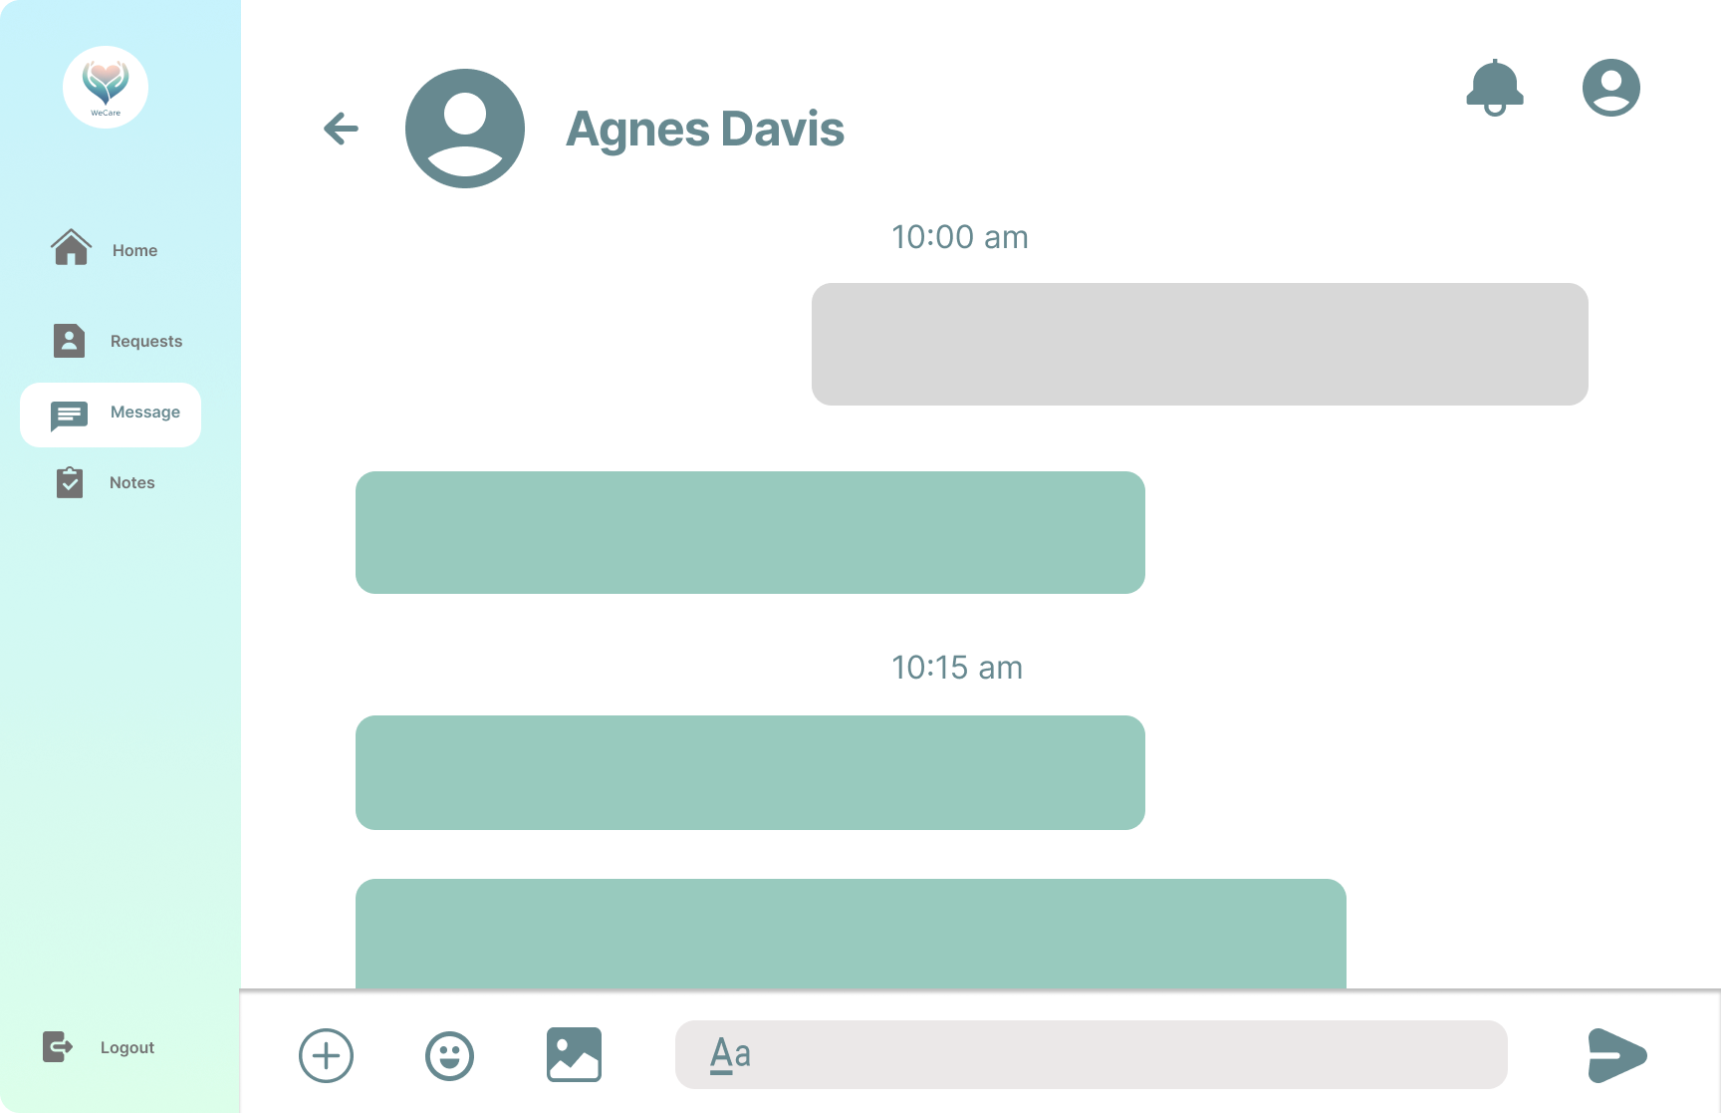

**Figure 39: WeCare Message Content**

The senior assistant can have conversations with the elderly on this website. From the viewpoint of the senior, it has the same arrangement.

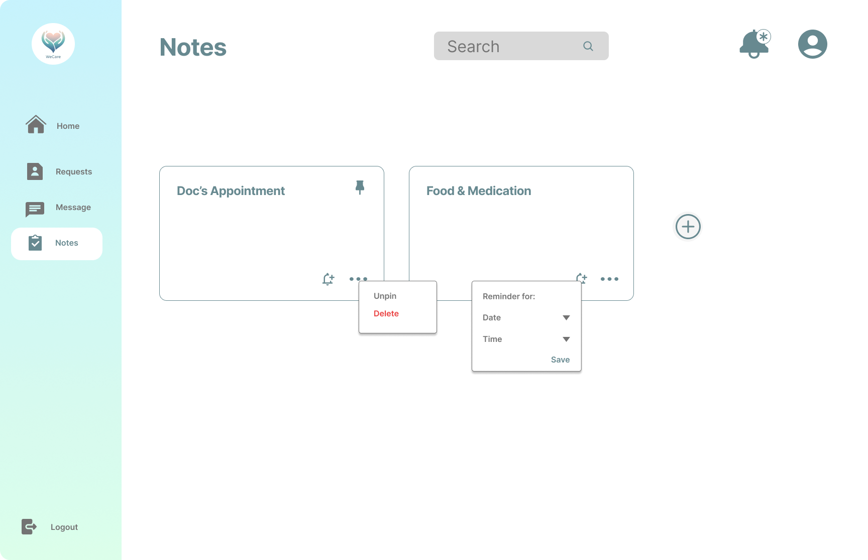

**Figure 40: WeCare Notes and Reminders**

The senior assistant is given an option to create notes for the tasks needed to be done in service of the senior user. They can manage their notes depending on their personal preferences. Setting up a reminder for the task is also a feature to help them get notified of upcoming appointments.

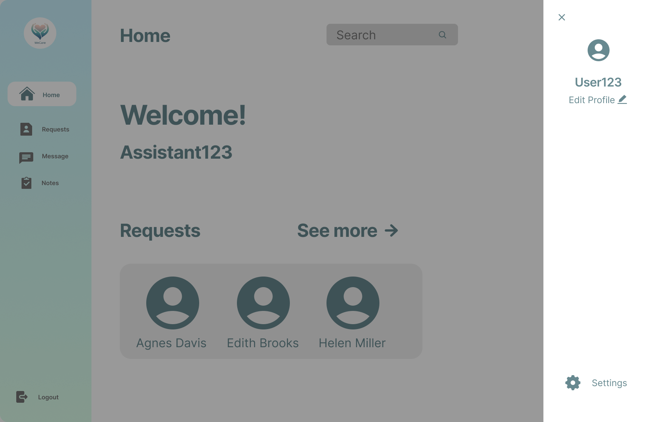

**Figure 41: WeCare Senior Assistant Account**

When the senior assistant clicks on the profile image in the top-right corner adjacent to the notification bell, this side panel slides up. It displays the ability to edit the profile and adjust the settings.

#### **WeCare: Admin**

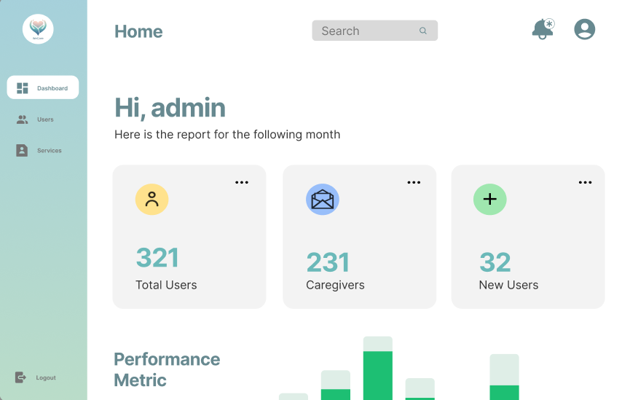

**Figure 42 : Admin Homepage**

Dashboard for WeCare Admin! You are able to oversee and manage every facet of our senior assistant services from here. Keep an eye on user accounts, oversee senior assistant profiles, respond to support inquiries, and make sure the platform runs smoothly..

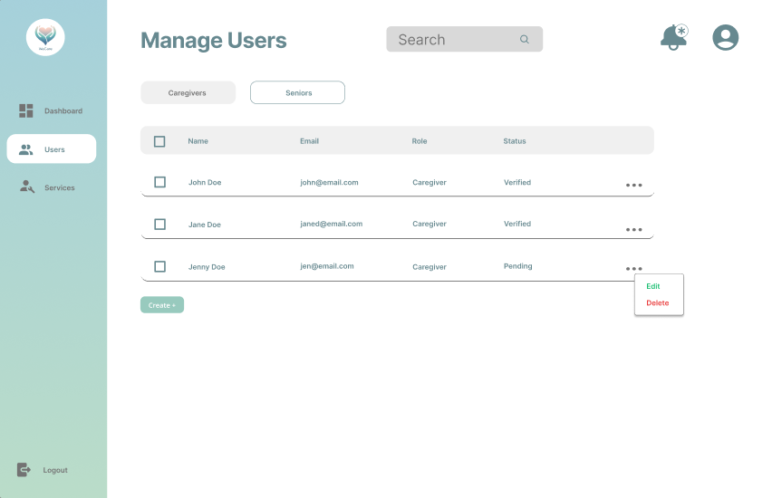

**Figure 43 : Senior Assistant Users Management**

All of the registered senior assistants are listed on the users page's senior assistant tab. It can be used to add, remove, modify, and search for a senior assistant on the list.

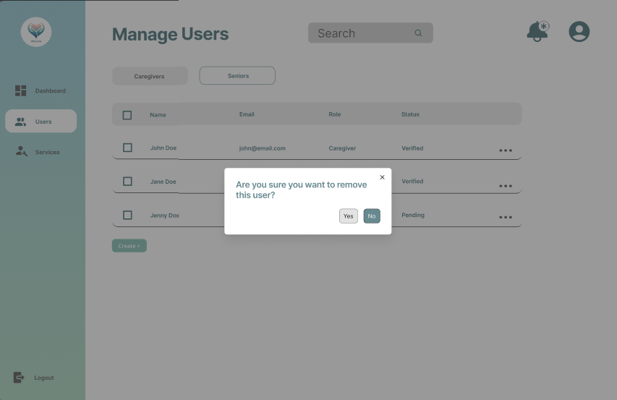

**Figure 44: Remove user prompt**

The admin is presented with two simple choices in the pop-up window that opens when they click "remove": "Yes" to approve the removal action or "No" to cancel it. This feature makes sure that users can easily and clearly manage their interactions within the WeCare app, enabling them to make decisions with confidence.

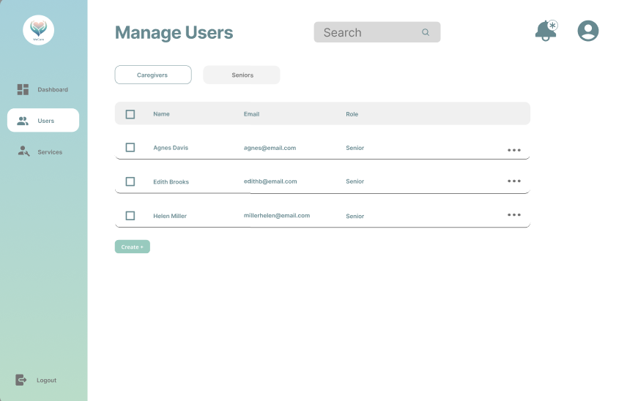

**Figure 45 : Senior Users Management**

The administrator can currently manage all senior citizens who have registered using this tab on the users' page. Similar to senior assistant management, it offers the ability to search for, create, modify, and remove senior users from the list.

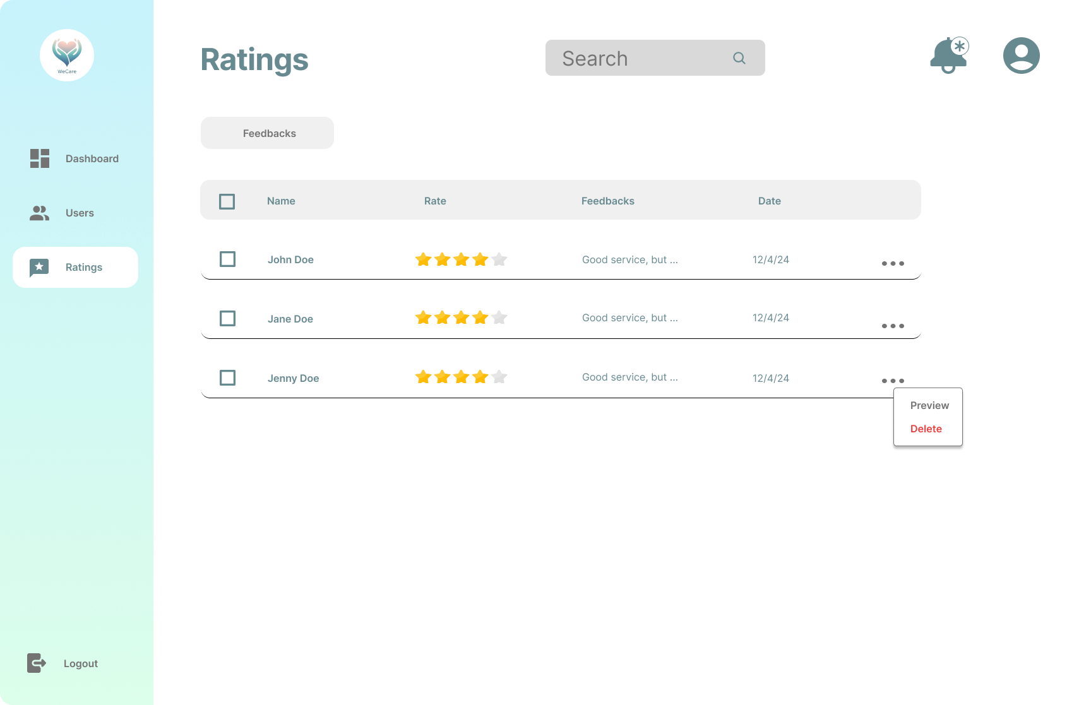

**Figure 46 : Manage Ratings**

Senior customers seeking to make reservations for their preferred senior assistant are listed on the page. It consists of two tabs with a list of approved and pending requests. Requests are subject to approval or rejection by the administrator.

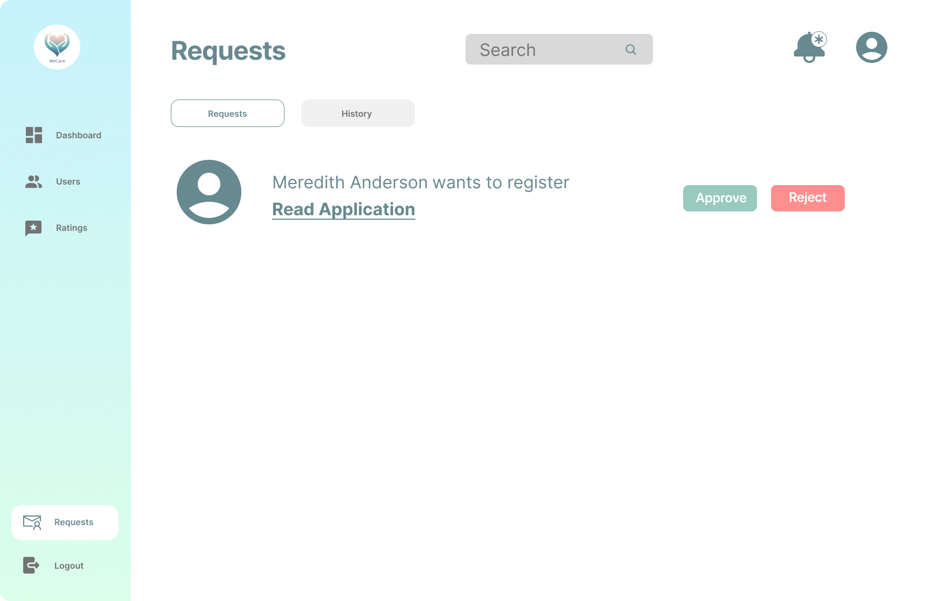

**Figure 47 : Manage Application**

Users attempting to get their account verified can send their application to the admin for verification. The admin has the authority to approve and reject the said application before the user is allowed to do further transactions. Once the decision has been made, the user will receive confirmation through their registered email.

**Database Design**

Database design is producing a detailed data model of a database. This data model contains all the logical and physical design choices and physical storage parameters needed to generate a design in a data language, which can then be used to create a database. An entirely attributed data model contains detailed attributes for each entity.

**Entity-Relationship Diagram**

The ERD represents a comprehensive caregiving system that captures information about senior assistants, senior citizens, tasks integrated in appointments, reminders, feedback, billing, emergency contacts, and messages. The system has 8 entities, each with its own set of attributes. The entities are interconnected through relationships, ensuring data consistency and integrity. Key relationships include: appointments being associated with one care recipient and one senior assistant, and feedback being associated with one senior assistant and one care recipient. The system also captures billing information, client assessments, emergency contacts, and messages exchanged between senior assistant and care recipients. Overall, the ERD provides a comprehensive framework for managing caregiving services and ensuring efficient data management and reporting.

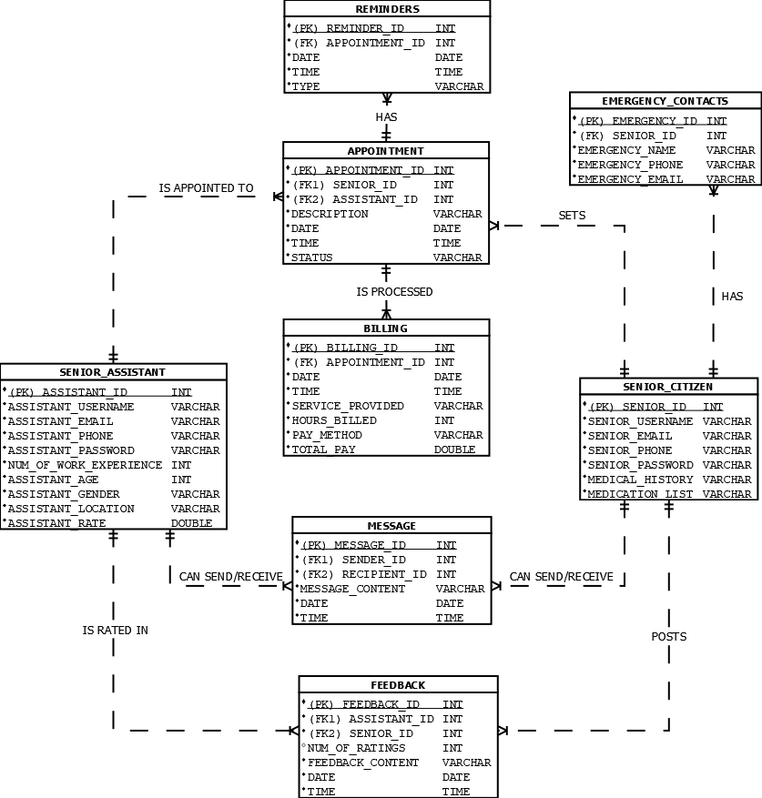

**Figure 48 : WeCare Entity-Relationship Diagram**

**Data Dictionary**

The WeCare web application is designed to provide a comprehensive platform for senior citizens to manage their daily lives, connect with senior assistants, and access essential services. This data dictionary outlines the key data elements, their descriptions, and relationships to ensure a clear understanding of the application's data structure.

This data dictionary provides a comprehensive overview of the WeCare web application's data structure, ensuring a clear understanding of the relationships between entities and data elements.

**Table 6**

**WeCare Data Dictionary**

| **WECARE - ENTITY** | **ATTRIBUTE NAME** | **CONTENTS** | **TYPE** | **FORMAT** | **RANGE** | **REQUIRED** | **FK or PK** | **FK REFERENCED** |
| --- | --- | --- | --- | --- | --- | --- | --- | --- |
| SENIOR ASSISTANT | ASSISTANT_ID | SENIOR ASSISTANT’S ID | INT | 99999999 | 1-99999999 | Y | PK |  |
| ASSISTANT_USERNAME | SENIOR ASSISTANT’S DISPLAY NAME | VARCHAR | XXXXXXXX |  | Y |  |  |
| ASSISTANT_EMAIL | SENIOR ASSISTANT’S EMAIL | VARCHAR | XXXXXX@XXXX.XXX |  | Y |  |  |
| ASSISTANT_PHONE | SENIOR ASSISTANT’S CONTACT NUMBER | VARCHAR | XXXXXXXX |  | Y |  |  |
| ASSISTANT_PASSWORD | SENIOR ASSISTANT’S PASSWORD | VARCHAR | XXXXXXXX |  | Y |  |  |
| NUM_OF_WORK_EXPERIENCE | NUMBER OF WORK EXPERIENCE | INT | 99999999 | 1-99999999 | Y |  |  |
| ASSISTANT_AGE | ASSISTANT’S AGE | INT | 99999999 | 1-99999999 | Y |  |  |
| ASSISTANT_GENDER | ASSISTANT’S GENDER | VARCHAR | XXXXXXXX |  | Y |  |  |
| ASSISTANT_LOCATION | SENIOR ASSISTANT’S LOCATION | VARCHAR | XXXXXXXX |  | Y |  |  |
| ASSISTANT_RATE | SENIOR ASSISTANT’S RATE | DOUBLE | 999999.99 | 1.00-999999.99 | Y |  |  |
| SENIOR_CITIZENS | SENIOR_ID | SENIOR’S ID | INT | 99999999 | 1-99999999 | Y | PK |  |
| SENIOR_USERNAME | SENIOR’S DISPLAY NAME | VARCHAR | XXXXXXXX |  | Y |  |  |
| SENIOR_EMAIL | SENIOR’S EMAIL | VARCHAR | XXXXXXXX |  | Y |  |  |
| SENIOR_PHONE | SENIOR’S CONTACT NUMBER | VARCHAR | XXXXXXXX |  | Y |  |  |
| SENIOR_PASSWORD | SENIOR’S PASSWORD | VARCHAR | XXXXXXXX |  | Y |  |  |
| MEDICAL_HISTORY | SENIOR’S MEDICAL BACKGROUND | VARCHAR | XXXXXXXX |  | Y |  |  |
| MEDICATION_LIST | SENIOR’S MEDICATION LIST | VARCHAR | XXXXXXXX |  | Y |  |  |
| APPOINTMENTS | APPOINTMENT_ID | APPOINTMENT ID | INT | 99999999 | 1-99999999 | Y | PK |  |
| SENIOR_ID | SENIOR’S ID | INT | 99999999 | 1-99999999 | Y | FK1 | SENIOR CITIZENS |
| ASSISTANT_ID | SENIOR ASSISTANT’S ID | INT | 99999999 | 1-99999999 | Y | FK2 | SENIOR ASSISTANT |
| DATE | PAYMENT DATE | DATE | DD-MM-YYYY | 1000-01-01 to 9999-12-31 | Y |  |  |
| TIME | PAYMENT_TIME | TIME | hh:mm:ss | 00:00:00 to 23:59:59 | Y |  |  |
| DESCRIPTION | APPOINTMENT DESCRIPTION | VARCHAR | XXXXXXXX |  | Y |  |  |
| STATUS | APPOINTMENT STATUS | VARCHAR | XXXXXXXX |  | Y |  |  |
| EMERGENCY_CONTACTS | EMERGENCY_ID | EMERGENCY CONTACT ID | INT | 99999999 | 1-99999999 | Y | PK |  |
| SENIOR_ID | SENIOR’S ID | INT | 99999999 | 1-99999999 | Y | FK | SENIOR CITIZENS |
| EMERGENCY_NAME | EMERGENCY CONTACT’S NAME | VARCHAR | XXXXXXXX |  | Y |  |  |
| EMERGENCY_PHONE | EMERGENCY CONTACT’S PHONE | VARCHAR | XXXXXXXX |  | Y |  |  |
| EMERGENCY_EMAIL | EMERGENCY CONTACT’S EMAIL | VARCHAR | XXXXXX@XXXX.XXX |  | Y |  |  |
| REMINDERS | REMINDER_ID | REMINDER ID | INT | 99999999 | 1-99999999 | Y | PK |  |
| APPOINTMENT_ID | APPOINTMENT ID | INT | 99999999 | 1-99999999 | Y | FK | APPOINTMENT |
| DATE | REMINDER DATE | DATE | DD-MM-YYYY | 1000-01-01 to 9999-12-31 | Y |  |  |
| TIME | REMINDER TIME | TIME | hh:mm:ss | 00:00:00 to 23:59:59 | Y |  |  |
| TYPE | REMINDER TYPE | VARCHAR | XXXXXXXX |  | Y |  |  |
| MESSAGE | MESSAGE_ID | MESSAGE ID | INT | 99999999 | 1-99999999 | Y | PK |  |
| SENDER_ID | SENDER ID | INT | 99999999 | 1-99999999 | Y | FK1 | SENIOR ASSISTANT//SENIORS |
| RECIPIENT_ID | RECEIVER ID | INT | 99999999 | 1-99999999 | Y | FK2 | SENIOR ASSISTANT/SENIORS |
| MESSAGE_CONTENT | MESSAGE CONTENT | VARCHAR | XXXXXXXX |  | Y |  |  |
| DATE | PAYMENT DATE | DATE | DD-MM-YYYY | 1000-01-01 to 9999-12-31 | Y |  |  |
| TIME | PAYMENT_TIME | TIME | hh:mm:ss | 00:00:00 to 23:59:59 | Y |  |  |
| FEEDBACK | FEEDBACK_ID | FEEDBACK ID | INT | 99999999 | 1-99999999 | Y | PK |  |
| ASSISTANT_ID | SENIOR ASSISTANT’S ID | INT | 99999999 | 1-99999999 | Y | FK1 | SENIOR ASSISTANT |
| SENIOR_ID | SENIOR’S ID | INT | 99999999 | 1-99999999 | Y | FK2 | SENIOR CITIZENS |
| NUM_OF_RATINGS | NUMBER OF RATINGS | INT | 99999999 | 1-99999999 | Y |  |  |
| FEEDBACK_CONTENT | FEEDBACK CONTENT | VARCHAR | XXXXXXXX |  | Y |  |  |
| DATE | PAYMENT DATE | DATE | DD-MM-YYYY | 1000-01-01 to 9999-12-31 | Y |  |  |
| TIME | PAYMENT_TIME | TIME | hh:mm:ss | 00:00:00 to 23:59:59 | Y |  |  |
| BILLING | BILLING_ID | BILLING ID | INT | 99999999 | 1-99999999 | Y | PK |  |
| APPOINTMENT_ID | SENIOR ID | INT | 99999999 | 1-99999999 | Y | FK | APPOINTMENT |
| DATE | PAYMENT DATE | DATE | DD-MM-YYYY | 1000-01-01 to 9999-12-31 | Y |  |  |
| TIME | PAYMENT_TIME | TIME | hh:mm:ss | 00:00:00 to 23:59:59 | Y |  |  |
| SERVICE_PROVIDED | SERVICE PROVIDED | VARCHAR | XXXXXXXX |  | Y |  |  |
| HOURS_BILLED | NO. OF HOURS BILLED | INT | 99999999 | 1-99999999 | Y |  |  |
| PAYMENT_METHOD | PAYMENT METHOD | VARCHAR | XXXXXXXX |  | Y |  |  |
| TOTAL_PAY | TOTAL PAY FOR SERVICE | DOUBLE | 999999.99 | 1-999999.99 | Y |  |  |

**Network Design**

**Network Model**

The network model of WeCare leverages the most excellent of both P2P and centralized frameworks to improve the caregiving encounter. By combining coordinate peer intuitive with the solidness of a central server, WeCare ensures that senior assistants have got to the foremost up-to-date data, in any case of their area or web network. This show underpins the sharing of best homes and assets among senior assistants, cultivating a collaborative community that can adjust to modern challenges and advancing care needs. In expansion to the specialized benefits, WeCare's cross breed show prioritizes the client encounter. The system's plan guarantees that it is instinctive and simple to utilize, minimizing the learning bend for senior assistants. Real-time communication devices empower speedy interviews and back, whereas the centralized server's information reinforcement capabilities give peace of intellect by securing against information loss.By coordination progressed innovation with a human-centric approach, WeCare's arrangement demonstrates a comprehensive arrangement for present day caregiving. It guarantees that senior assistant can work productively and successfully, whether they are working autonomously or as portion of a bigger arrange, eventually making strides the quality of care for all beneficiaries

**Network Topology**

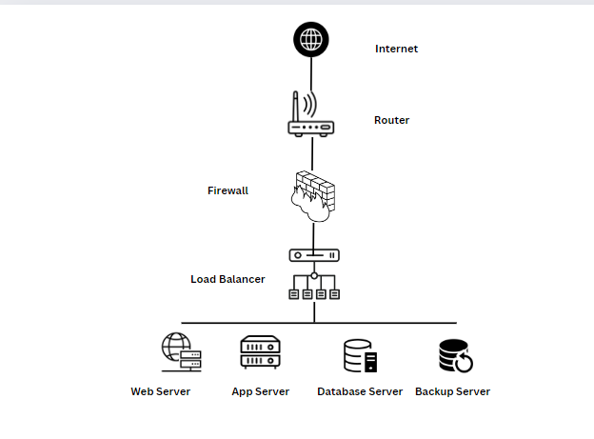

**Figure 49 : WeCare Hybrid Network Topology**

The hybrid network topology implemented by the WeCare platform blends centralized control with decentralized service distribution to optimize performance, scalability, and security. At its core is a centralized hub, the Load Balancer, which coordinates traffic among essential servers: Web Server, App Server, Database Server, Notification Server, Auth Server, and Payment Gateway. This design ensures efficient data management, real-time updates, and consistent service delivery while accommodating future growth. However, it requires robust monitoring to mitigate potential single points of failure and network congestion. Overall, the hybrid topology enables WeCare to maintain reliability and responsiveness in managing senior assistant services and user interactions effectively.

**Development/Construction/Build Phase**

This section defines the technology stack diagram, software specifications, hardware specifications, and the list of modules for the development of the proposed system.

**Technology Stack (Development)**

The technology stack diagram for "WeCare" encompasses a carefully selected set of technologies essential for its development and operation in enhancing elderly care services. At its core, the application leverages React.js framework, renowned for its robustness in building responsive and dynamic user interfaces tailored for modern web applications. Bootstrap CSS complements React.js, providing a responsive design framework with pre-built components that ensure consistent styling and layout across various devices, optimizing user experience.

JavaScript (ES6+) powers the frontend functionalities, enabling interactive features and real-time updates crucial for enhancing user engagement and accessibility. On the backend, Express.js, a minimal and flexible Node.js web application framework, facilitates efficient server-side scripting and API development, ensuring seamless integration with databases and external services.

For data management, "WeCare" adopts a hybrid approach utilizing both PostgreSQL and MongoDB. PostgreSQL, hosted on the robust Google Cloud Platform (GCP), serves as the backend database, offering scalability, reliability, and robust SQL capabilities for managing structured data such as patient records and senior assistant information. MongoDB complements this setup with its flexible document-based storage, ideal for storing unstructured or semi-structured data and accommodating diverse data models relevant to healthcare applications.

Windows Server provides a stable and secure operating system environment for hosting the application, ensuring compatibility with Microsoft technologies and supporting enterprise-level deployments. Google Cloud Platform further enhances "WeCare" with scalable cloud computing services, including virtual machines (Compute Engine) and managed databases (Cloud SQL for PostgreSQL), enabling reliable infrastructure for deployment, scaling, and data storage management.

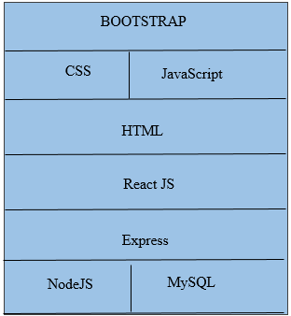

**Figure 50: WeCare Development Technology Stack Diagram**

"The 'WeCare' web application is optimized to provide a seamless user experience across various platforms, including computers, smartphones, and tablets, prioritizing accessibility and efficiency in elderly care services.

The infrastructure supporting 'WeCare' includes robust technologies tailored for scalability, reliability, and secure data management. Client devices, such as computers, smartphones, or tablets, are integral to the technology stack, serving as the primary platforms for users to engage with the application.

Selected technologies like Bootstrap, CSS, JavaScript, HTML, ReactJS, Express, MySQL, NodeJS are strategically chosen to foster a cohesive development environment. These technologies enable 'WeCare' to deliver a visually appealing, engaging, and efficient web application experience.

By leveraging these tools and frameworks, 'WeCare' ensures seamless user interaction, robust data handling capabilities, and effective integration with essential features for elderly care management, enhancing overall user satisfaction."

**Software Specification**

The software specification outlines the capabilities and software technologies needed to build and deploy the proposed system. The development team has carefully selected this particular set of software to ensure optimal performance of the system.

**Table 8**

SOFTWARE SPECIFICATION FOR DEVELOPMENT

| Operating System | Windows server 2019 |
| --- | --- |
| Web Server | IIS (Internet Information Services) or Node.js built-in server |
| Database Server | MySQL |
| Application Server | Node.js with Express.js |
| Frontend Technologies | React.js, Bootstrap, CSS, JavaScript, HTML |
| Profile Management | Managed within Node.js server, handling user profiles and settings |
| Development Tools | Visual Studio Code, Git |
| Monitoring and Management | Windows Admin Center for server management, XAMPP for MySQL management |

**Hardware Specification**

The hardware specification plays a crucial role in determining the performance and functionality of the proposed system. To ensure optimal operation and meet the requirements of WeCare, the development team has carefully considered the hardware components and specifications.

**Table 9**

HARDWARE SPECIFICATION FOR DEVELOPMENT

| Processor (CPU) | Intel Xeon Silver 4210 (10 cores, 20 threads) or AMD EPYC 7302 (16 cores, 32 threads) |
| --- | --- |
| Memory (RAM) | 16 GB to 32 GB DDR4 |
| Storage | 512 GB to 1 TB NVMe SSD (Primary Storage) |
| Cooling | High-efficiency cooling system to maintain optimal operating temperatures |
| Power supply | Single High-Quality Power Supply |
| Network | Single 1 Gbps Network Interface Card |
| Backup Solution | Automated Backup System |

**Program Specification**

The program specification is a comprehensive document that outlines the objectives and functionalities of a software application. It includes technical information about the software creation process, including the programming language, frameworks, and development tools. These are the program specs that are meant to be implemented.

**List of Modules**

A list of modules will serve as guidelines for the developers in implementing the system.



University of Cebu

College of Computer Studies

Cebu City

**Table 10**

List of Modules: Web Application

| **Programmer** | **Modules** | **Senior** | **Senior assistant** | **Admin** |
| --- | --- | --- | --- | --- |
| Hespher Dumali | **Management** | | | |
| User Profile Management | | | |
| 1. Registration and Authentication | * | * |  |
| 1. Edit Profile Information | * | * |  |
| 1. Manage Feedback |  | * | * |
| No. of Points (*1 point per module per user*) | | 1 | 1 | 1 |
| John Lloyd Pepino/Mathew James Dagle/Jerkhim Remando | **Booking Management** | | | |
| 1. Search senior assistant | * |  |  |
| 1. View senior assistant details | * |  | * |
| 1. Post Feedback & Ratings | * |  |  |
| 1. Messaging | * | * |  |
| 1. Schedule Appointments | * |  |  |
| 1. Modify or Cancel Bookings | * |  |  |
| 1. Appointment Reminders | * | * |  |
| No. of Points (*1 point per module per user*) | | 1 | 1 | 1 |
| Jerhim Remando / John Lloyd Pepino | **Senior Assistant Profile Management** | | | |
| 1. Registration and Authentication | * | * | * |
| 1. Edit Profile Information | * | * | * |
| 1. Availability Scheduling |  | * |  |
| No. of Points (*1 point per module per user*) | | 1 | 1 | 1 |
| Jerkhim Remando | **Feedback Management** | | | |
| 1. Collect User Feedback |  | * | * |
| 1. Review and Respond to feedback |  |  | * |
| No. of Points (*1 point per module per user*) | | 1 | 1 | 1 |
| Jerkhim Remando/Mathew James Dagle | **Transaction** | | | |
| Senior Assistant Search | | | |
| 1. Filter Search Option | * |  | * |
| 1. Detailed Profiles and Availability |  | * | * |
| No. of Points (*1 point per module per user*) | | 1 | 1 | 1 |
| Hespher Dumali/Kristine Cañete | Senior Assistant Details | | | |
| 1. View Detailed Profiles | * | * | * |
| 1. Qualification and Experience |  | * |  |
| 1. Reviews & Ratings | * | * | * |
| No. of Points (*1 point per module per user*) | | 1 | 1 | 1 |
| John Lloyd Pepino/Mathew James Dagle | Post Feedbacks & Ratings | | | |
| 1. Provide Service and Reviews |  | * |  |
| 1. Rate Senior Assistant | * |  |  |
| 1. View Aggregate Ratings |  | * | * |
| No. of Points (*1 point per module per user*) | | 1 | 1 | 1 |
| Hespher Dumali/Jerkhim Remando | Messaging System | | | |
| 1. Real time messaging | * | * |  |
| 1. Message history | * | * | * |
| 1. Secure Communication |  |  | * |
| No. of Points (*1 point per module per user*) | | 1 | 1 | 1 |
| John Lloyd Pepino/Kristine Cañete | **Notification** | | | |
| Notification Management | | | |
| 1. Real-time Notifications | * | * |  |
| 1. Push Notification | * | * |  |
| No. of Points (*1 point per module per user*) | | 1 | 1 | 1 |
| Mathew James Dagle/John Lloyd Pepino | Service Request Notifactions | | | |
| 1. Notify Senior Assistants of Requests. |  | * | * |
| 1. Track Request Status | * | * | * |
| No. of Points (*1 point per module per user*) | | 1 | 1 | 1 |
| Jerkhim Remando/Kristine Cañete | Feedback & Ratings Notifications | | | |
| 1. Receive Notification for New Feedback | * | * | * |
| 1. Respond to Feedback |  |  | * |
| 1. Monitor Rating Changes |  |  | * |
| No. of Points (*1 point per module per user*) | | 1 | 1 | 1 |
| Jerkhim Remando/Mathew James Dagle | Confirm Booking | | | |
| 1. Confirm Booking | * |  | * |
| 1. Send Confirmation Notifications |  | * | * |
| 1. Track Confirmation Status |  |  | * |
| No. of Points (*1 point per module per user*) | | 1 | 1 | 1 |
| Total Number of Modules | | | 12 | |



Mr.Nonito Odjinar

**Adviser’s Signature**

**Testing Plan**

**Unit Testing**

Unit testing is a systematic evaluation of individual system elements, each of which replicates the features found in a module.

**TABLE 11**

**UNIT TESTING WECARE WEB APPLICATION**

| TEST  CASE ID | UNIT TEST | DESCRIPTION | EXPECTED RESULT | ACTUAL RESULT |
| --- | --- | --- | --- | --- |
| **MANAGEMENT** | | | | |
| **CASE 1** | User Profile | Ensure the user's personal information and preferences can be viewed and edited. | Users can successfully view and edit their profile information. | As expected. |
| **CASE 2** | Booking | Validate the booking functionality, including creation, modification, and cancellation of bookings. | Users can create, modify, and cancel bookings successfully. | As expected. |
| **CASE 3** | Senior Assistant Profile | Ensure the senior assistant's personal and professional information can be viewed and edited. | Senior Assistant's profile information can be viewed and edited without errors. | As expected. |
| **CASE 4** | Manage  Feedback | Validate the feedback management system, including submission, viewing, and responding to feedback. | Feedback can be submitted, viewed, and responded to correctly. | As expected. |
| **TRANSACTIONS** | | | | |
| **CASE 1** | Search Senior Assistant | Validate the functionality to search for a senior assistant based on various criteria. | Users can successfully search for a senior assistant using different criteria. | As expected. |
| **CASE 2** | View Senior Assistant | Ensure users can view detailed information about a senior assistant. | Users can see the senior assistant's profile with all relevant details. | As expected. |
| **CASE 3** | Post Feedback & Ratings | Validate the functionality to post feedback and rate senior assistants. | Users can post feedback and ratings for senior assistants without any issues. | As expected. |
| **CASE 4** | Messaging | Ensure the messaging system allows users to send and receive messages to/from senior assistants. | Users can send and receive messages to/from senior assistants successfully. | As expected. |
| **REPORTS** | | | | |
| **CASE 1** | View booking data | Validate the functionality to view booking data. | Admin can view all booking data correctly | As expected. |
| **CASE 2** | Payments transaction | Ensure users can view and manage payment transactions. | Users can view and manage their payment transactions correctly. | As expected. |
| **NOTIFICATIONS** | | | | |
| **CASE 1** | Receive notifications | Ensure users receive notifications in real-time. | Users receive notifications as events occur. | As expected. |
| **CASE 2** | View notifications | Ensure users can view all received notifications. | Users can view a list of all notifications. | As expected. |
| **CASE 3** | View Service request | Validate the functionality to view service requests. | Users can view all service requests they have made. | As expected. |
| **CASE 4** | View Feedbacks & Ratings. | Ensure users can view feedback and ratings they have posted or received. | Users can view all their feedback and ratings. | As expected. |
| **CONFIRM BOOKING** | | | | |
|  |  |  |  |  |

**Integration Testing**

These types of tests reveal defects by looking at how integrated components are connected.

**TABLE 12**

**INTEGRATION TESTING WECARE**

| Test Objective: |  |
| --- | --- |
| Technique: |  |
| Completion Criteria: |  |
| Special Considerations: |  |
| Responsibility: |  |

**System Testing**

This type of testing entails a simulated assessment carried out on-site by a separate testing team. Evaluations of the user interface, performance, instructional content, visuals, and overall user experience are the main points of emphasis.

**TABLE 13**

**SYSTEM TESTING WECARE**

| Test Objective: |  |
| --- | --- |
| Technique: |  |
| Completion Criteria: |  |
| Special Considerations: |  |
| Responsibility: |  |

**Acceptance Testing**

**TABLE 14**

**ACCEPTANCE TESTING WECARE**

| Test Objective: |  |
| --- | --- |
| Technique: |  |
| Completion Criteria: |  |
| Special Considerations: |  |
| Responsibility: |  |

**REFERENCES**

Adelman, R. D., Tmanova, L. L., Delgado, D., Dion, S., & Lachs, M. S. (2014). Career burden: A clinical review. *JAMA*, 311, 1052–1060. https://doi.org/10.1001/jama.2014.304

Czaja, S. J., Boot, W. R., Charness, N., Rogers, W. A., & Sharit, J. (2017). Improving social support for older adults through technology: Findings from the PRISM randomized controlled trial. *The Gerontologist*, 57(5), e88-e97. https://doi.org/10.1093/geront/gnw249

Kang, E. A., Lee, Y. K., Lim, J. M., Joo, B. H., & Bae, H. W. (2019). National survey of long-term care in Korea, Ministry of Health and Welfare. Korea Institute for Health and Social Affairs. Retrieved from http://www.mohw.go.kr/react/jb/sjb030301vw.jsp?PAR_MENU_ID=030303&MENU_ID=032901&CONT_SEQ=354919

Zapata, B. C., Fernández-Alemán, J. L., Idri, A., & Toval, A. (2015). Empirical studies on usability of mHealth apps: A systematic literature review. *Journal of Medical Systems*, 39, Article 1. https://doi.org/10.1007/s10916-014-0167-6

Lam, K., Lu, A. D., Shi, Y., & Covinsky, K. E. (2020). Assessing telemedicine unreadiness among older adults in the United States during the COVID-19 pandemic. *JAMA Internal Medicine*, 180(10), 1389–1391. https://doi.org/10.1001/jamainternmed.2020.2671

Charles, L., Brémault-Phillips, S., Parmar, J., Johnson, M., & Sacrey, L.-A. (2017). Understanding how to support family caregivers of seniors with complex needs. *Canadian Geriatrics Journal, 20*(2), 75–84.<https://doi.org/10.5770/cgj.20.252>

Fisher, R., Parmar, J., Duggleby, W., Tian, P. G. J., Janzen, W., Anderson, S., & Brémault-Phillips, S. (2017). Health-care workforce training to effectively support family caregivers of seniors in care. *Canadian Geriatrics Journal, 20*(2), 75-84.<https://doi.org/10.5770/cgj.20.252>

Fisher, R., Parmar, J., Duggleby, W., Tian, P. G. J., Janzen, W., Anderson, S., & Brémault-Phillips, S. (2017). Health-care workforce training to effectively support family caregivers of seniors in care. *Canadian Geriatrics Journal, 20*(2), 75-84.<https://doi.org/10.5770/cgj.20.252>

**CURRICULUM VITAE**

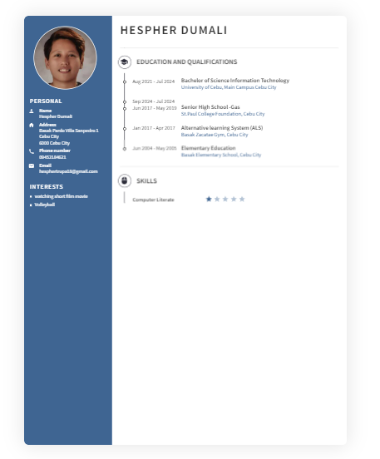

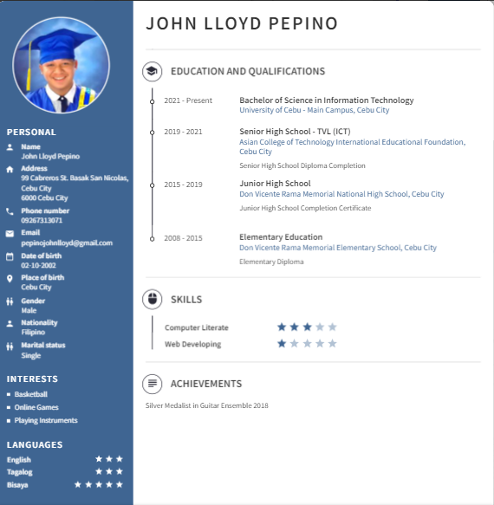

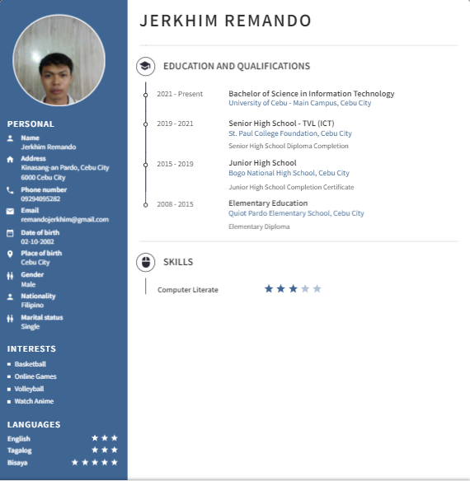

## 

## 

## 

## 

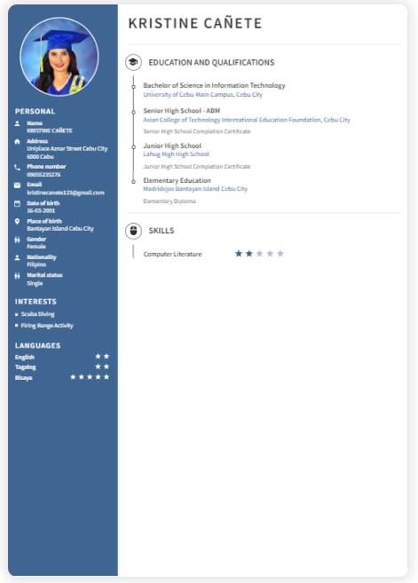

# 

# 

# 

# **APPENDICES**

## **Appendix A: Oath of Confirmation Form**

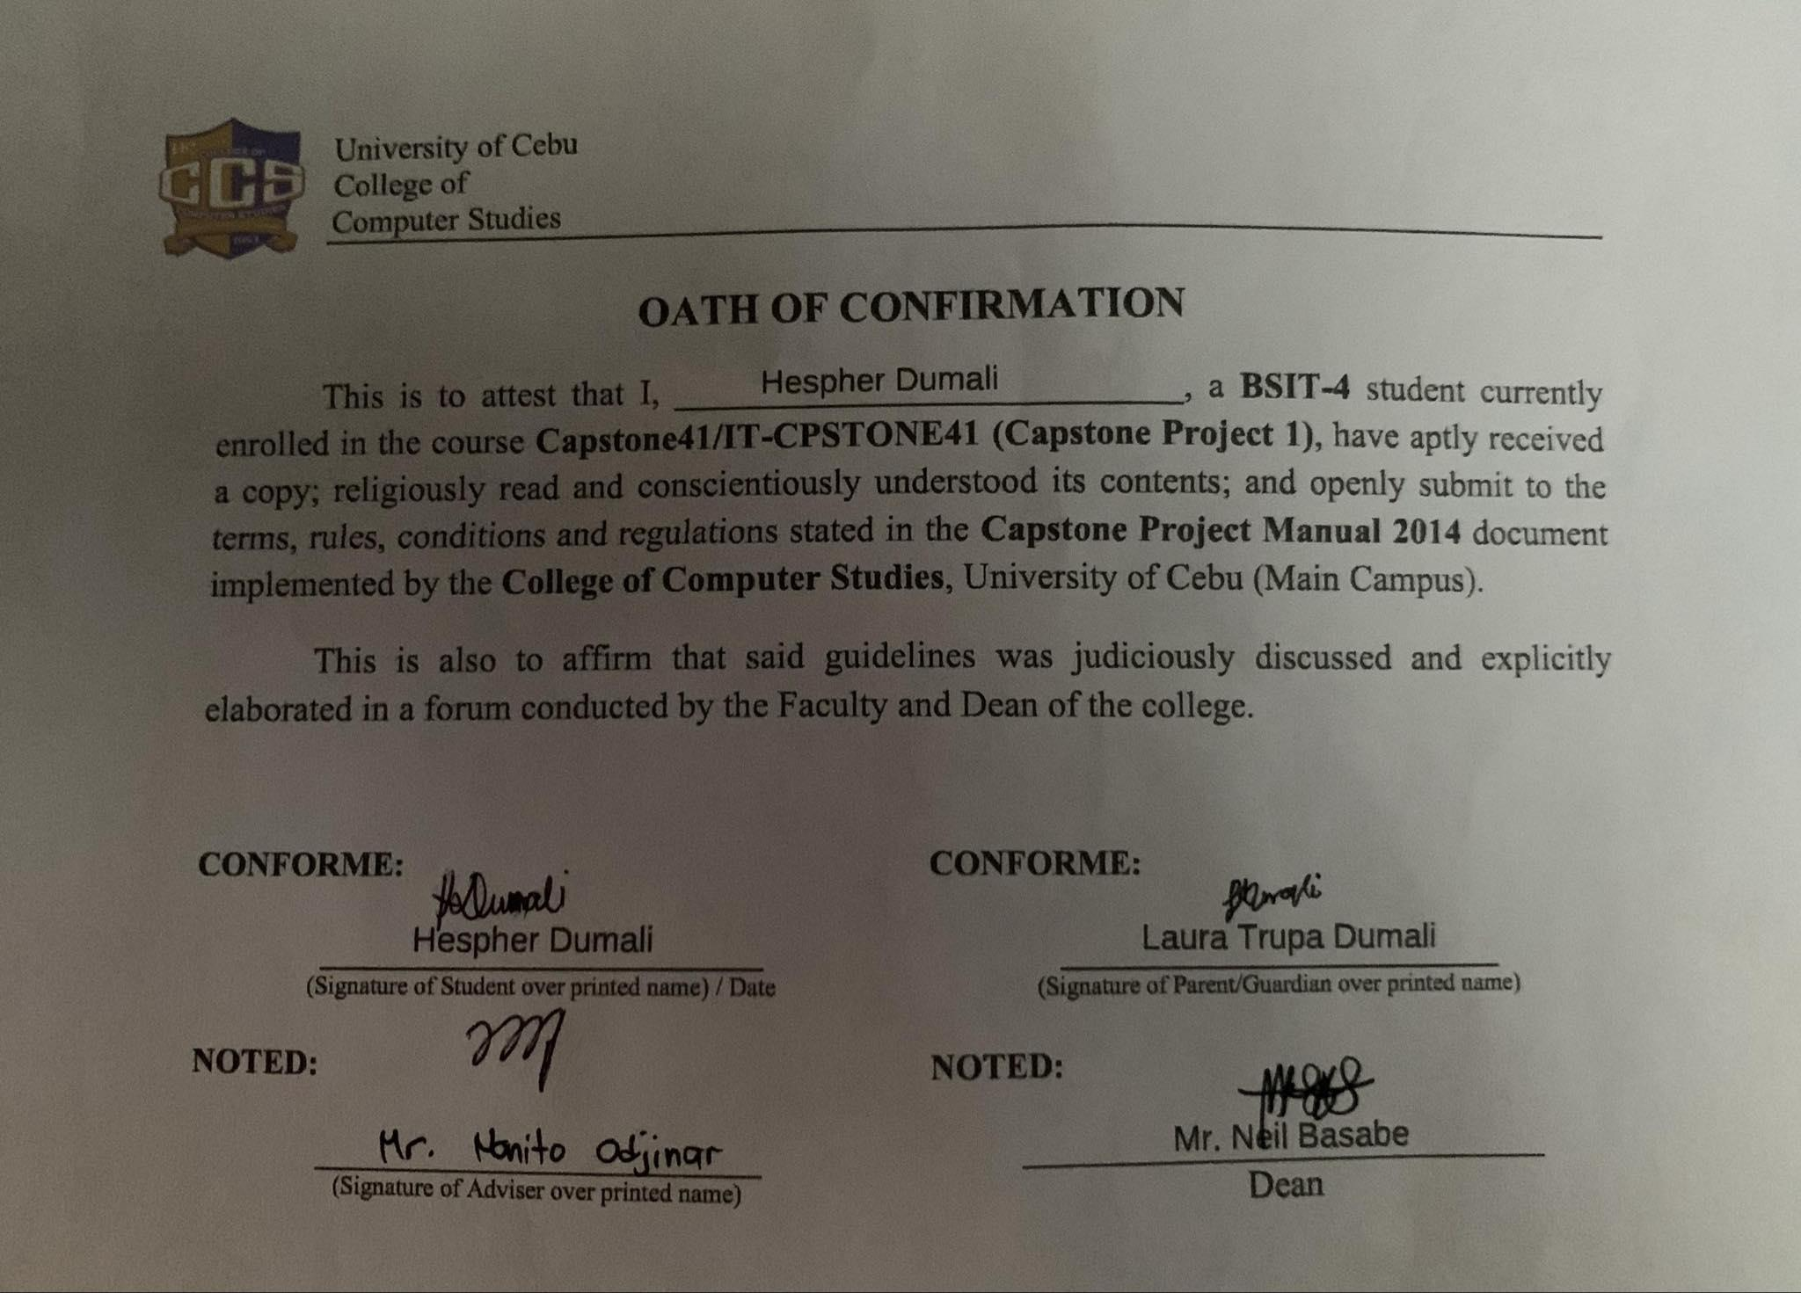

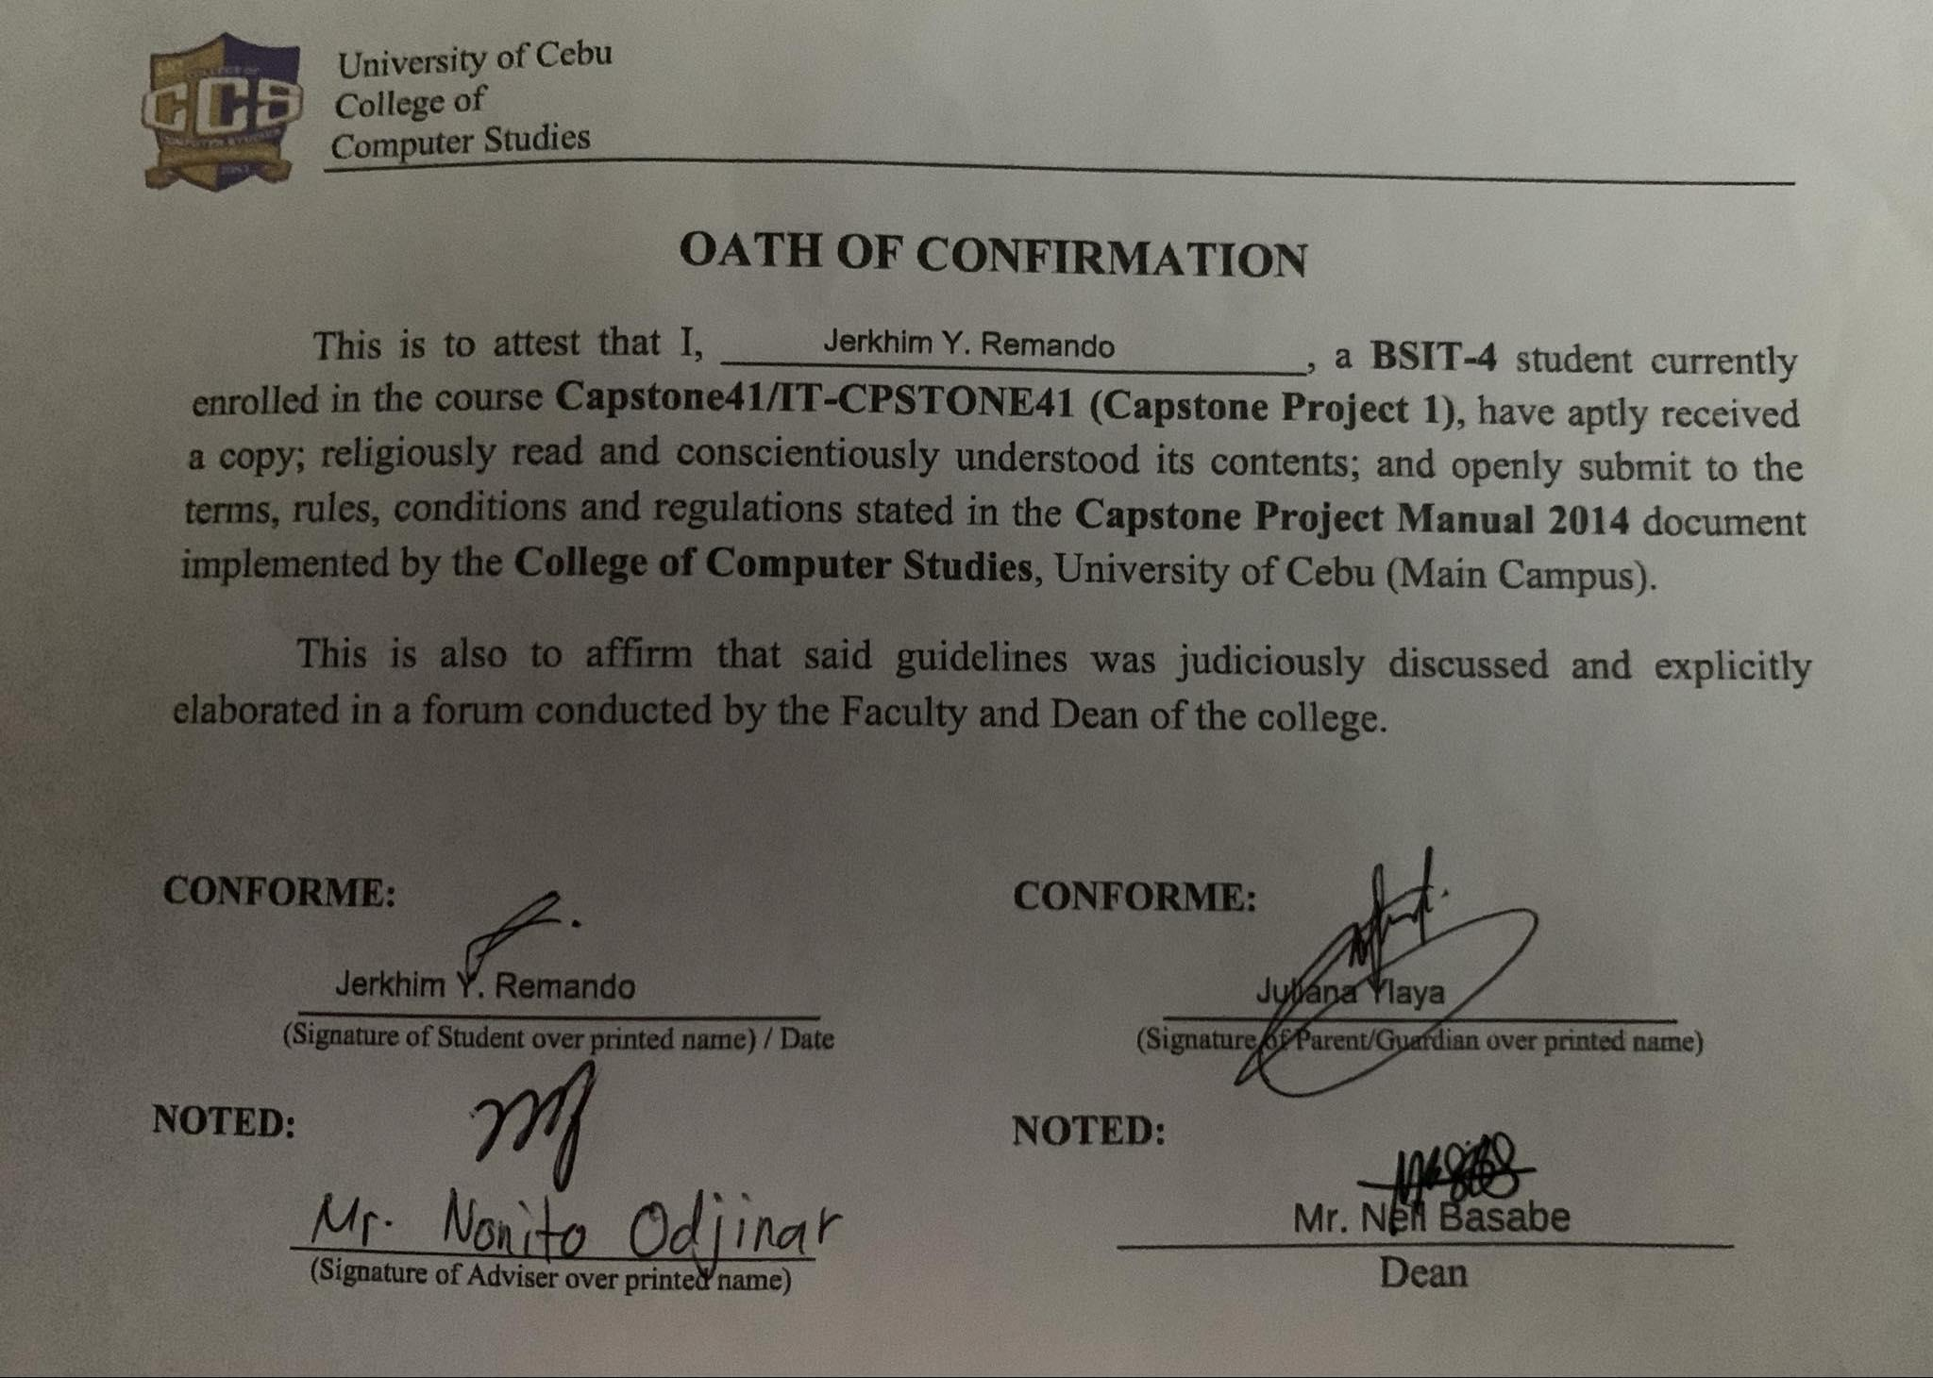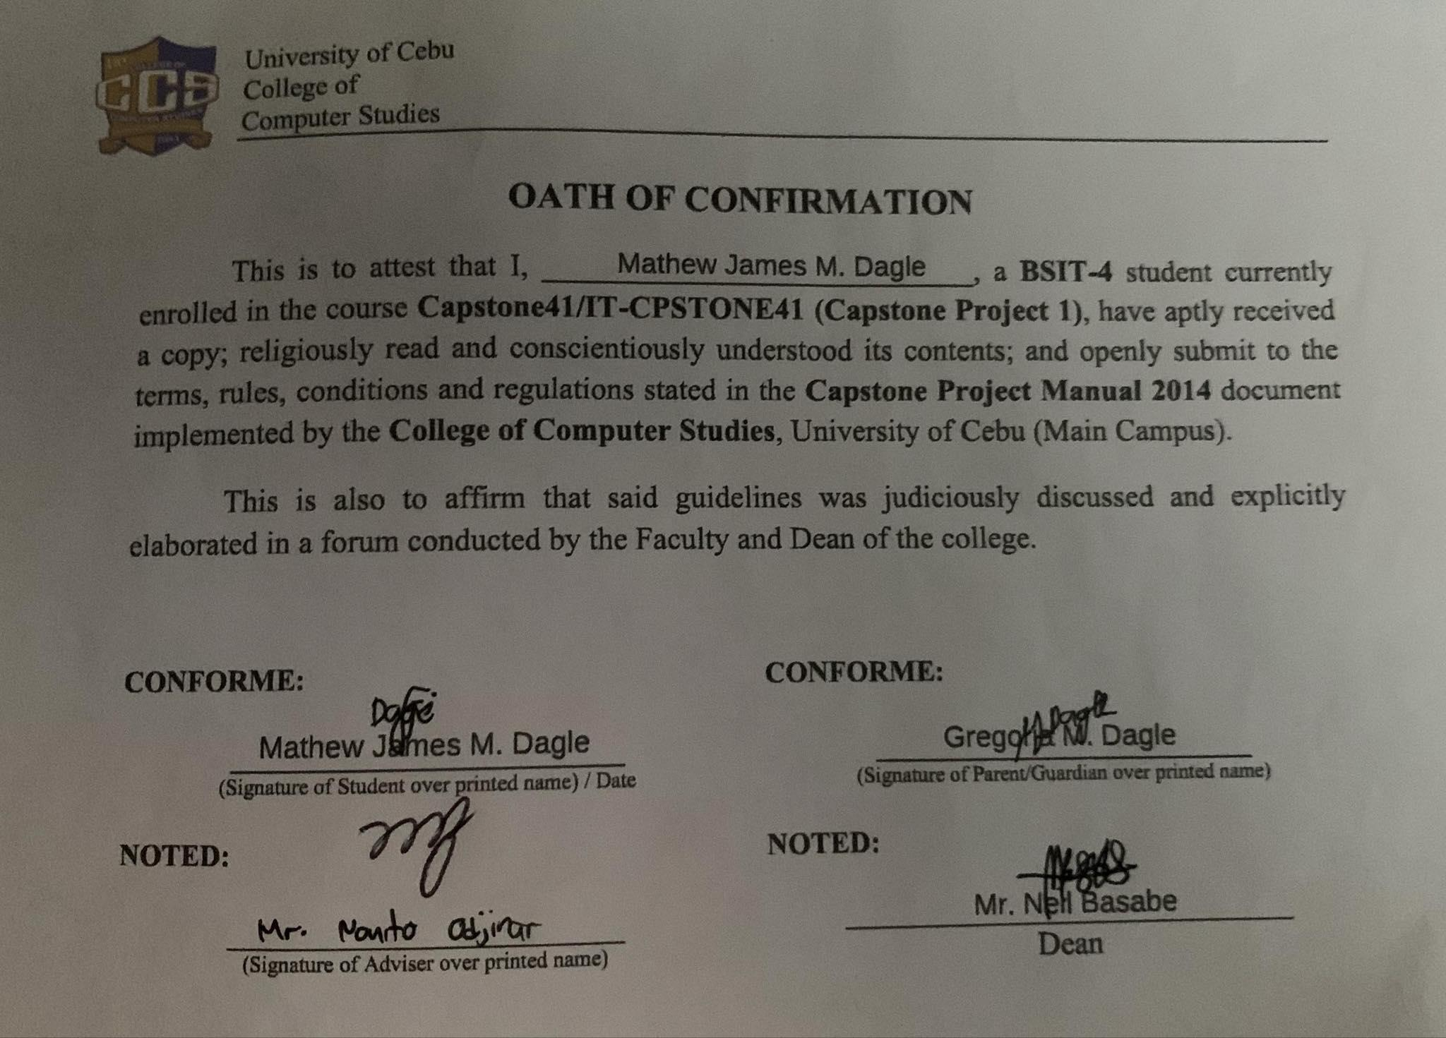

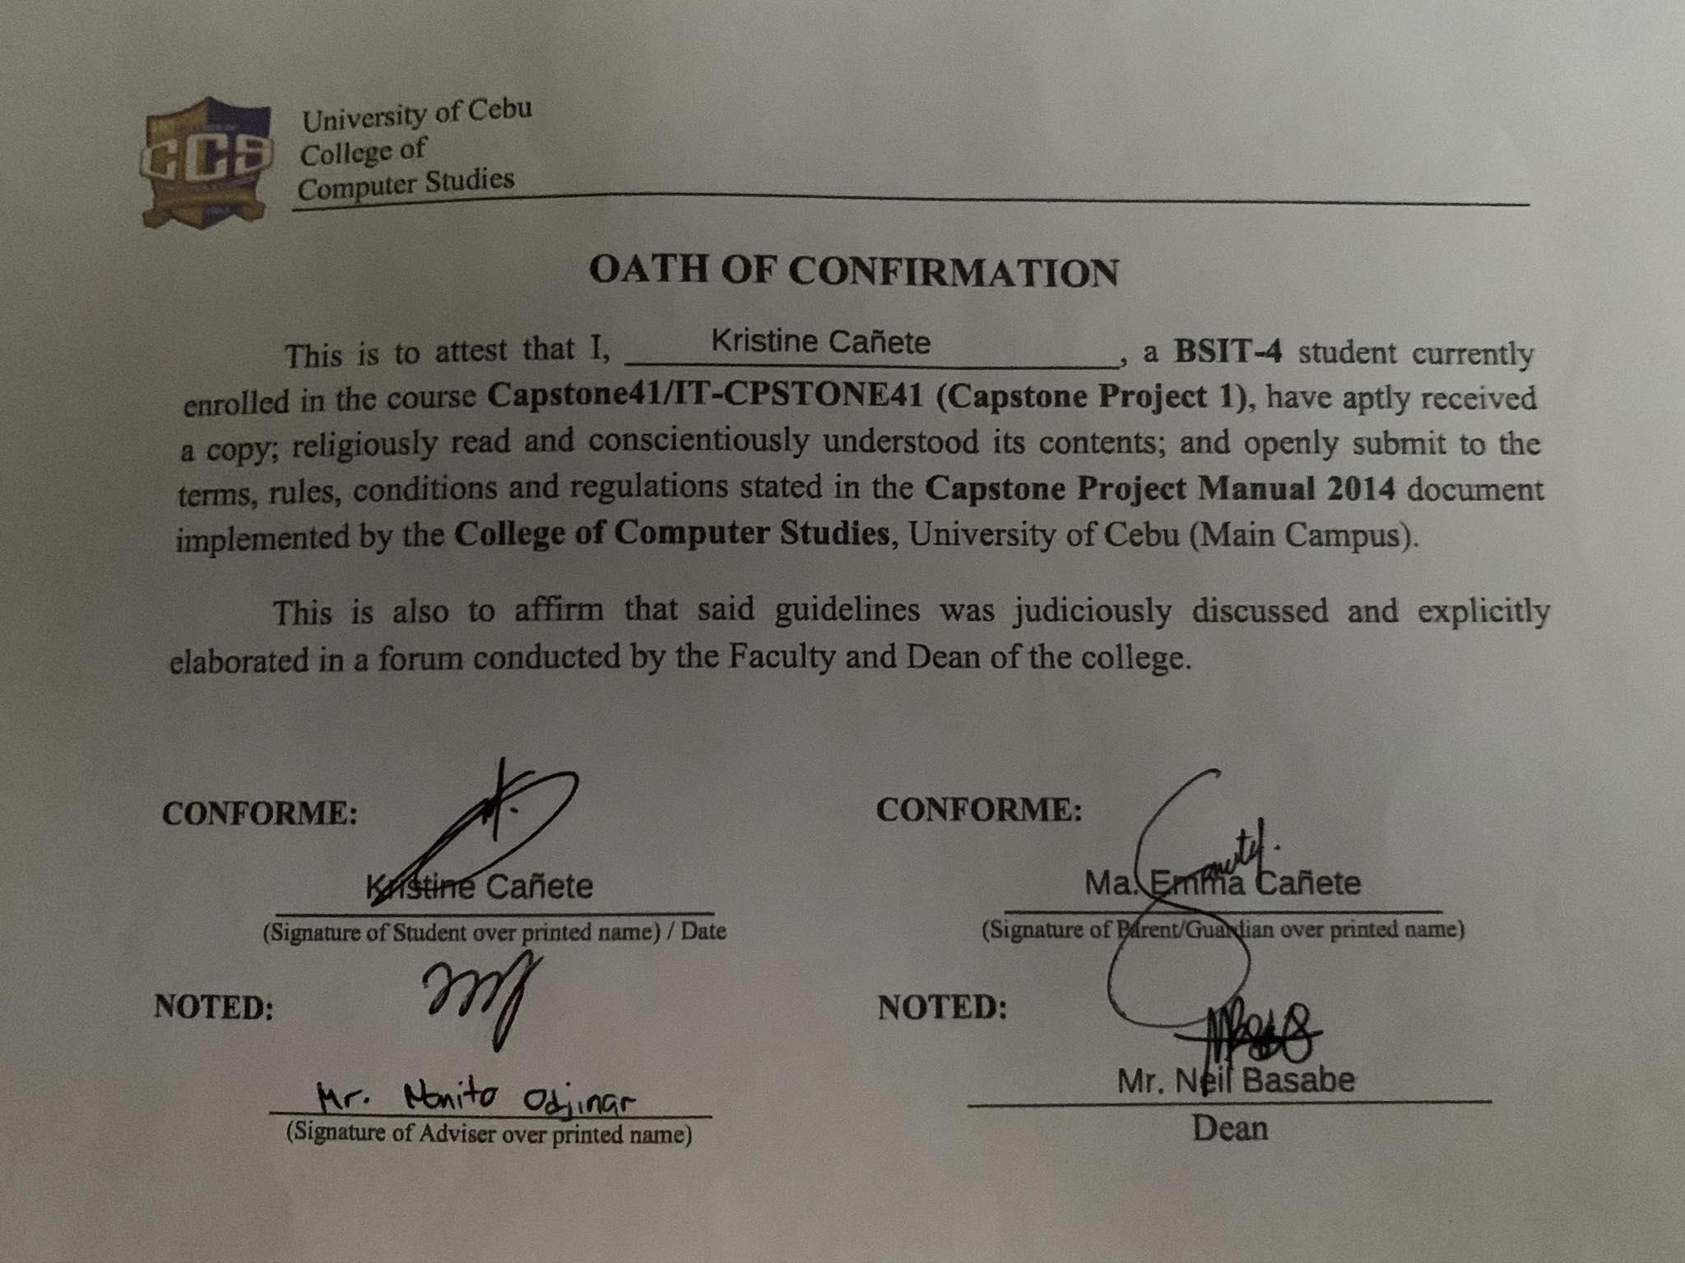

## **Appendix B: Capstone Project Team Composition Form**

## 

## 

## 

## 

## 

## 

## 

## **Appendix C: Capstone Project Business Model Canvas Template**

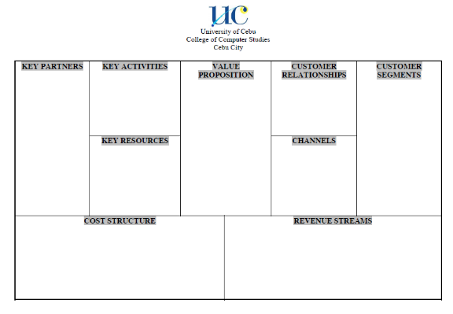

## **Appendix D: Capstone Project Related Studies Comparative Matrix Template**

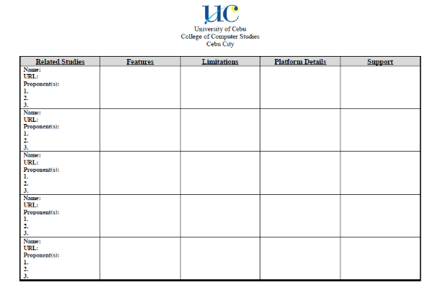

## 

## **Appendix E: Capstone Project Working Title Form**

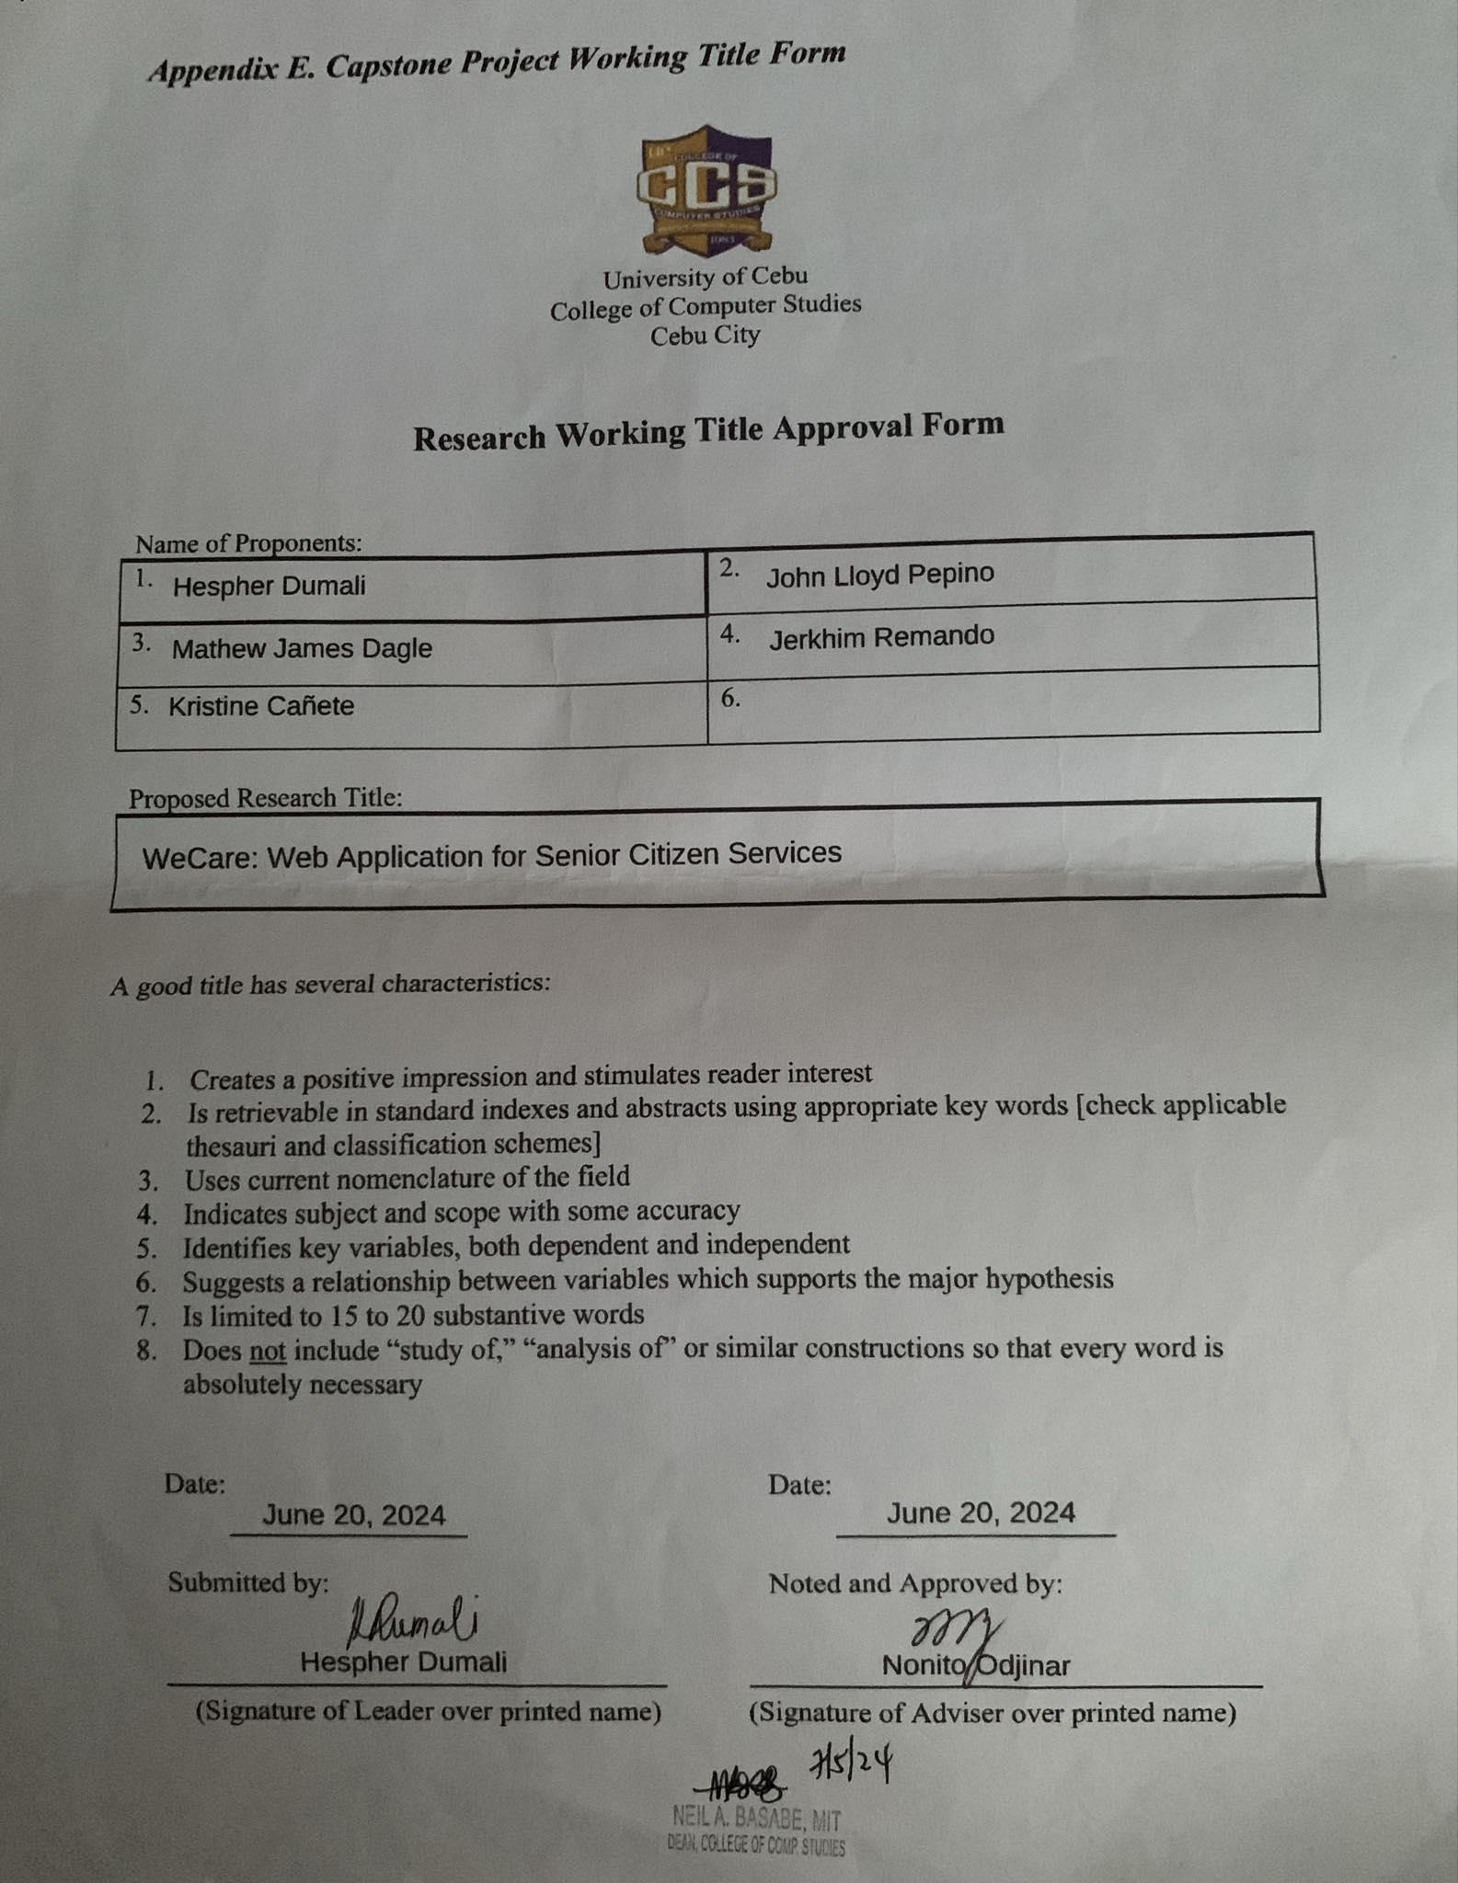

## **Appendix F: Capstone Project Gantt Chart Template**

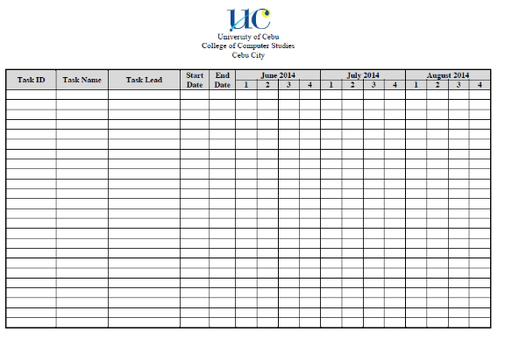

## **Appendix G: Consultation Logs Form**

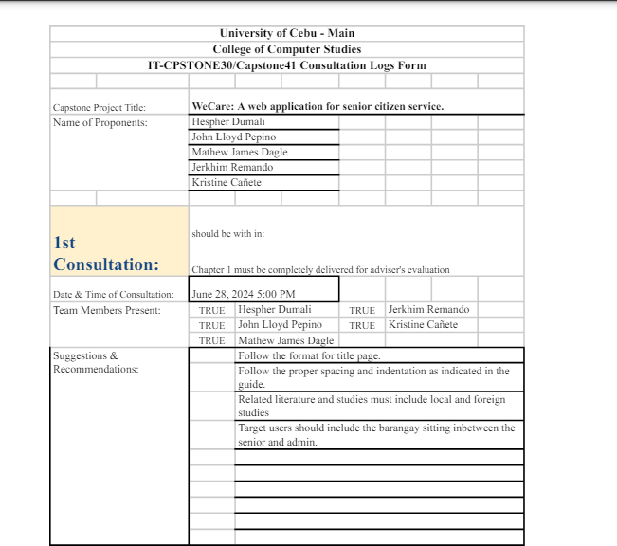

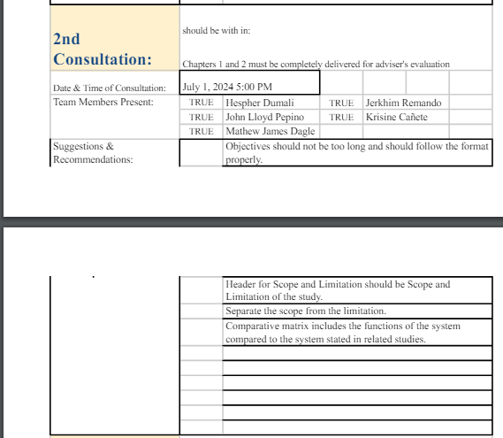



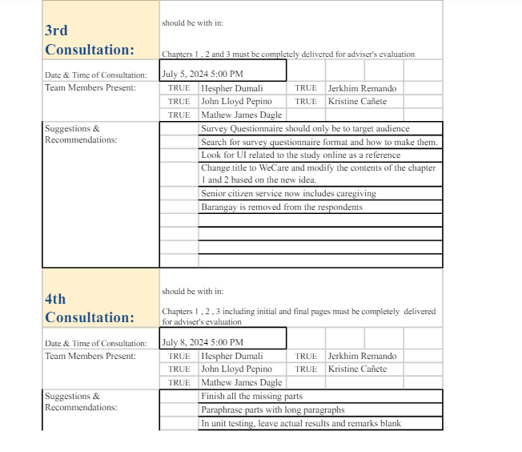

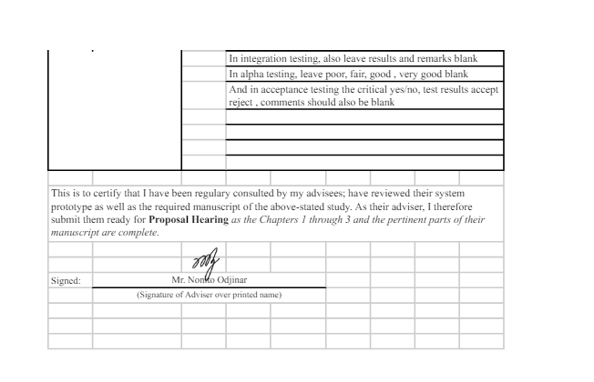

## **Appendix L: Capstone Project Hearing Notice Form**

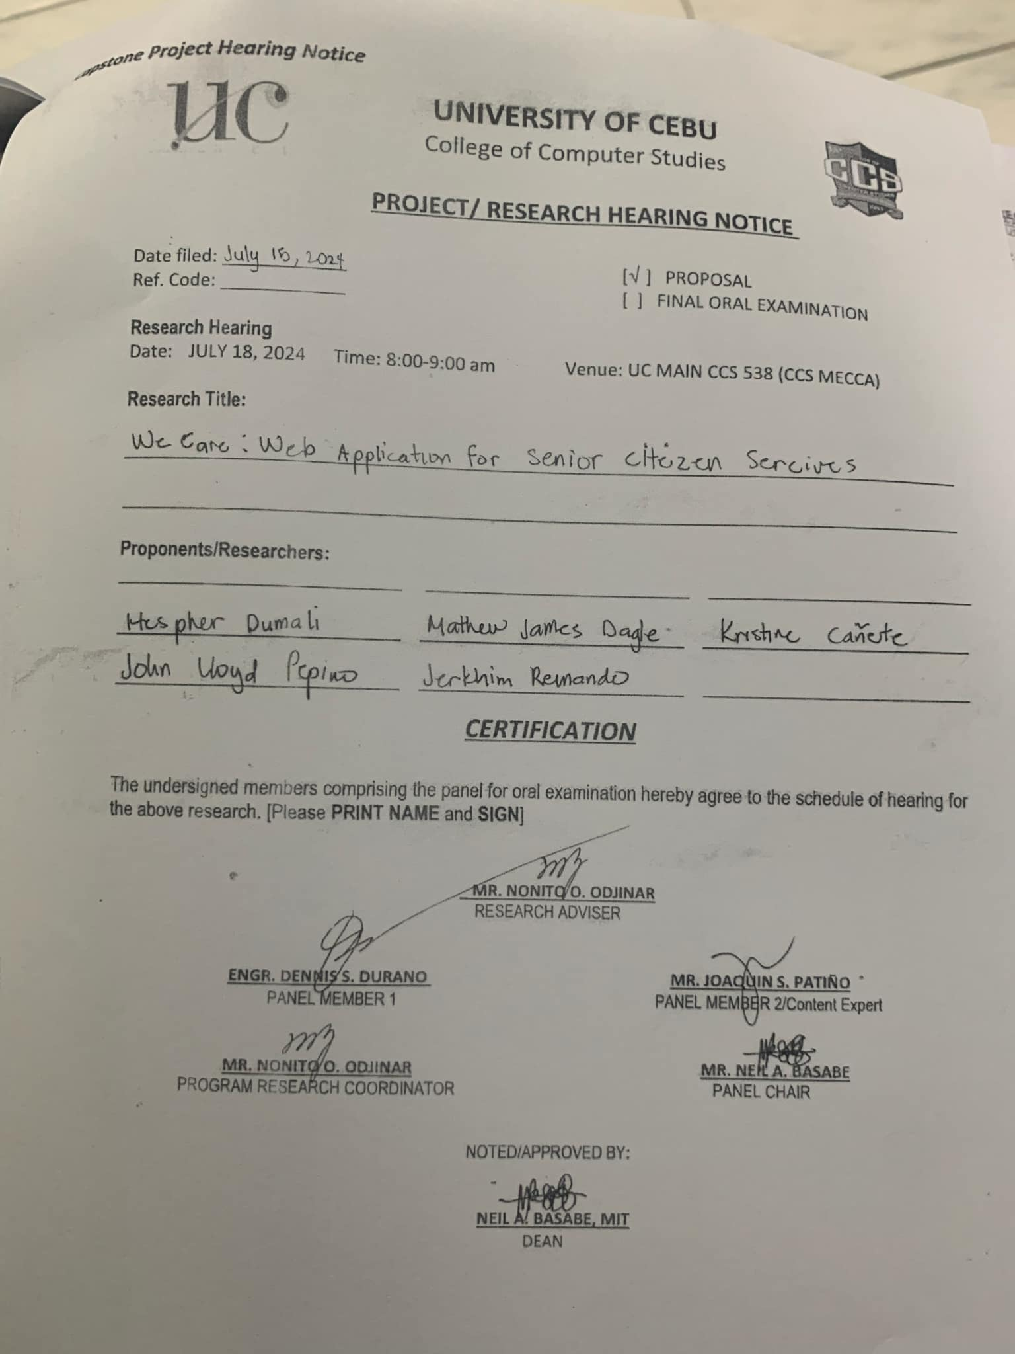

## **Appendix M: Capstone Project Panel Honoraria (Form 10)**

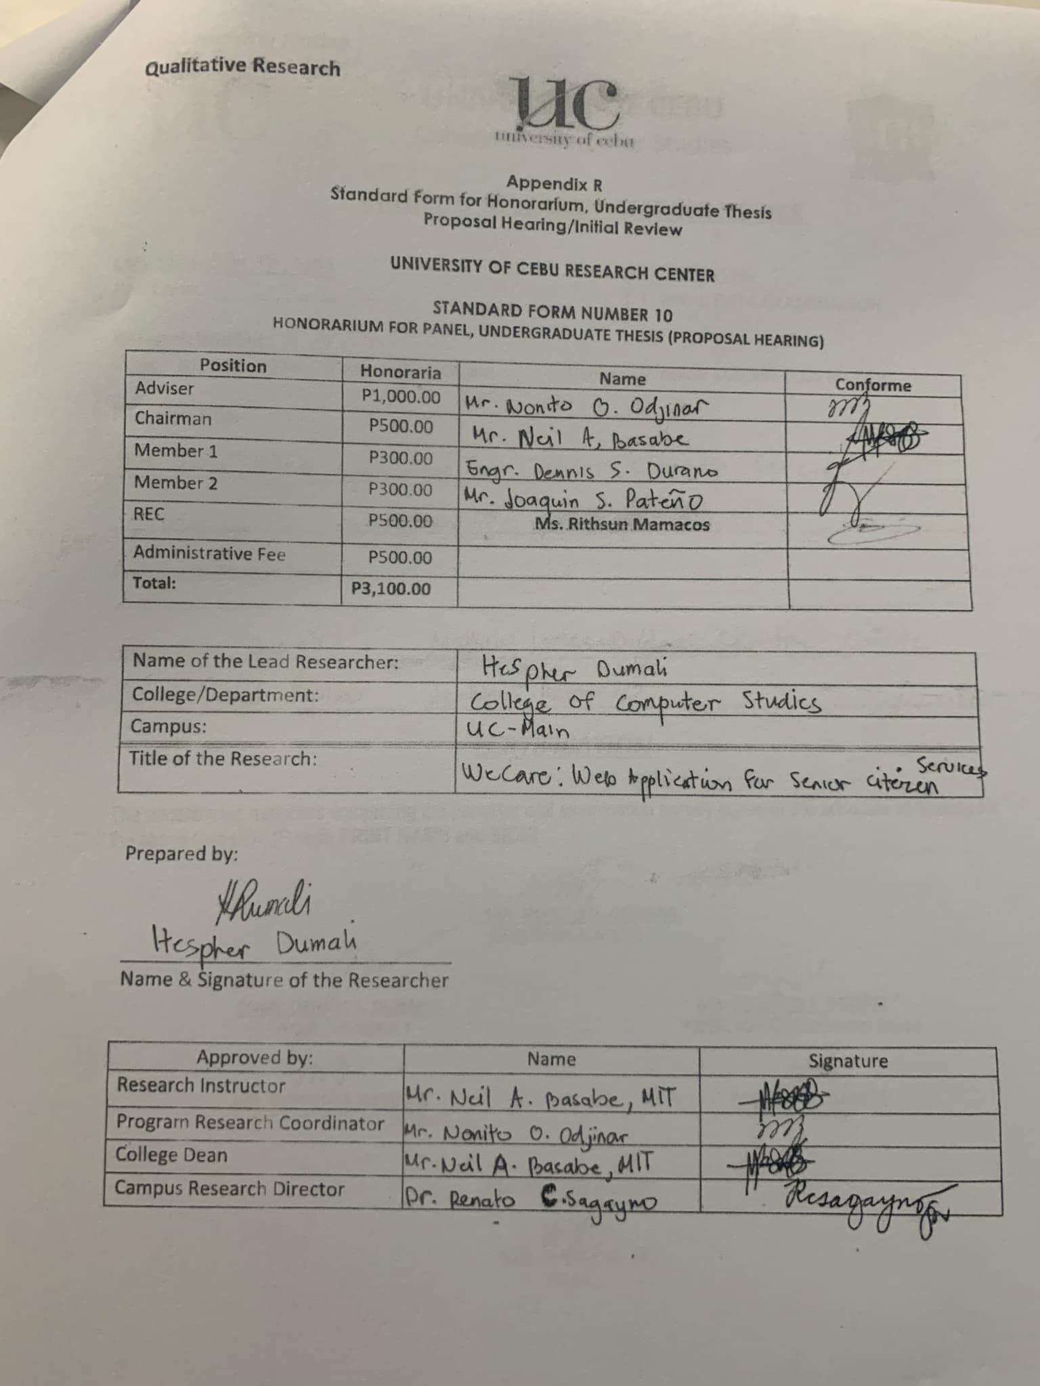

**Appendix O: Capstone Project Manuscript Title Page Template**

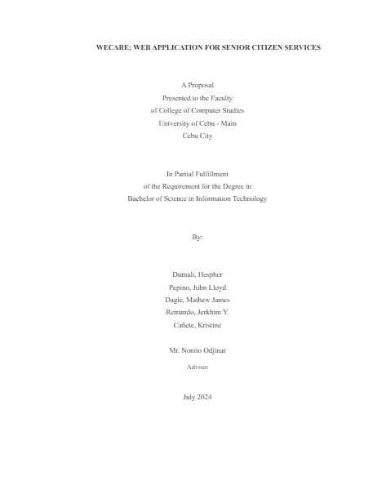

## **Appendix R: List of Modules Template**

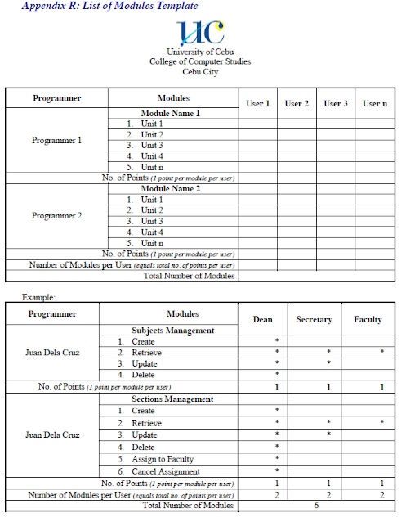

**Grammar and Plagiarism Form (Form 19)**

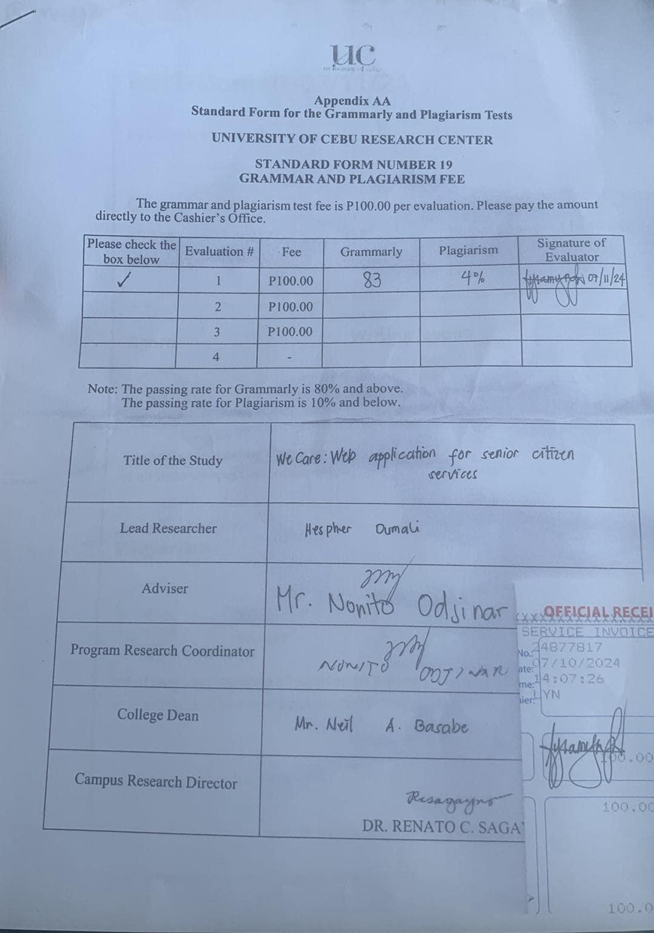

**Grammar and Plagiarism Result**

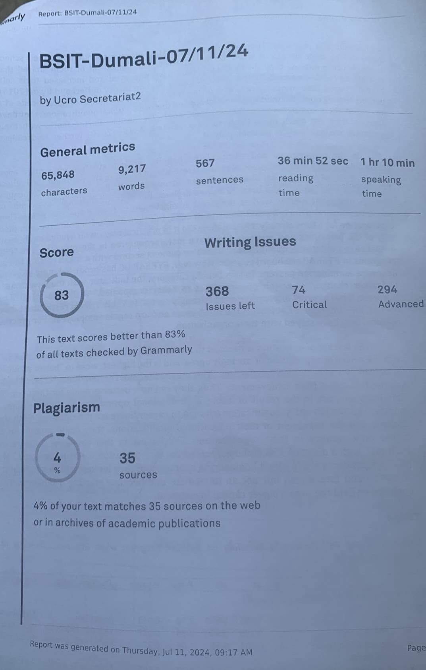

**Capstone Project Minutes of Proceeding**

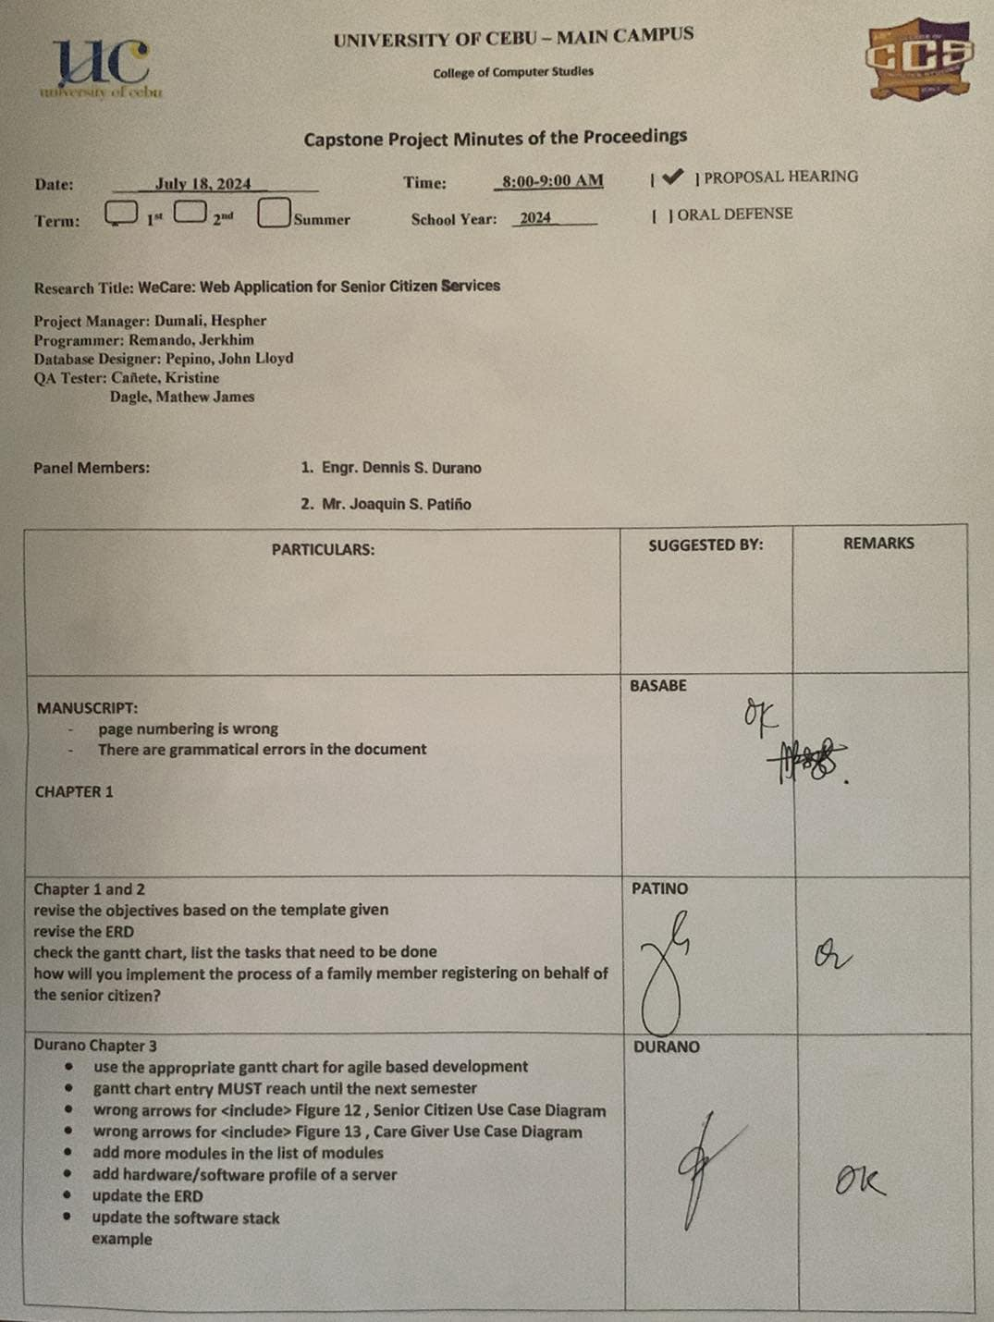

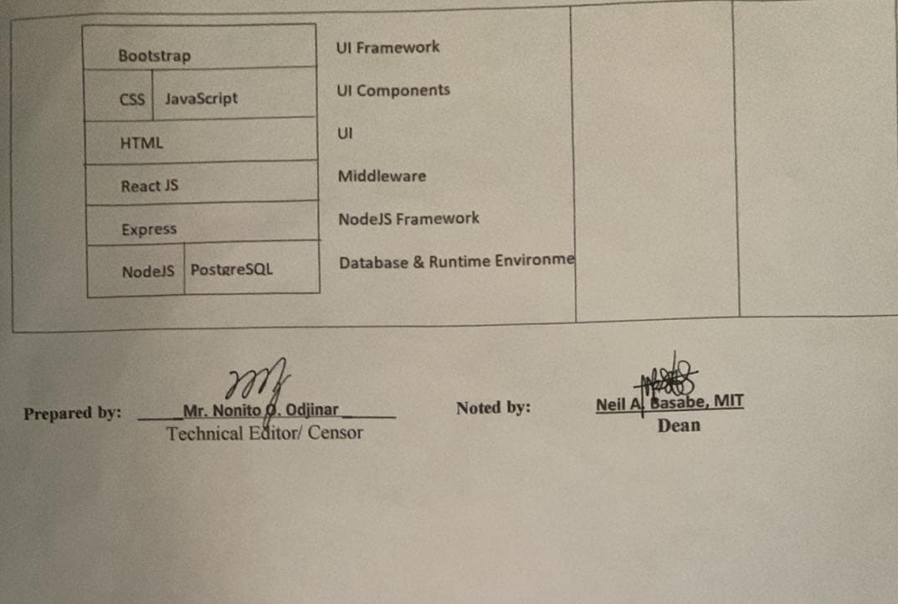

**Transmittal Letter**

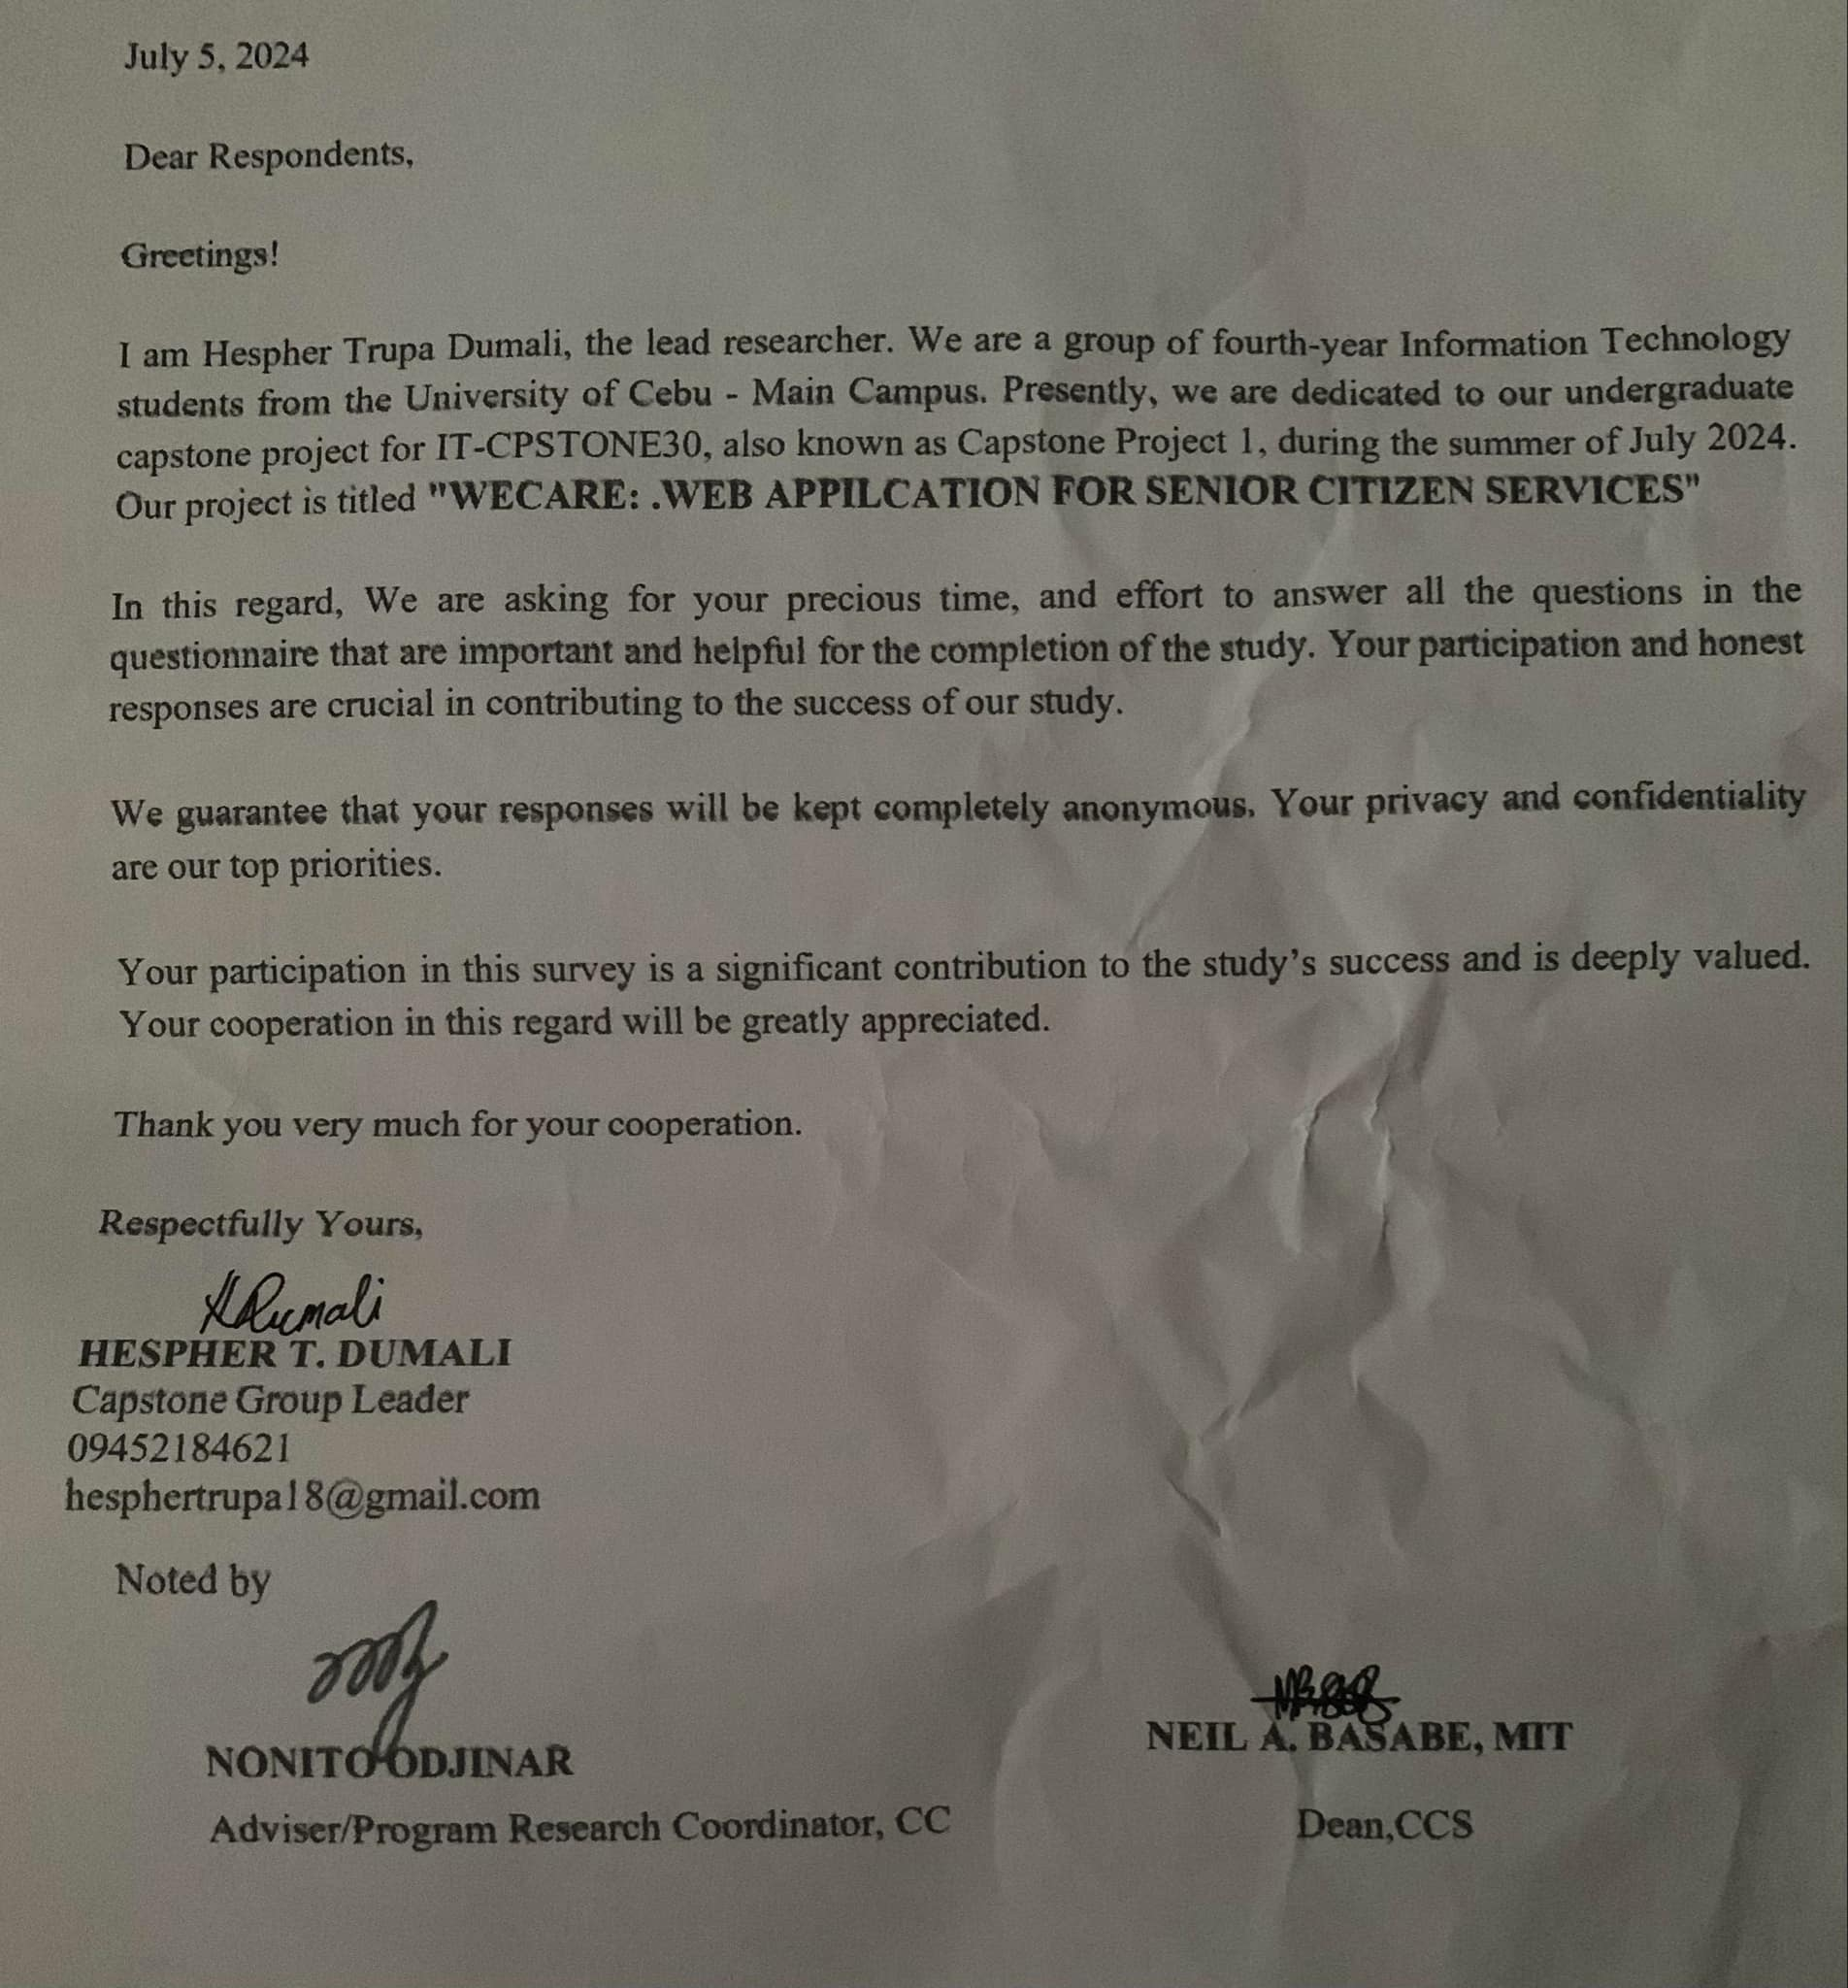

**Survey Questionnaire for Senior Assistant**

This questionnaire is designed to gather valuable insights from senior assistants like you, by understanding the current experiences, challenges, and needs. The responses will help us refine our web application to better meet the needs of senior assistants, ultimately improving the caregiving experience.

**I. Demographics**

How old are you?

What do you prefer as?

* + Male
  + Female
  + Other:

How comfortable are you in using technology?

* + Very comfortable
  + Less comfortable
  + I don't use technology
  + Other:

**II. Background and Experience**

Have you ever been a senior assistant for more than a year?

* + Yes
  + No

Do you currently provide care for a friend or family member?

* + Yes
  + No

Have you ever received formal training in caregiving?

* + Yes
  + No

Do you provide care for more than 20 hours per week?

* + Yes
  + No

**III. Feature-Specific Feedback**

Do you use any assistive technologies in your caregiving duties?

* + Yes
  + No

How easy is it for you to coordinate care currently?

Very difficult

* + 1
  + 2
  + 3
  + 4
  + 5

Very easy

Would you consider yourself prepared for potential medical emergencies?

* + Yes
  + No

**IV. Overall Feedback and Suggestion**

Is there anything else you'd like to share about your caregiving experiences or needs?

Any additional comments or suggestions for improving caregiving services?

**Survey Questionnaire for Elders**

This survey is designed to provide senior citizens with a comprehensive platform for accessing various services and resources. The response will help us refine our web application to better meet the needs. Your feedback will help us improve the application and better serve the senior community. Please answer the questions honestly, and to the best of your ability.

**I. Demographics**

To better understand our respondents, we'd like to gather some basic information about you. Please take a moment to answer the following questions:

How old are you?

What is your gender?

* + Male
  + Female
  + Other:

Are you currently living alone or with others?

* + I live alone
  + I have someone to look after me
  + Other:

How comfortable are you in using technology?

* + Very comfortable
  + Less comfortable
  + I don't use technology

What are your current methods of accessing senior services? (Select all that apply)

* Online
* Phone
* In-Person
* Other:

**II. Healthcare and Wellness**

We're interested in understanding your current health and wellness habits. Please share your experiences with us:

How would you rate your overall health?

* + Excellent
  + Good
  + Fair
  + Poor

Have you ever tried caregiving services?

* + Yes
  + No

If your answer to question number 7 is yes, how was your experience? otherwise leave it blank.

* + Excellent
  + Good
  + Fair
  + Poor

Do you have difficulties with daily activities (e.g., bathing, dressing, cooking)?

* + Yes
  + No

**III. Feature-Specific Feedback**

We'd like to gather your thoughts on the features of WeCare and how they might address your needs. Please share your opinions on the following:

How easy is it for you to schedule appointments currently?

Very difficult

* + 1
  + 2
  + 3
  + 4
  + 5

Very easy

Have you ever needed to contact someone in case of an emergency?*

* + Yes
  + No

How often do you forget important tasks or appointments?

Rarely

* + 1
  + 2
  + 3
  + 4
  + 5

Very often

**IV. Overall Experience and Suggestions**

We value your overall opinion on WeCare and any suggestions you may have for improvement:

Is there anything else you'd like to share about your experiences or needs?

Any additional comments or suggestions about senior services in general?